

USEFUL JAPANESE DICTIONARY FOR VIETNAMESE

USER MANUAL DOCUMENT

**Project Code: UJD_VN**

**Document Code: UJD_VN_User Manual_v1.0_EN**

**Ha Noi, 15/08/2014**

Record of change

*A - Added M - Modified D - Deleted

|  |  |  |  |  |
| --- | --- | --- | --- | --- |
| Effective Date | Changed Items | A* M, D | Change Description | New Version |
| 15/08/2014 |  | A | Add new | v1.0 |
|  |  |  |  |  |
|  |  |  |  |  |
|  |  |  |  |  |
|  |  |  |  |  |
|  |  |  |  |  |
|  |  |  |  |  |
|  |  |  |  |  |
|  |  |  |  |  |
|  |  |  |  |  |
|  |  |  |  |  |
|  |  |  |  |  |
|  |  |  |  |  |
|  |  |  |  |  |
|  |  |  |  |  |
|  |  |  |  |  |
|  |  |  |  |  |
|  |  |  |  |  |
|  |  |  |  |  |
|  |  |  |  |  |
|  |  |  |  |  |

SIGNATURE PAGE

ORIGINATOR: Phạm Tiến Đạt 15/08/2014

Team member

REVIEWERS: Nguyễn Ngọc Tuấn 16/08/2014

Team member

APPROVAL: Nguyễn Văn Sang 16/08/2014

Supervisor

# Installation guide

## Introduction

* This document contains guide-lines step by step to use UJD_VN website, and set up its own database.

## Environment

* Following are the software required to start the UJD_VN System:
* Operating System: Windows 7, WinXP, Win8
* Browsers: Firefox 20, Chrome 36 or higher.
* Database: MySQL 5.6.16 or higher
* Xampp 1.8.3/ PHP 5.5.11

## Application Installation

### Set up Environments:

* Web: If users want to use UJD_VN system on personal computer, users need to install Chrome36 /Firefox 20 or higher version and MySQL to create and store database.
* Server: Xampp 1.8.3

### Set up Xampp 1.8.3

Go to link: http://toidongianchannel.wordpress.com/2014/03/31/huong-dan-cai-dat-localhost-bang-phan-mem-xampp-server/ and follow the guides

### Create Database

* After set up Xampp 1.8.3, start XAMPP Control Panel :

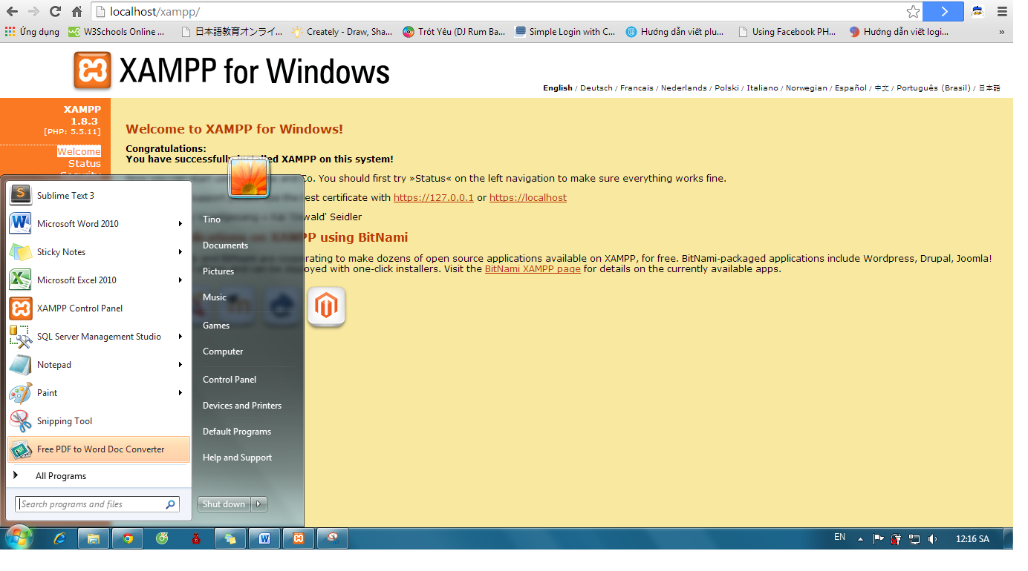

* Click “Start”of Apache and MySQL:

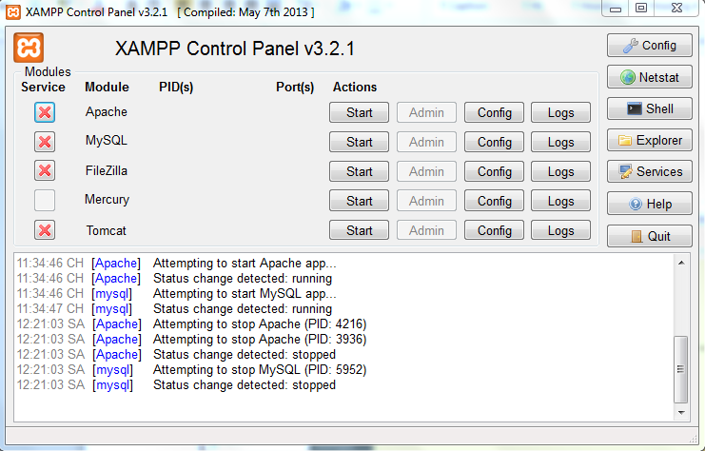

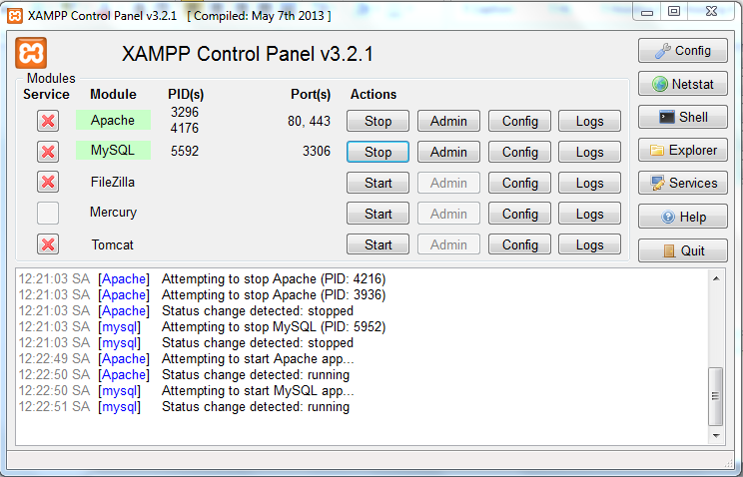

* Go to link: http://localhost/xampp/ and click on phpMyAdmin

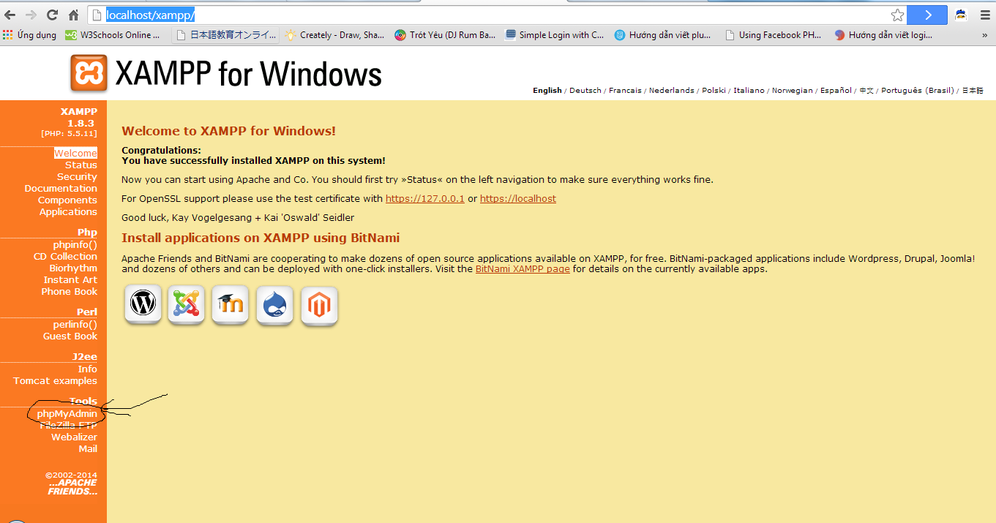

* Click on “New” to create a new database with name as “japanesedictionary” and collation “utf8_general_ci”. After click “Create”

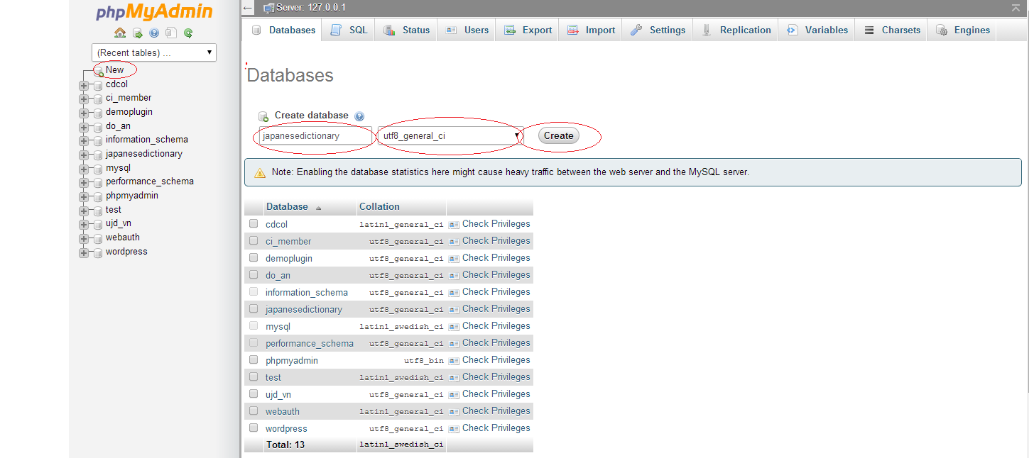

* After click “Create”, a new database were created with name as “japanesedictionary”

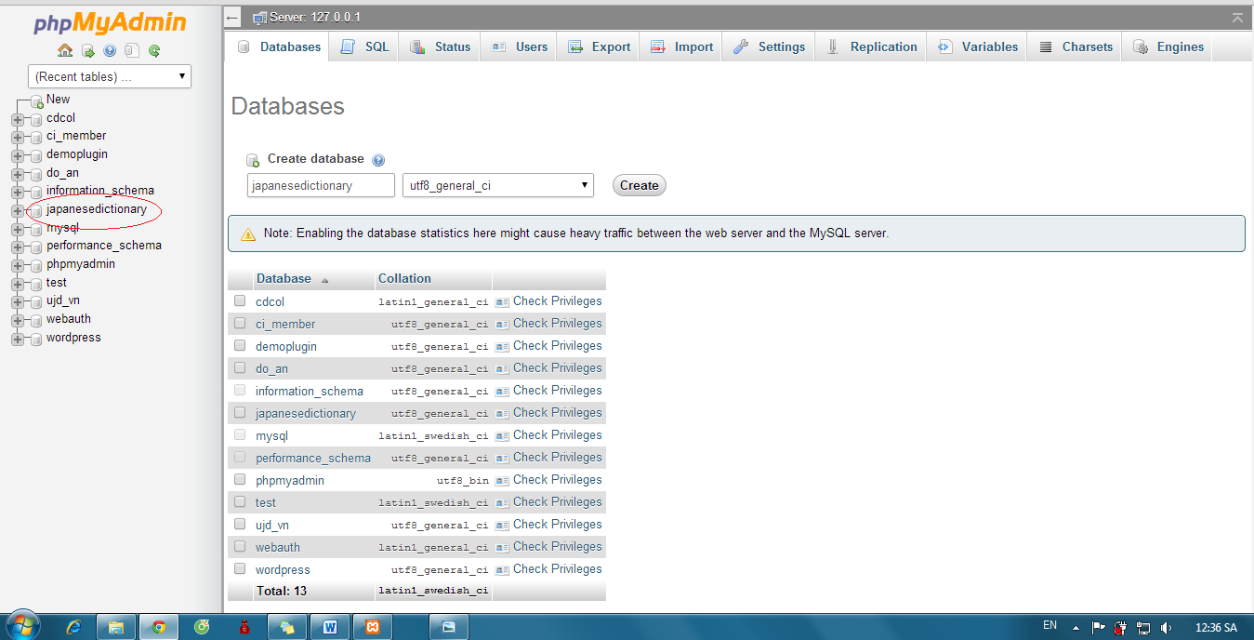

* Click “japanesedictionary” and “Import” :

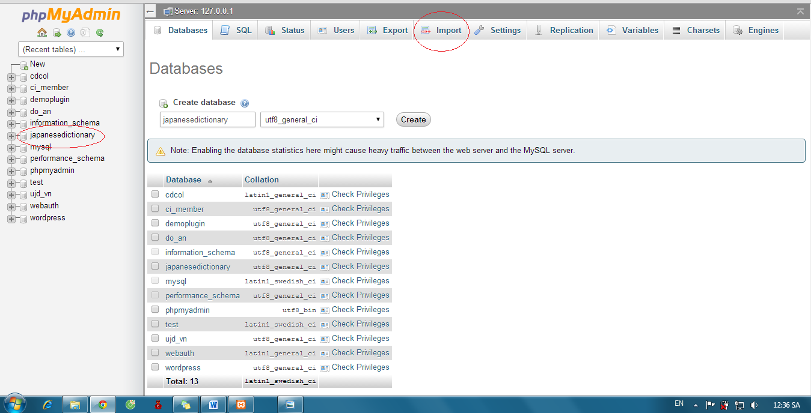

* Click “Chọn tệp” button:

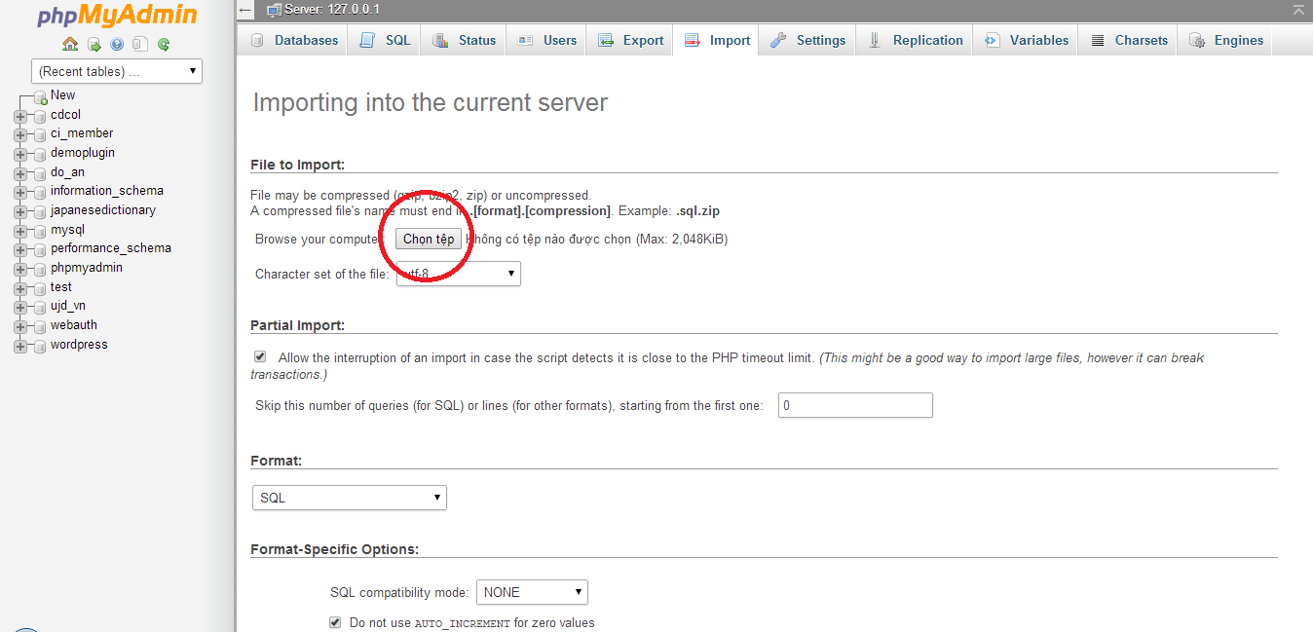

* Select file “japanesedictionary.sql”

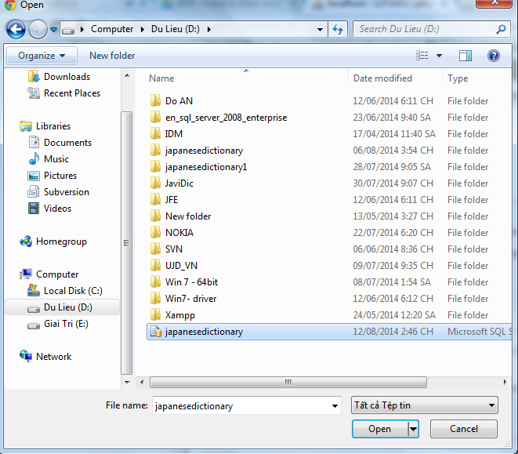

* Click “Go”

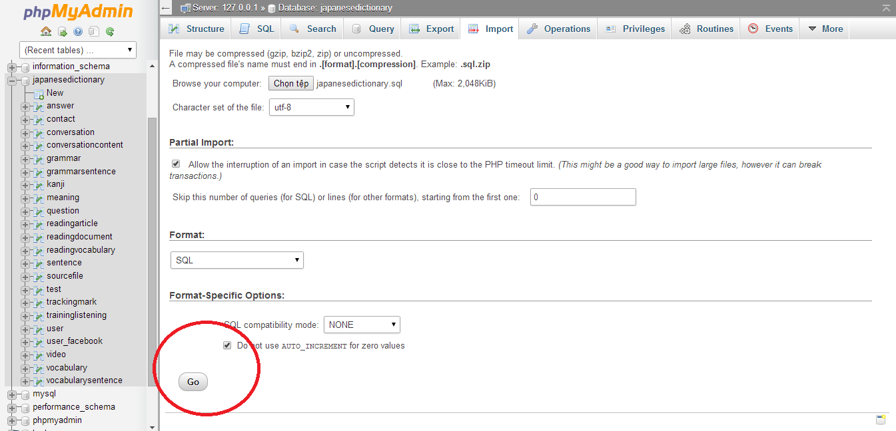

* Database was created with some table that contained data

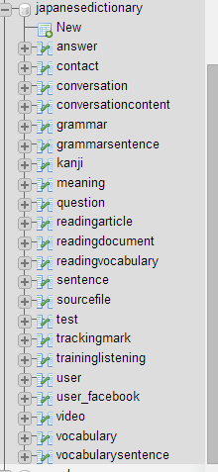

### Installation Web Application

Step 1: Preparing package japanesedictionary.rar. Make sure package is available (incorrupt).

Step 2: Move package to htdocs folder of folder which installed xampp server (:..\Xampp\htdocs)

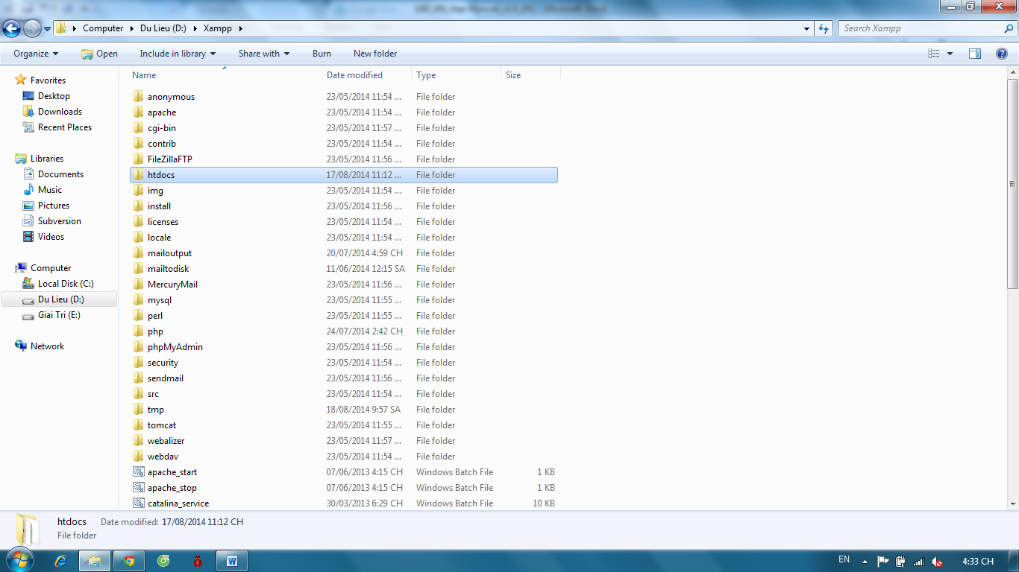

Step 3: Extract file japanesedictionary.rar, select “Extract here”

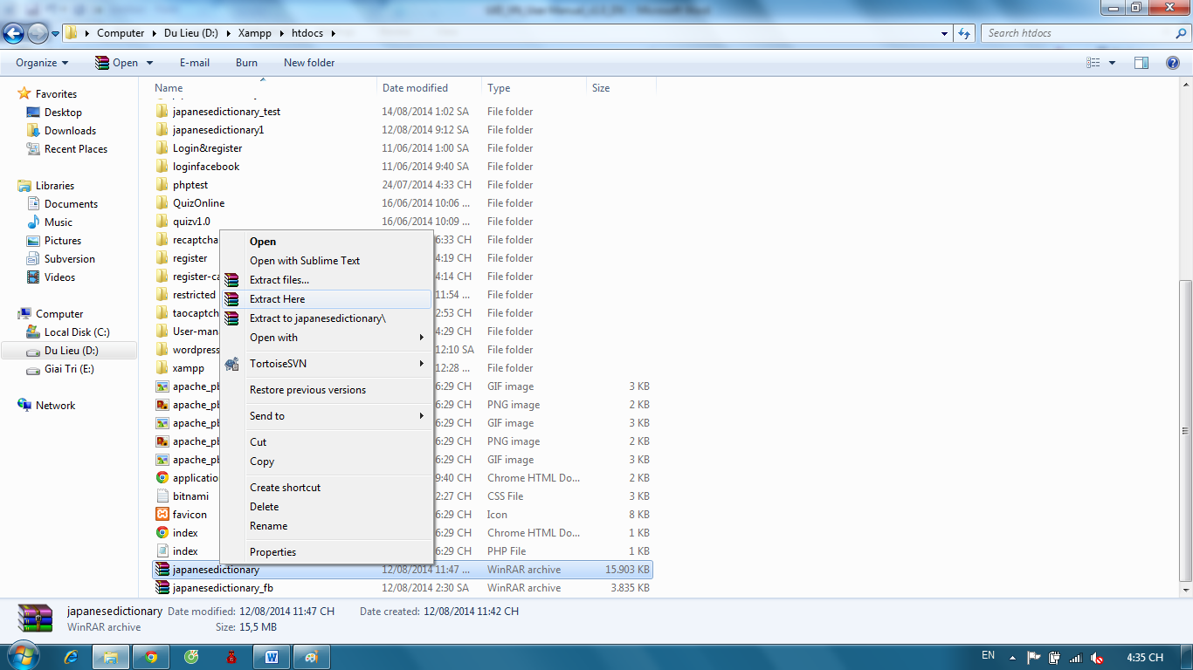

Step 4: Open Browser (Chrome or Firefox) and go to link http://localhost/japanesedictionary/index.php/Home/verify/login or http://localhost/japanesedictionary/index.php/Admin/verify/login

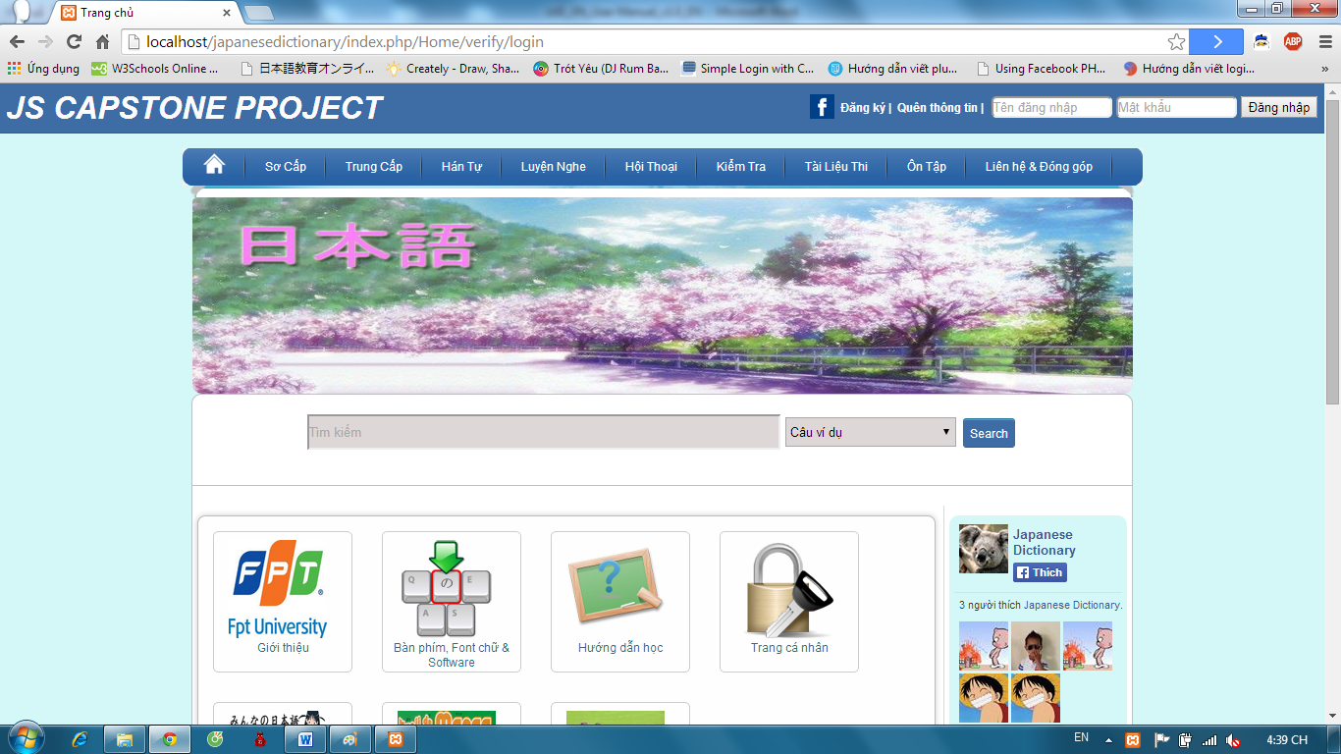

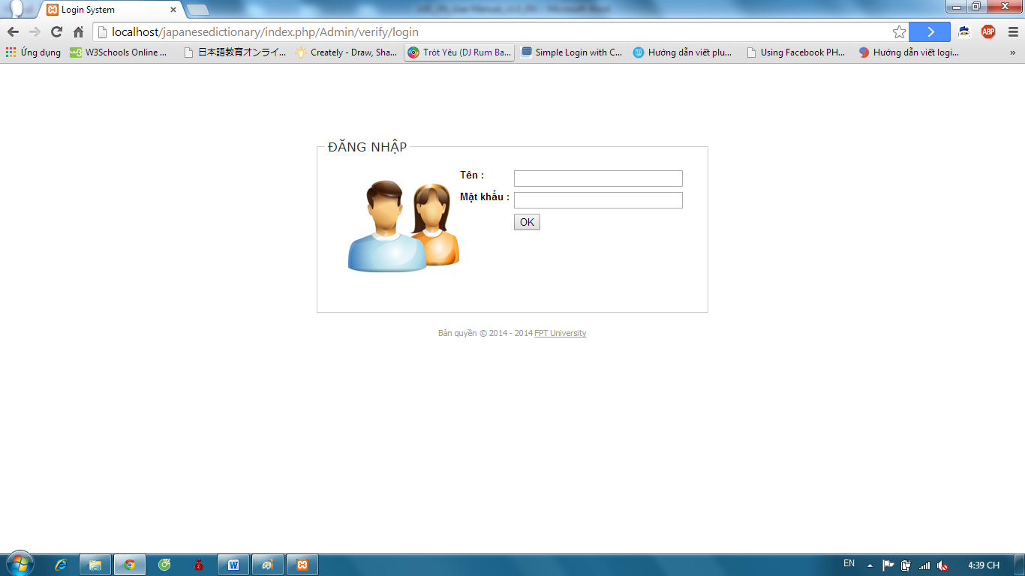

# User guide

## Overview

* This user's manual has been developed to help users better understand the requirements that may apply to use this website by providing them simple step by step tutorials. This manual is intended to help make website's functions more accessible and their associated requirements more understandable to users.

## Details guidelines

### Homepage

The first page which user will see is the homepage. From this page the user can go to every page they want.

Open browser and enter to the address bar: http://localhost/japanesedictionary/index.php/Home/verify/login

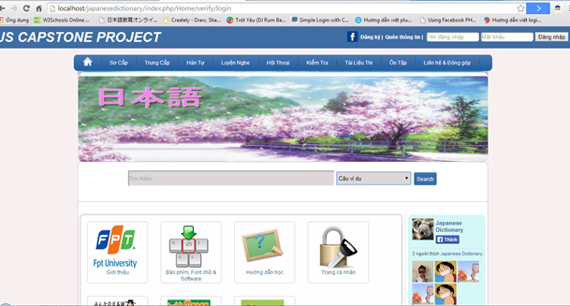

### Search sentences

To use search sentences function on website, the users do the steps below:

Step 1: Choose option search “Câu ví dụ”

Step 2: Type vocabulary’s hiragana or vocabulary’s romaji into search box on Home page

Step 3: Click “Search” button. Display result list of found.

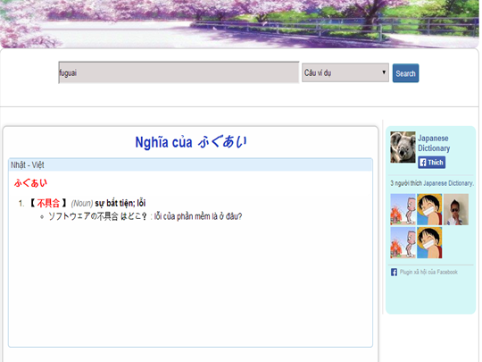

### Search conversation

To use search conversation function on website, the users do the steps below:

Step 1: Choose option search “Hội thoại”

Step 2: Type conversation’s title into search box on Home page

Step 3: Click “Search” button. Display result list of found.

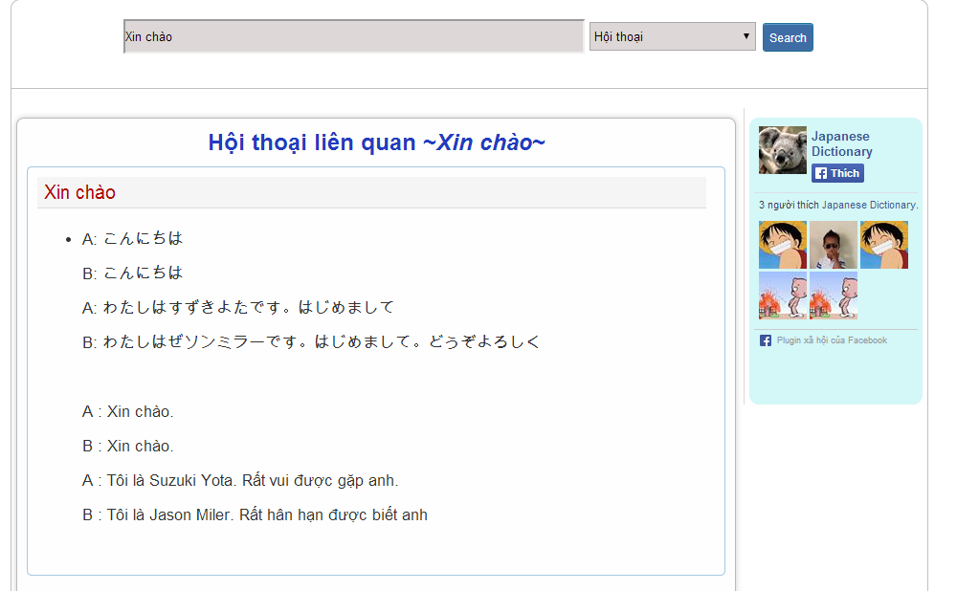

### Search grammar

To use search grammar function on website, the users do the steps below:

Step 1: Choose option search “Ngữ pháp”

Step 2: Type grammar’s hiragana or grammar’s romaji into search box on Home page

Step 3: Click “Search” button. Display result list of found.

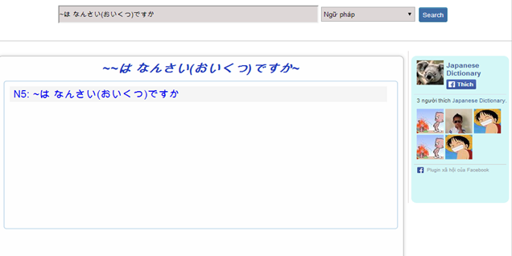

Step 4: Click title of grammar that was found to view detail.

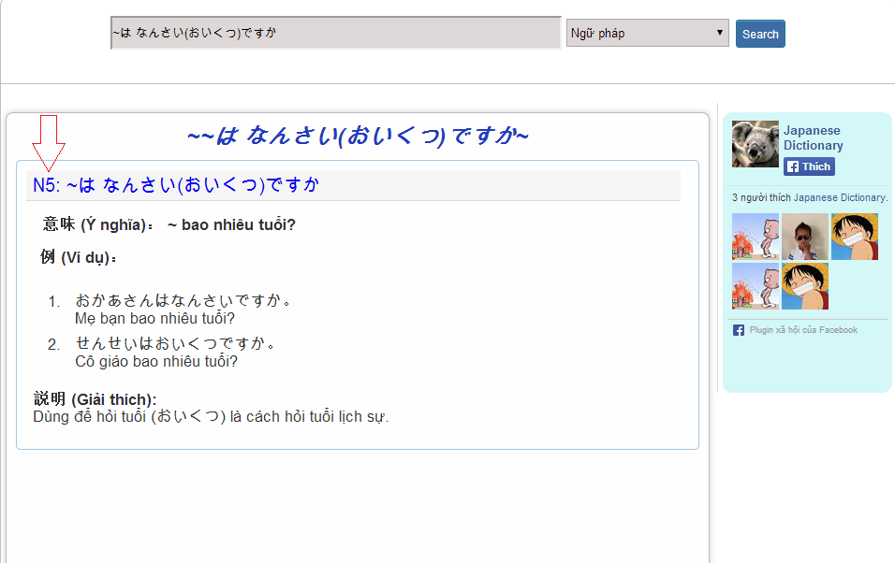

### Search video

To use search conversation function on website, the users do the steps below:

Step 1: Choose option search “Video”

Step 2: Type video’s title into search box on Home page

Step 3: Click “Search” button. Display result list of found.

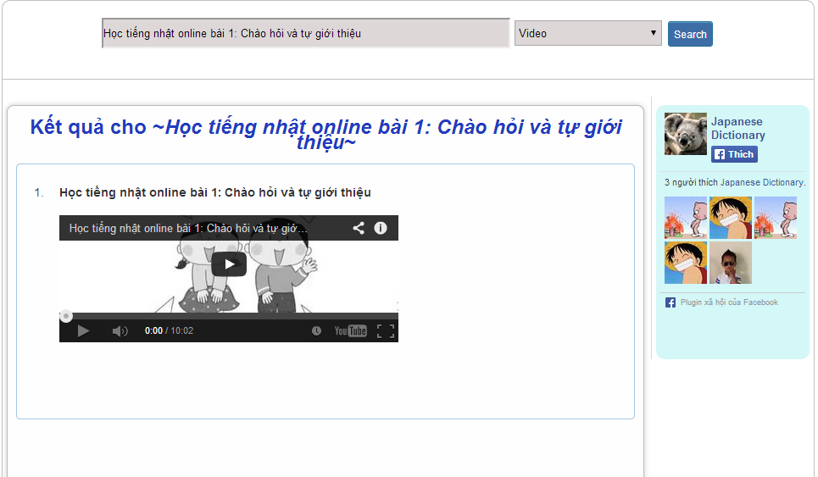

### Login

#### Login by facebook

To use login by facebook function on website, the users do the steps below:

Step 1: Click icon Facebook on Homepage

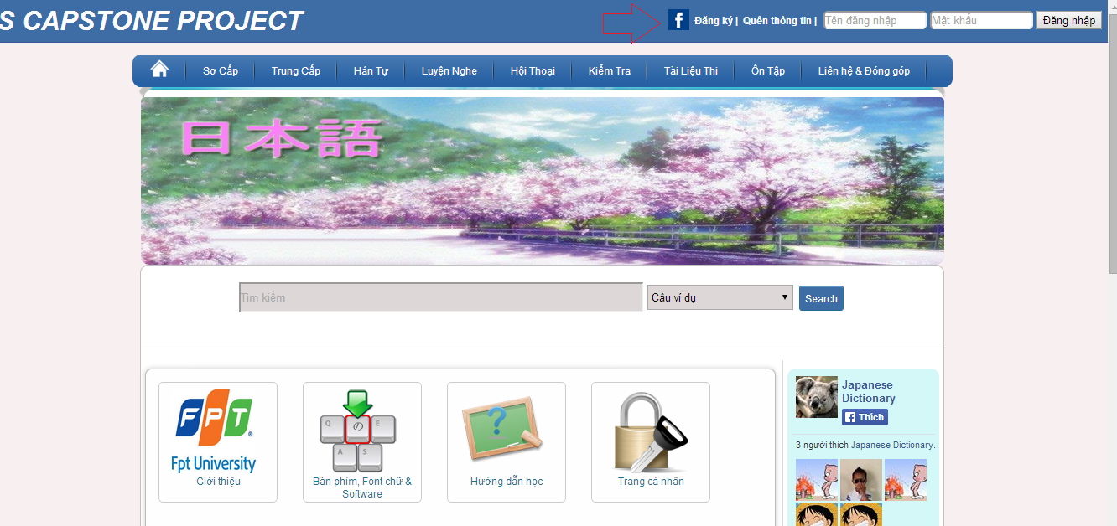

Step 2: If you not login Facebook, user need input username and password of Facebook account and login.

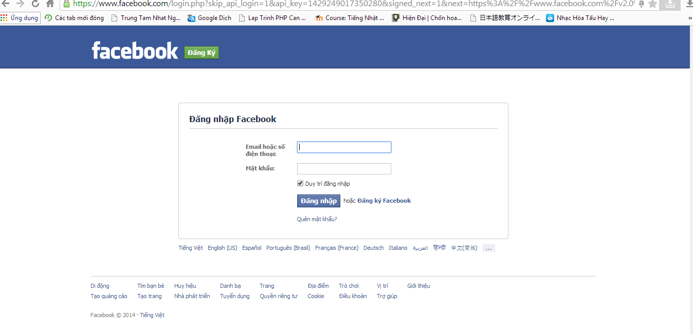

Step 3: Click “Đồng ý” to login by Facebook.

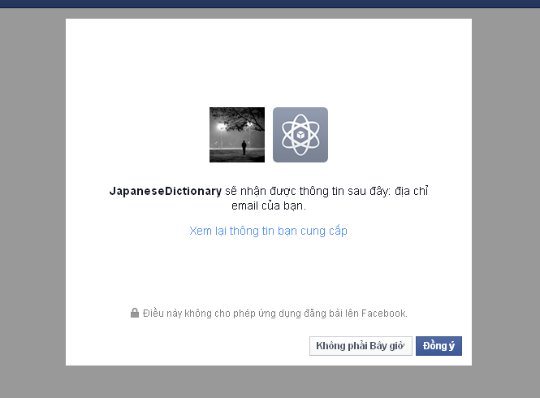

Step 4: System will redirect to homepage if login successful.

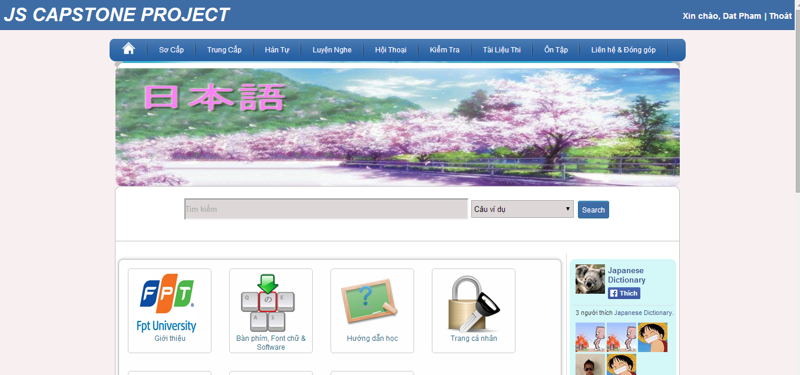

#### Login by registered account

To use login by register account function on website, the users do the steps below:

Step 1: Go to homepage

Step 2: Input correct username and password

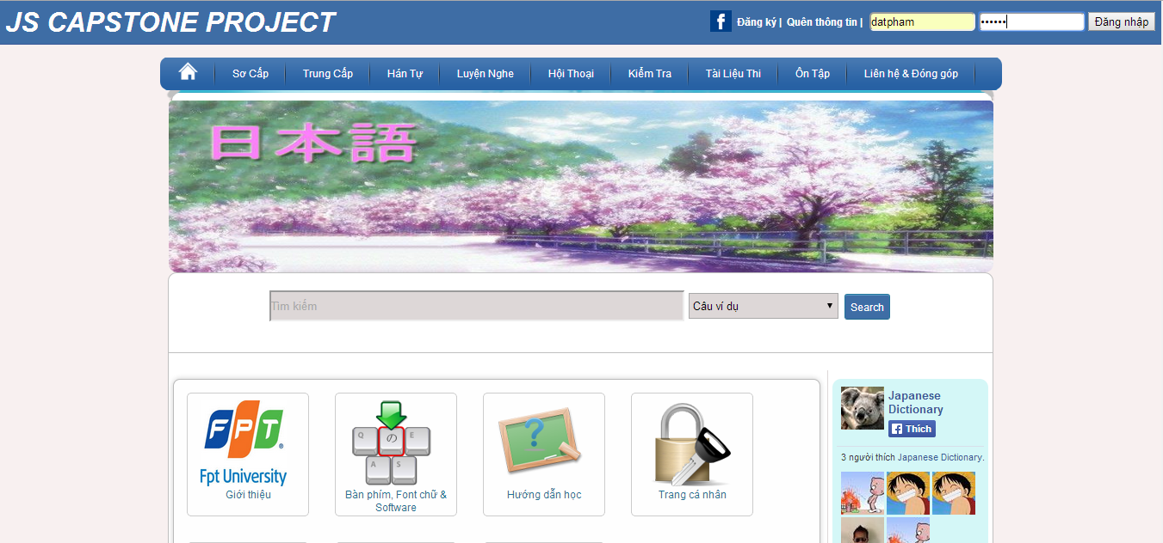

Step 3: Click “Đăng nhập” button

* Success:



* Fails: Error message will notify. You must be try again.

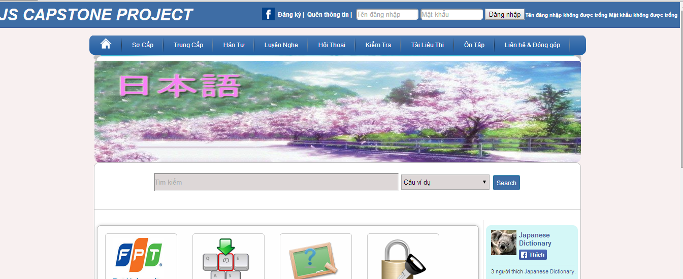

### Logout

To use logout function on website, the users do the steps below:

Step 1: Login with facebook account or registered account as 4.2.6

Step 2: Click “Thoát” link.

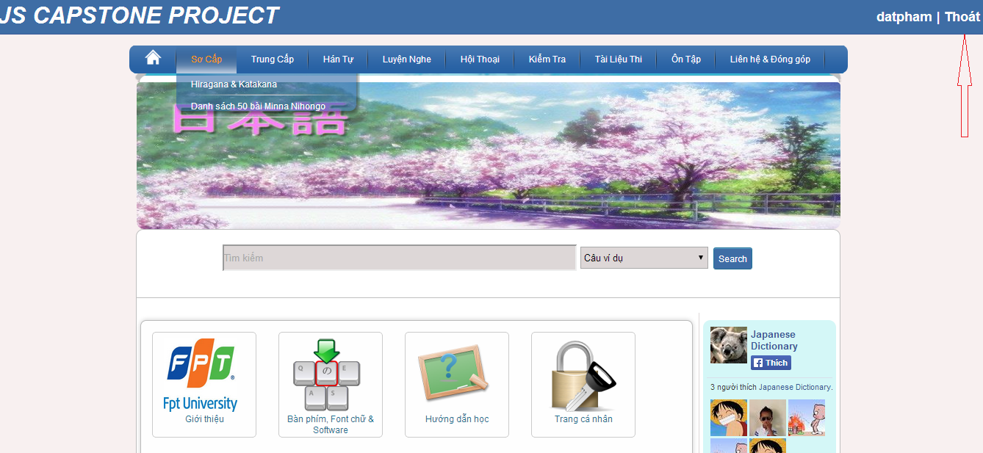

### Register

To use register function on website, the users do the steps below:

Step 1: Go to homepage

Step 2: Click “Đăng ký” link.

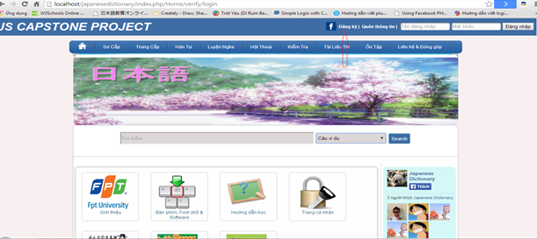

Step 3: Fill full your information to textbox. (*) is required.

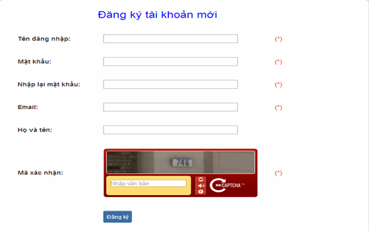

Step 4: Click “Đăng ký” button. System will check your information.

* If it suitable, a new account will create.

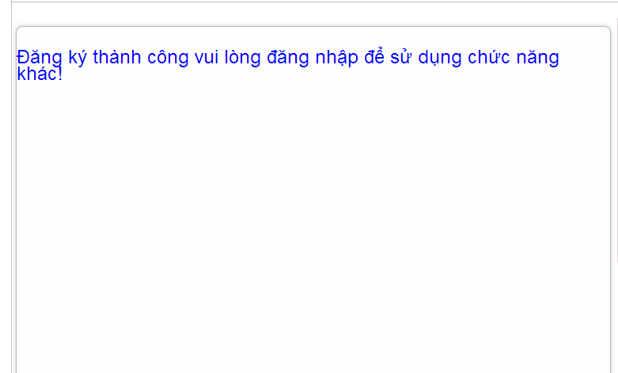

* If it unsuitable, error message will notify. You must be trying again.

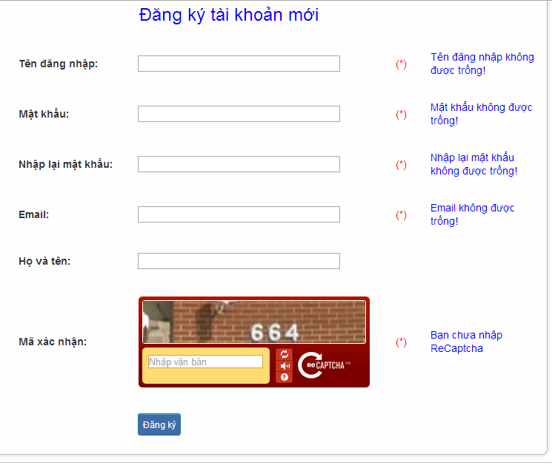

### Edit profile

To use edit profile function on website, the users do the steps below:

Step 1: Login with Facebook account or registered account as 4.2.6

Step 2:

* Method 1: Click “username” link.

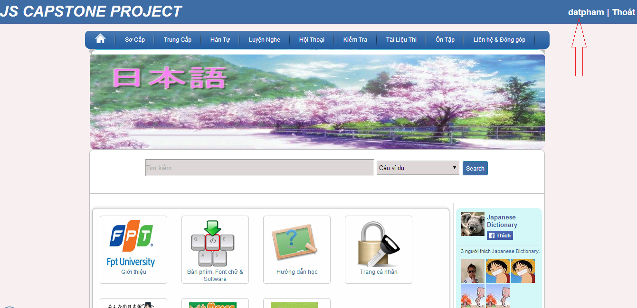

* Method 2:

+ Click “Trang cá nhân” link.

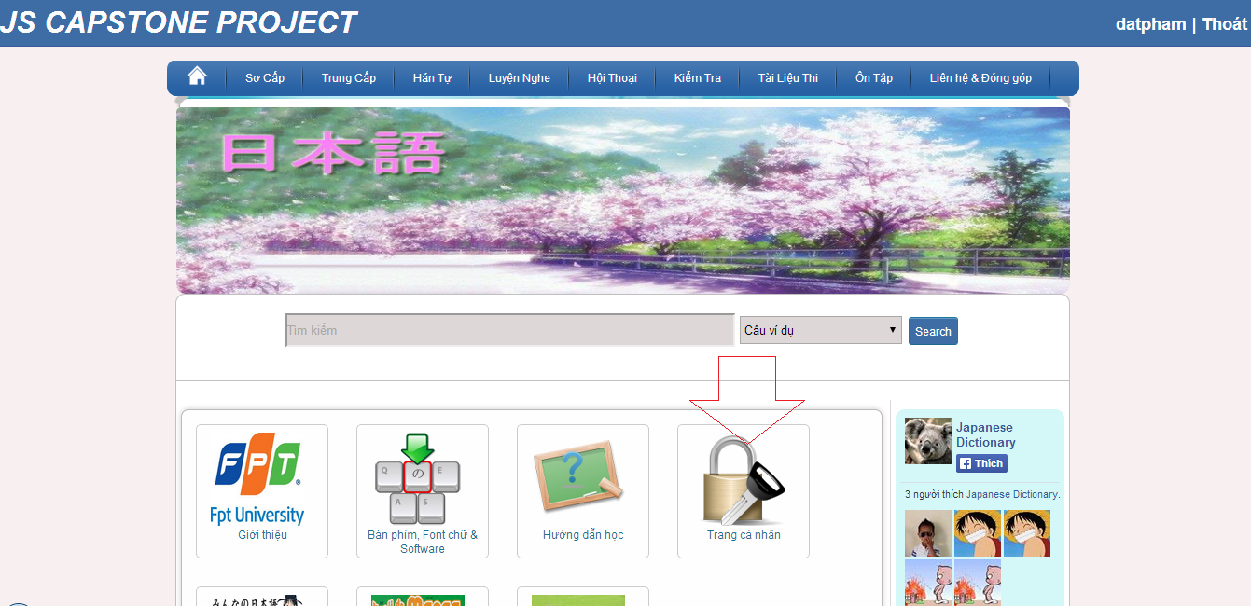

+ Click “Thay đổi thông tin” button

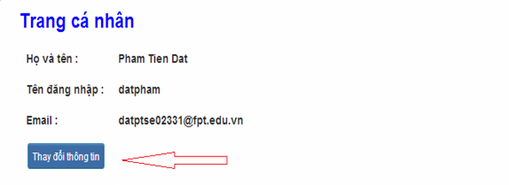

Step 3: Input correct information that you want change (email, họ tên, mật khẩu).

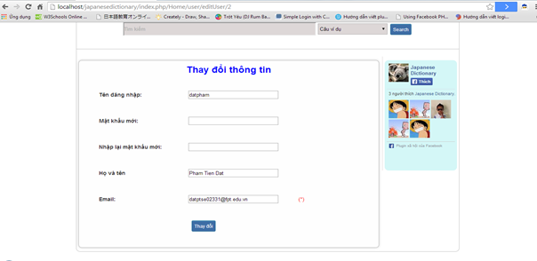

Step 4 : Click “Thay đổi” button.

* Success: System redirect to homepage

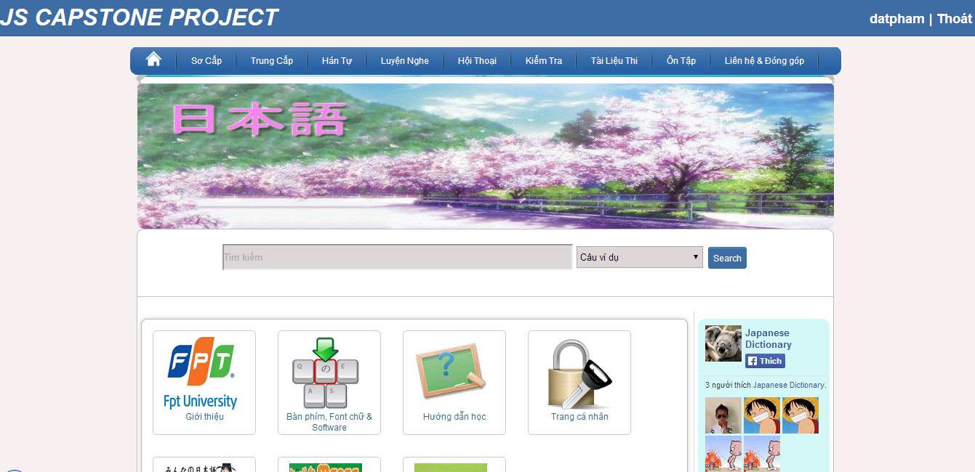

* Fails: Error message will notify. You must be try again.

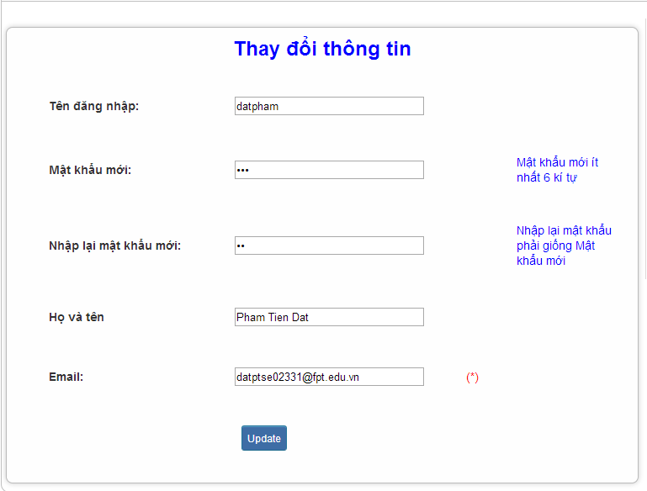

### Forgot Password

To use forgot password function on website, the users do the steps below:

Step 1: Go to homepage.

Step 2: Click “Quên thông tin” link.

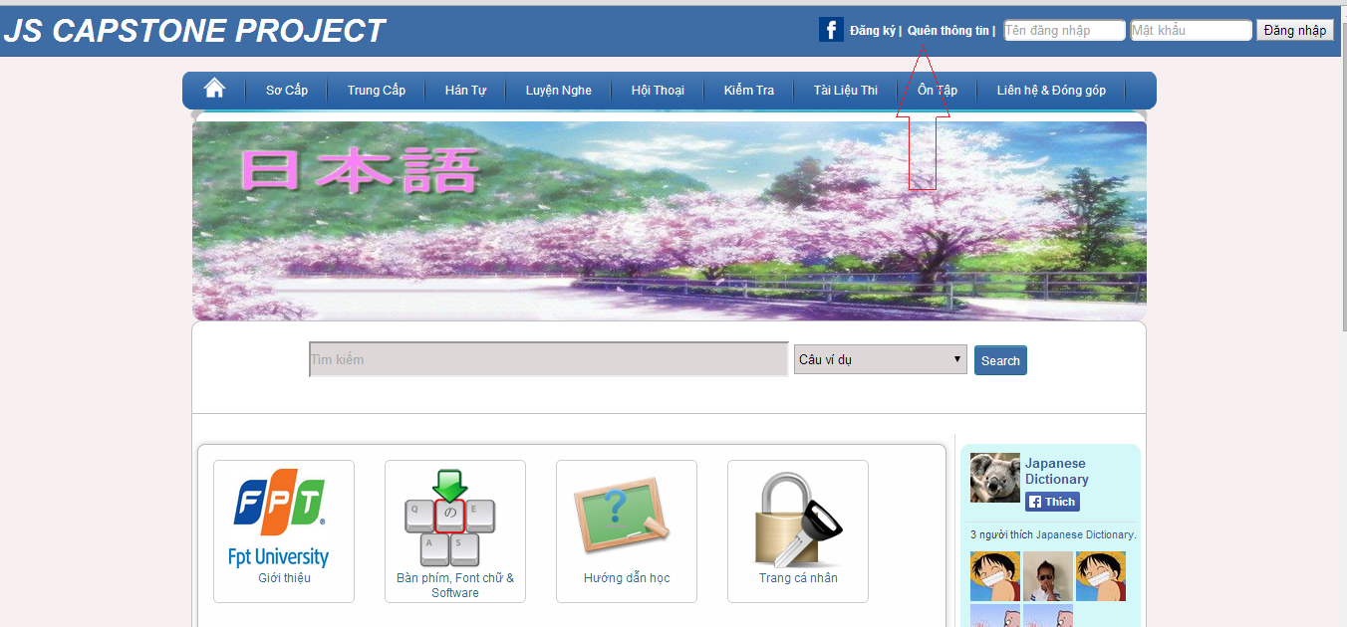

Step 3: Input email that use to register your account.

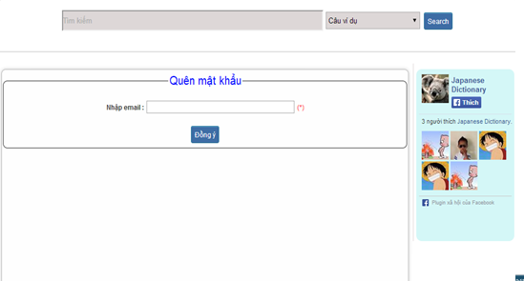

Step 4: Click “Đồng ý” button

* Success: Password will reset and send to your email

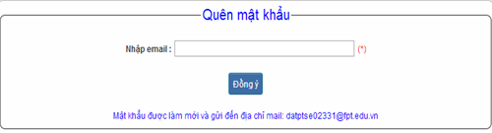

* Fails: Error message will notify. You must be try again.

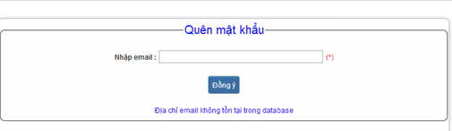

### Contribute content

To use contribute content function on website, the users do the steps below:

Step 1**:** Go to homepage.

Step 2**:** Hover on “Liên hệ & Đóng góp” and click “Đóng góp database”.

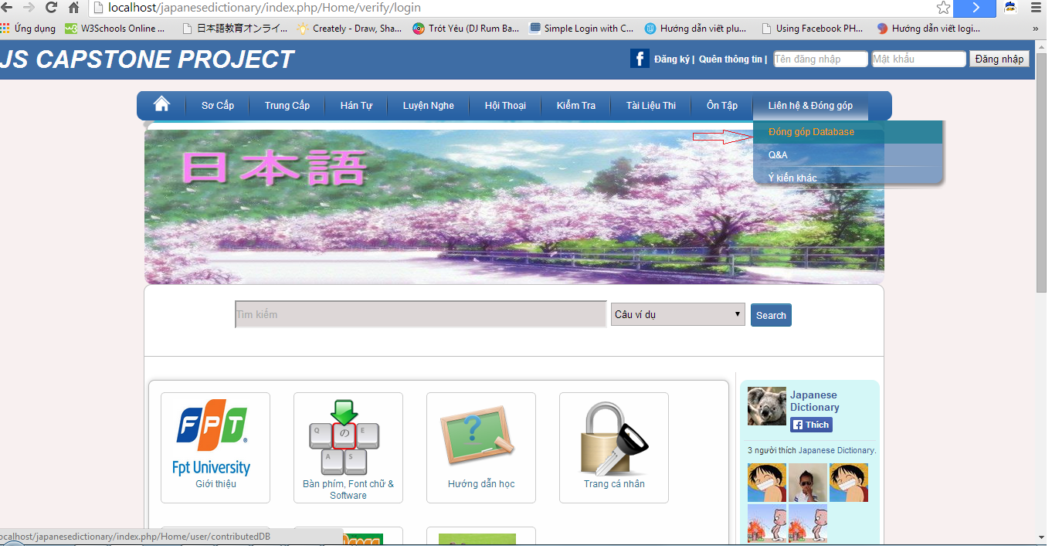

Step 3**:** Choose 1 of 3 type contribute

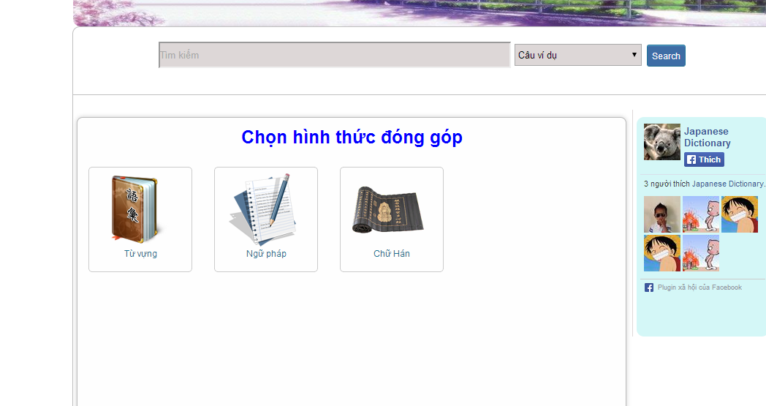

Step 4**:** Input correct information that you want contributed.

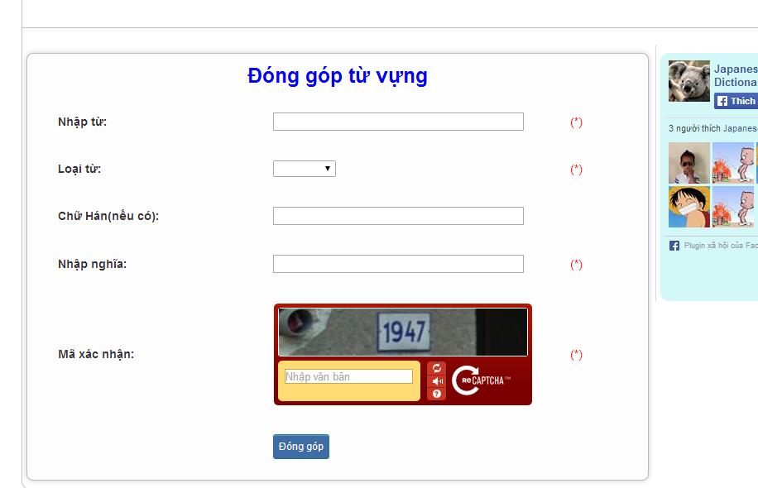

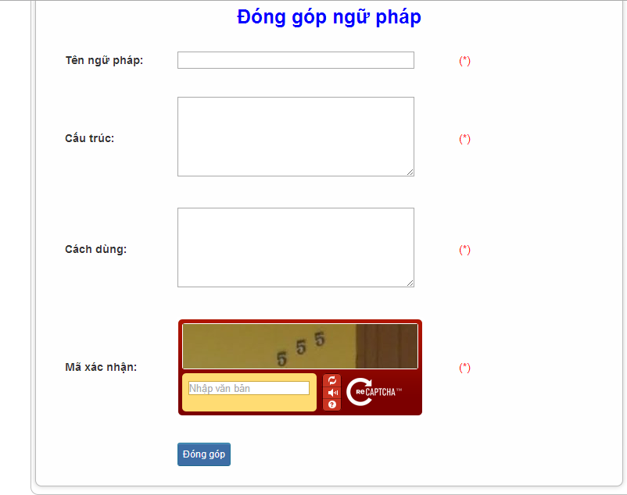

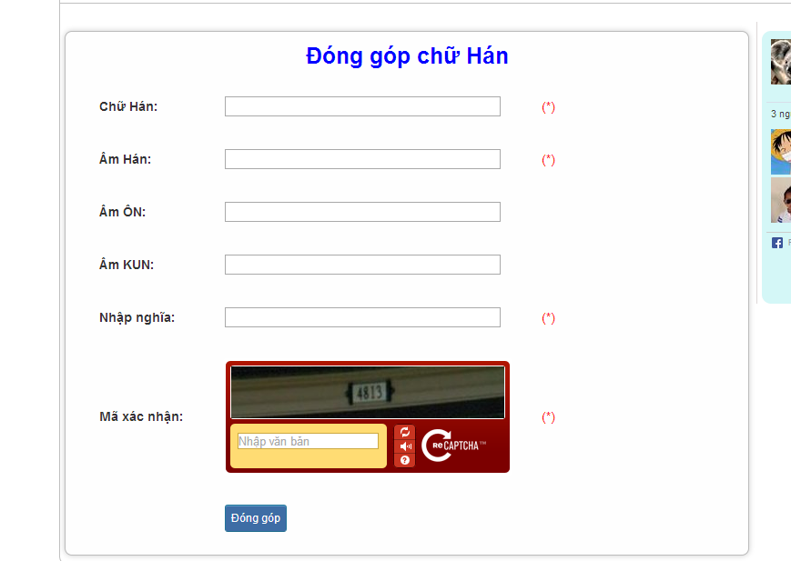

Step 5: Click “Đóng góp” button

* Success:

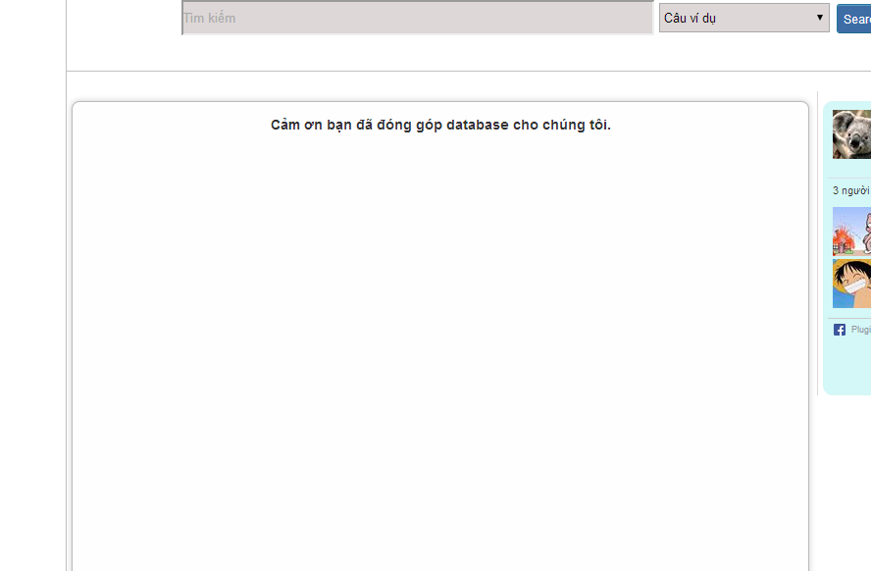

* Fails: Error message will notify. You must be try again.

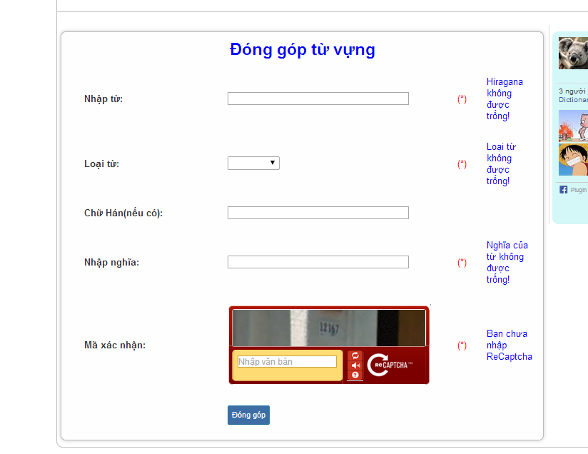

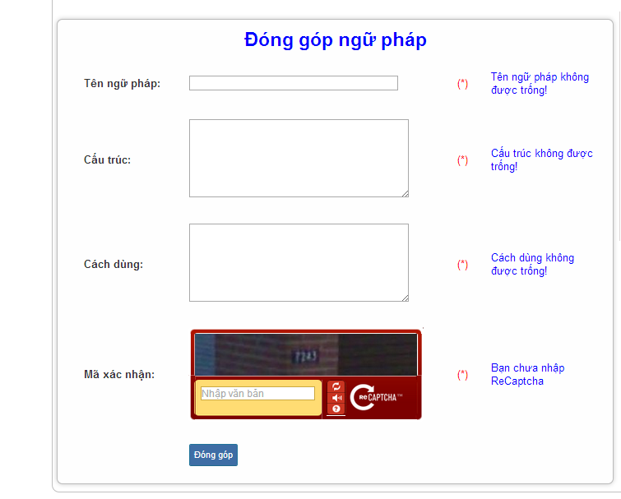

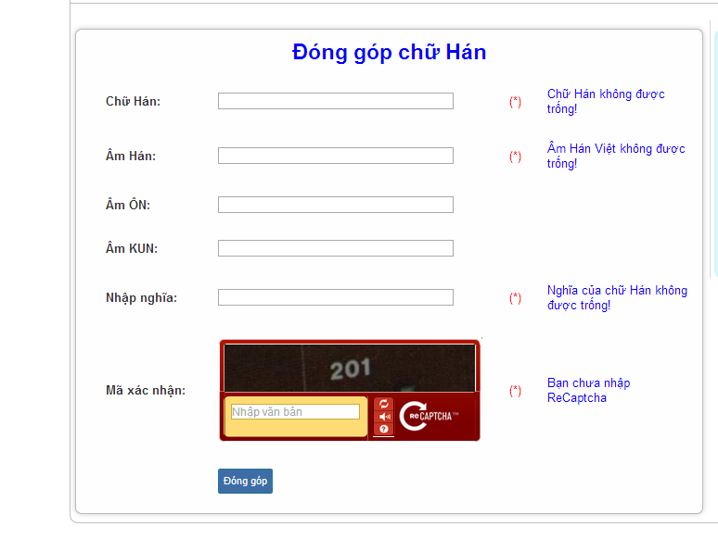

### Contribute opinion

To use contribute opinion function on website, the users do the steps below:

Step 1**:** Go to homepage.

Step 2**:** Hover on “Liên hệ & Đóng góp” and click “Ý kiến khác”.

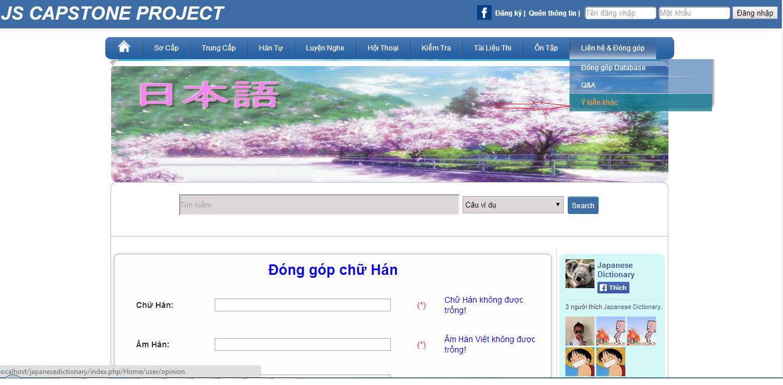

Step 3: Input correct opinion’s information that you want contributed.

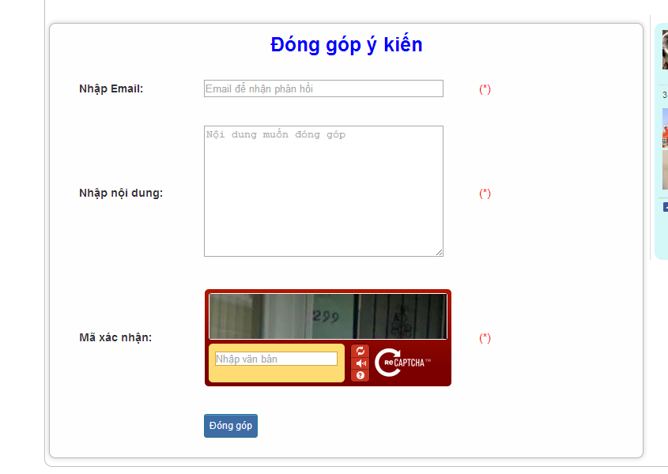

Step 4: Click “Đóng góp” button

* Success :

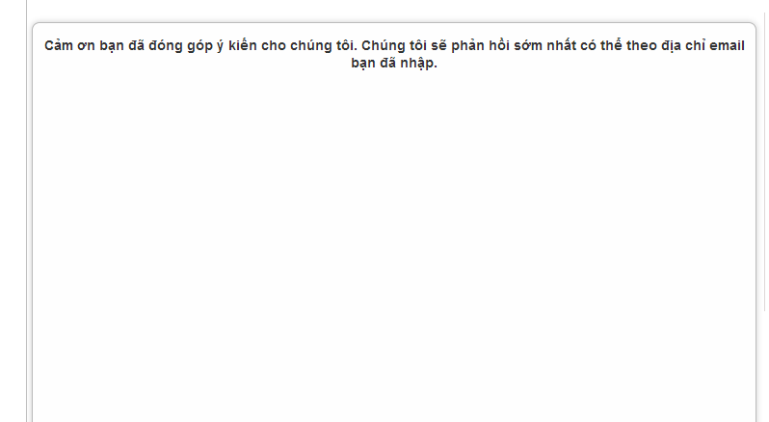

* Fails: Error message will notify. You must be try again.

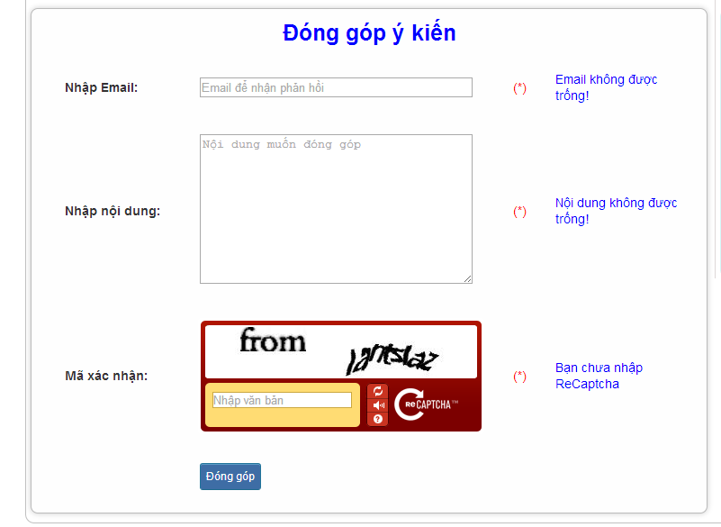

### Send Q & A

To use Send Q&A function on website, the users do the steps below:

Step 1**:** Go to homepage.

Step 2**:** Hover on “Liên hệ & Đóng góp” and click “Q&A”.

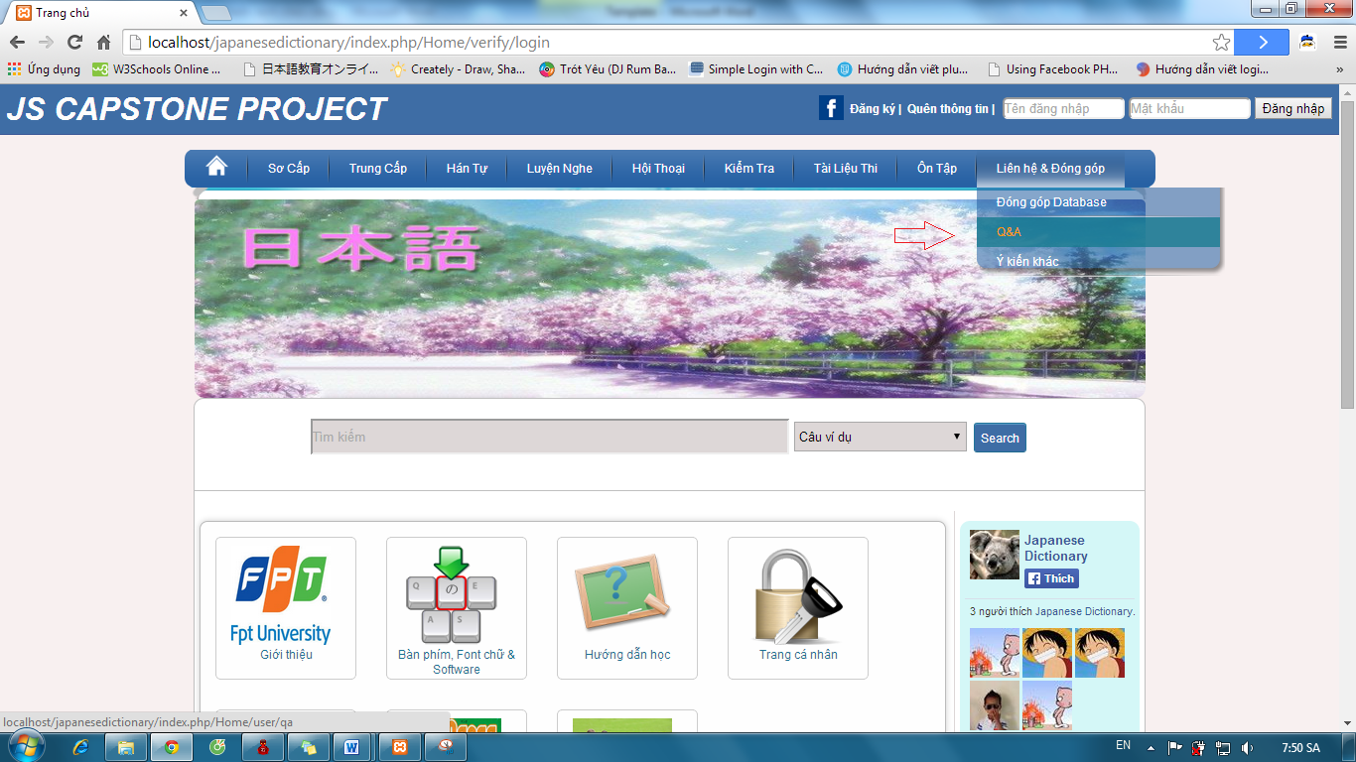

Step 3: Input correct opinion’s information that you want contributed.



Step 4: Click “Đóng góp” button

* Success :



* Fails: Error message will notify. You must be try again.



### Test

To use test function on website, the users do the steps below:

Step 1: Login with facebook account or registered account as 4.2.6

Step 2:Hover on “Kiểm tra” and click 1 of 3 level to test.

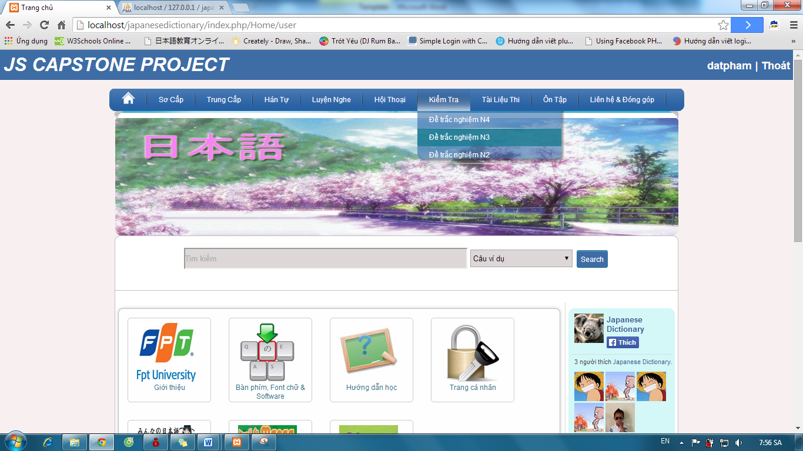

Step 3:Click one of the test link

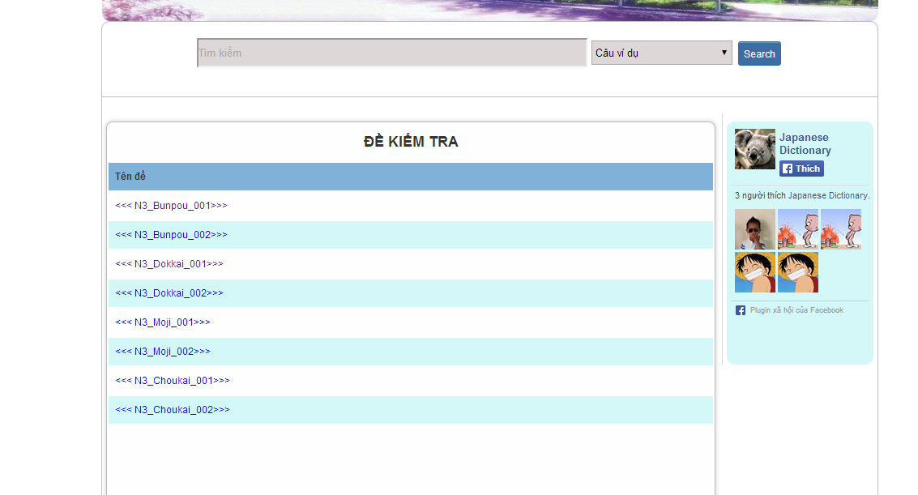

Step 4: Tick on your answer and click “Hoàn thành” button

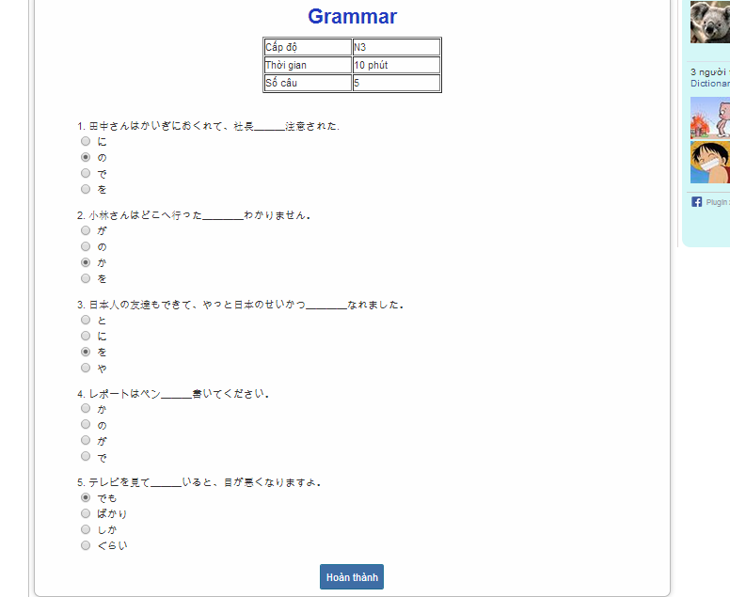

Step 5: Click “đây” link to view correct answer

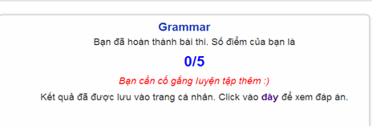

Step 6: Click “Quay lại” button after view correct answer

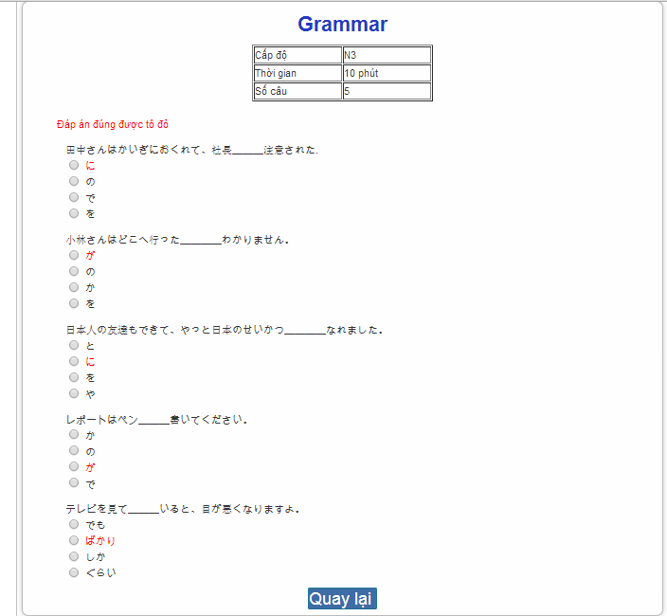

### Tracking mark

To use tracking mark function on website, the users do the steps below:

Step 1: Login with Facebook account or registered account as 4.2.6

Step 2: Click “Trang cá nhân” link on homepage



Step 3: View your mark.

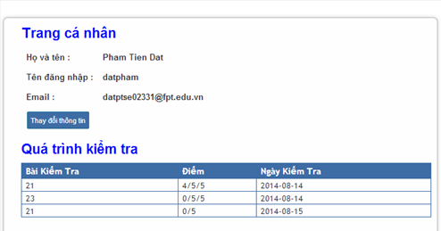

### Training Listening

To use training listening function on website, the users do the steps below:

Step 1: Go to homepage

Step 2: Hover on “Luyện nghe” and click 1 of 2 levels to listen.

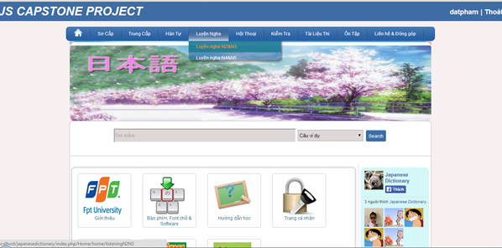

Step 3: Click one of the lesson listening links.

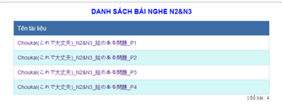

Step 4: Click play button to listen and click “Dịch&Đáp án” to view listening’s detail.

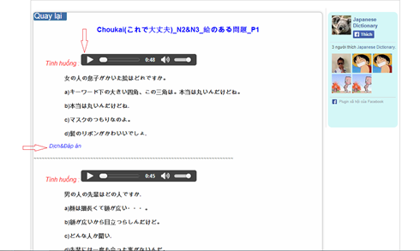

Step 5: Click “Quay lại” button after view listening’s detail.

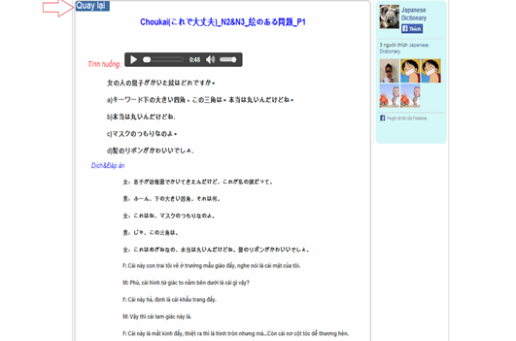

### Listening conversation

To use listening conversation function on website, the users do the steps below:

Step 1: Go to homepage

Step 2: Hover on “Hội thoại” and click 1 of 3 levels to listening conversation.

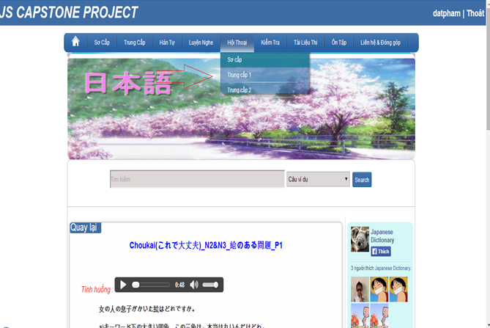

Step 3: Click one of the lesson of conversation links.

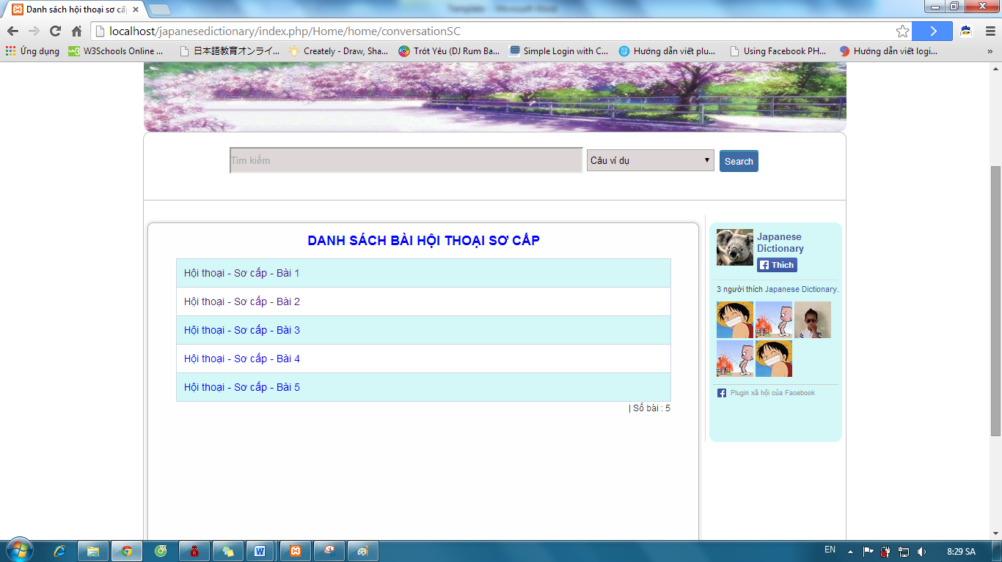

Step 4: Click play button to listen and click “Dịch” to view conversation’s content.

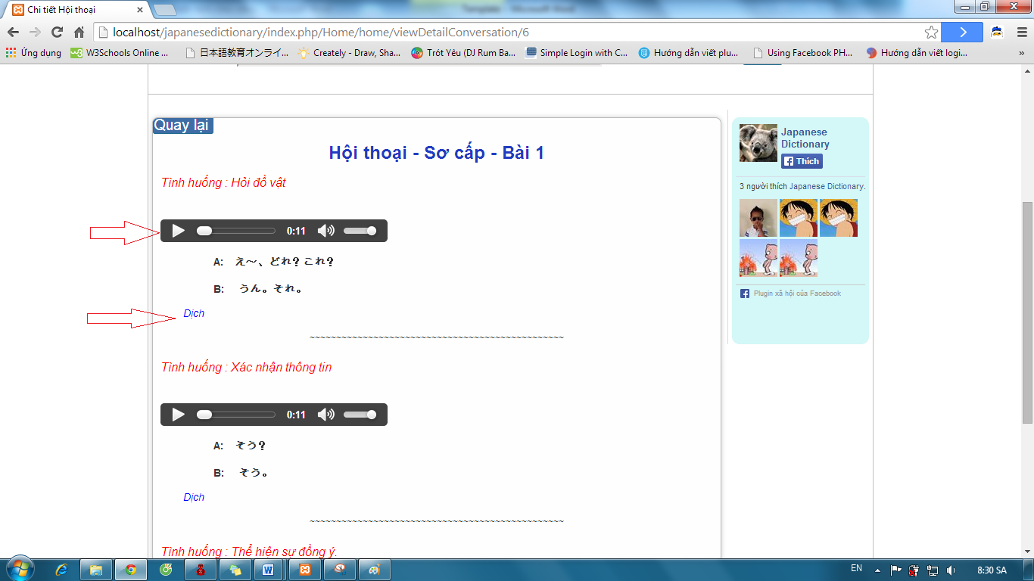

Step 5: Click “Quay lại” button after view conversation’s content 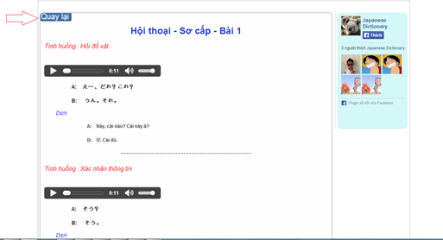

### Reading Document

To use reading document function on website, the users do the steps below:

#### View alphabet

Step 1: Go to homepage

Step 2: Hover on “Sơ cấp” and click “Hiragana & Katakana” to view alphabet.

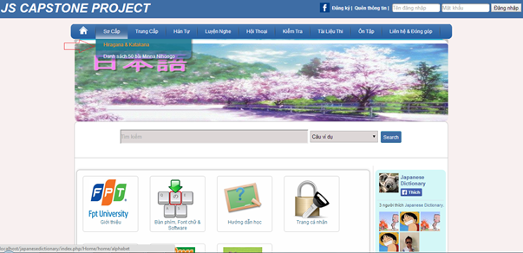

Step 3: Click “Bảng chữ cái Hiragana” link or “Bảng chữ cái Katakana” link to view alphabet.

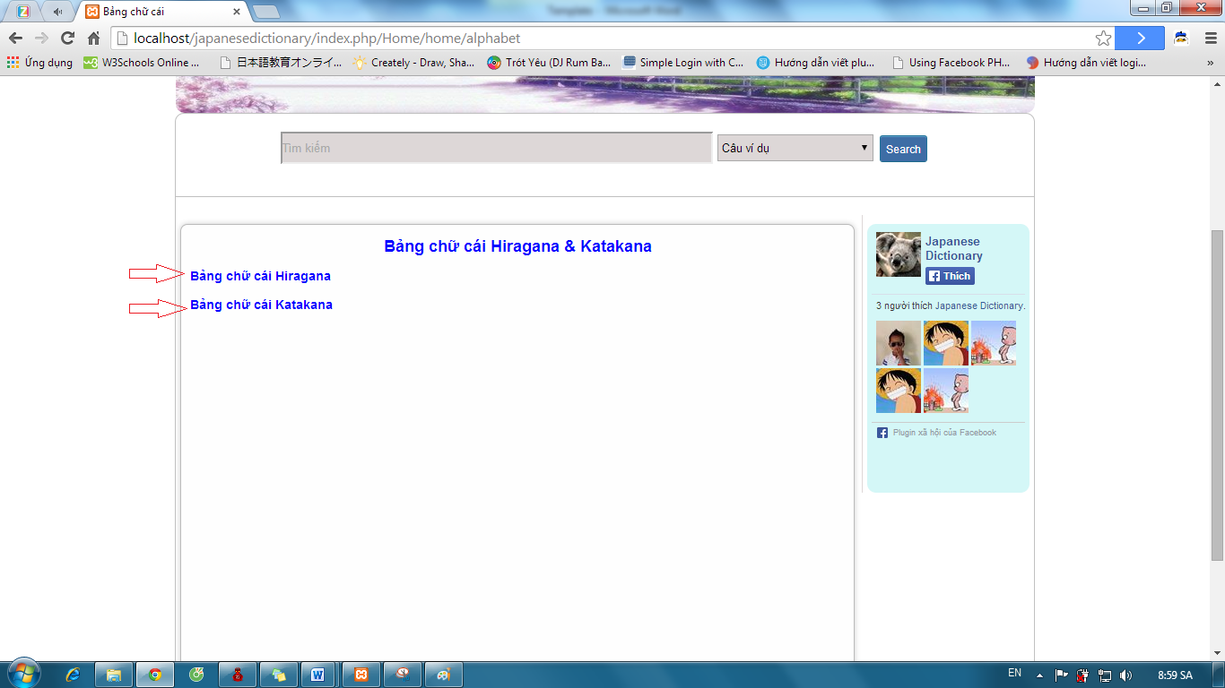

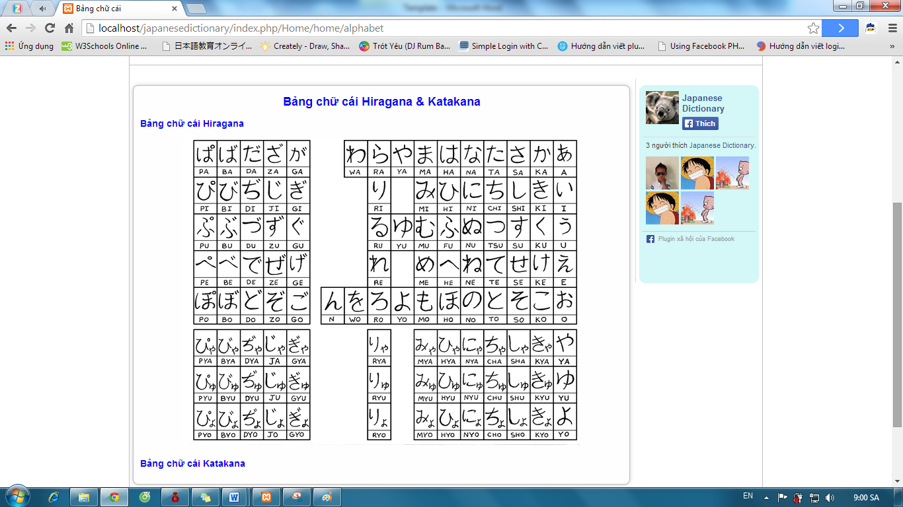

#### View document level Minna

Step 1: Go to homepage

Step 2: Hover on “Sơ cấp” and click “Danh sách 50 bài Minna Nihongo” link.

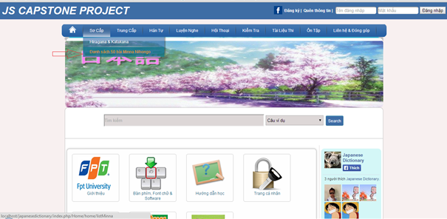

Step 3: Click one of the lessons.

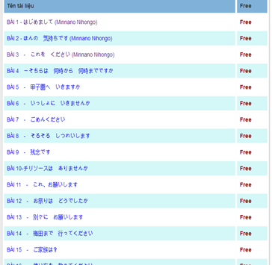

Step 4: Click one of the lesson’s content.

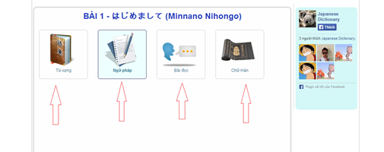

Step 5: Click “Quay lại” button after view content of lesson.

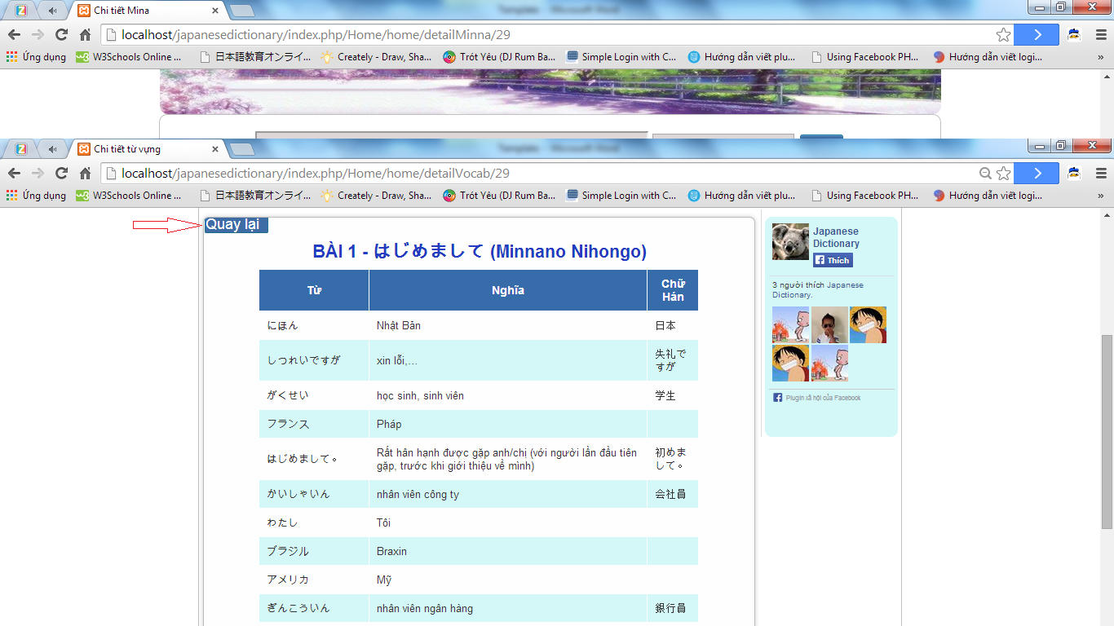

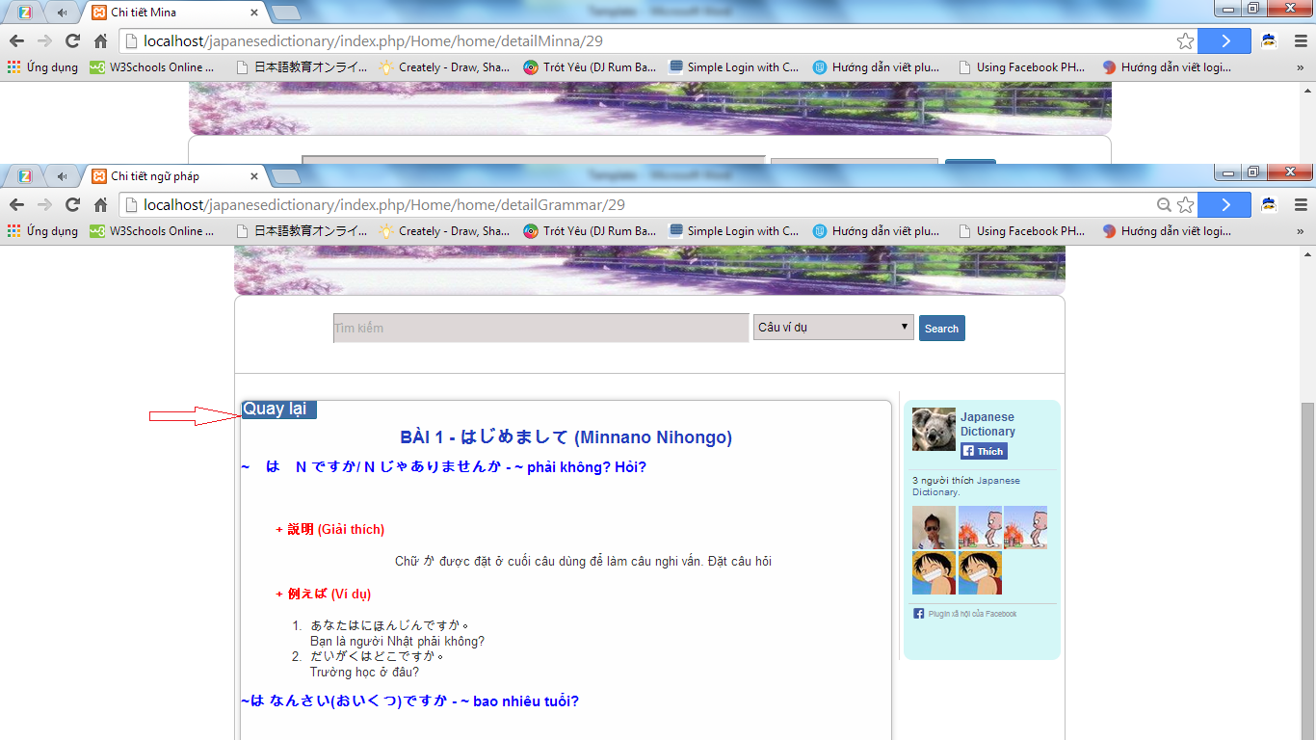

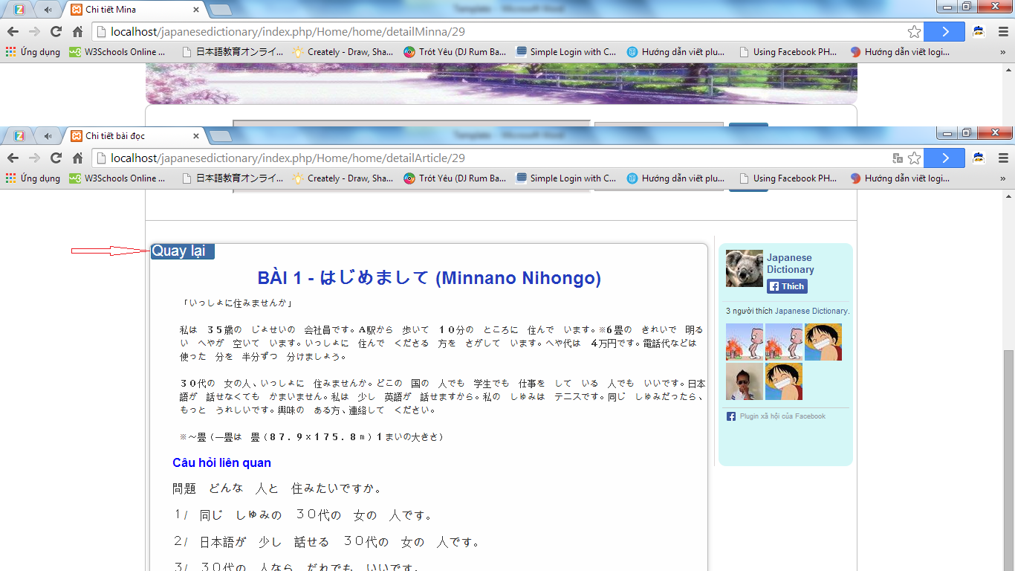

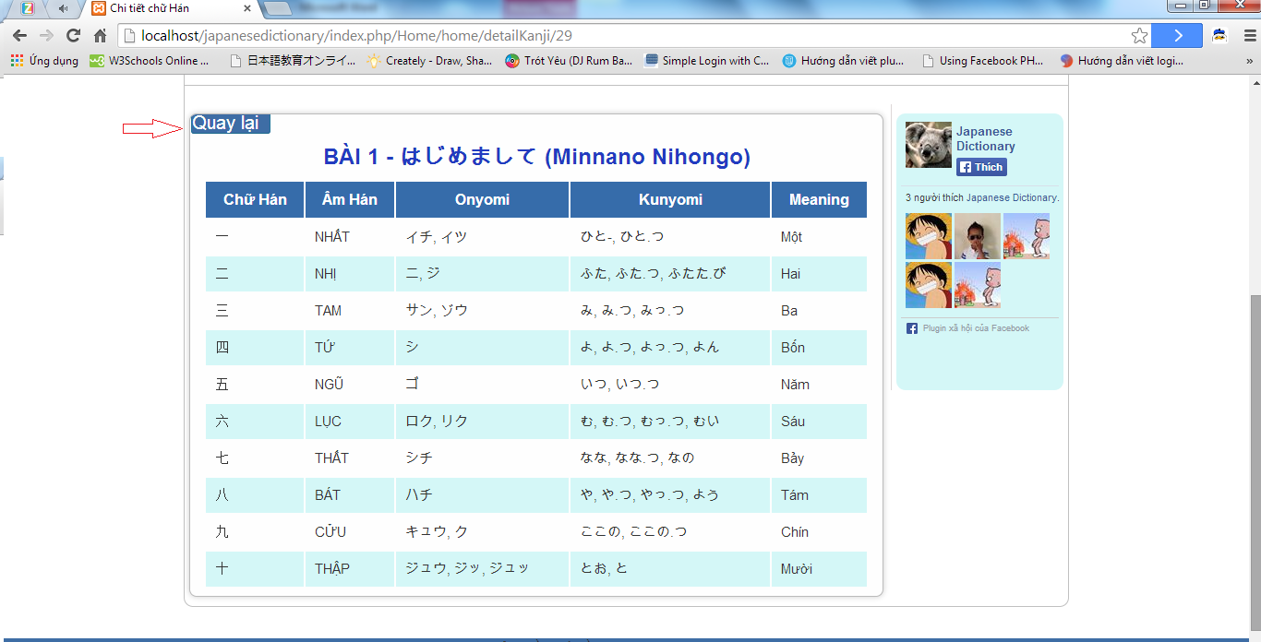

#### View document level intermediate

Step 1: Go to homepage

Step 2: Hover on “Trung cấp” and click one of the level links.

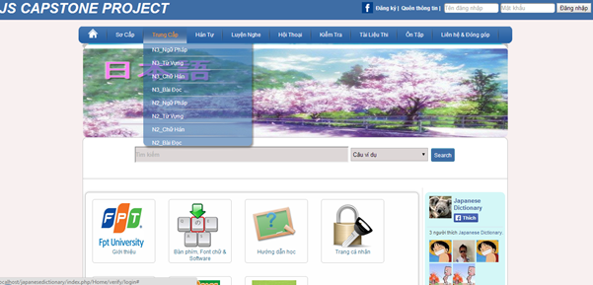

Step 3: Click one of the lesson links.

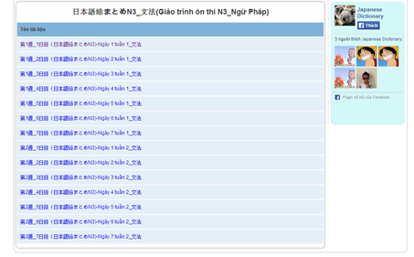

Step 4: Click “Quay lại” button after view lesson’s content.

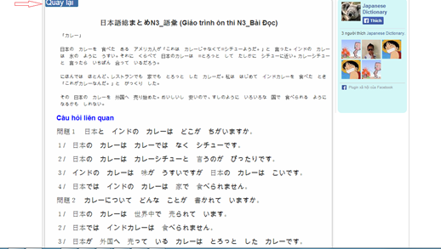

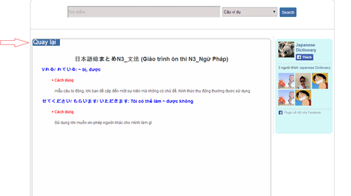

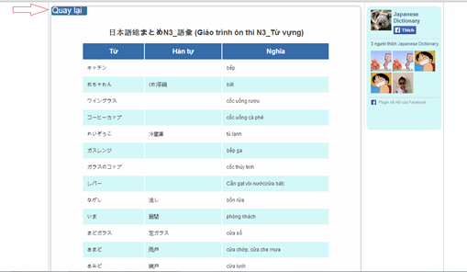

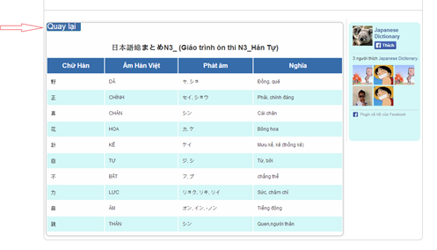

### Login with admin account

To use login with admin account function on website, the users do the steps below:

Step 1: Go to link http://localhost/japanesedictionary/index.php/admin/verify/login

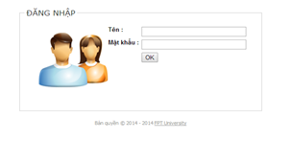

Step 2: Input correct username and password and click “OK” button.

* Success: Redirect to homepage admin.

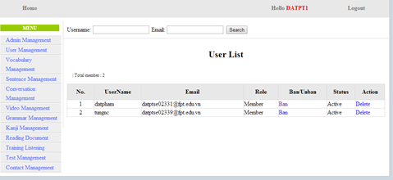

* Fails: Error message will notify. You must try again.

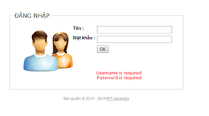

### Admin’s account management

#### Add new Admin

To use add new admin function on website, the users do the steps below:

Step 1: Login with supper admin account as 4.2.19.

Step 2: Click “Admin Management” link.

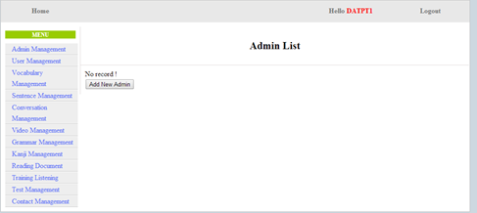

Step 3: Click “Add New Admin” button and input correct information that you want use to create a new account.

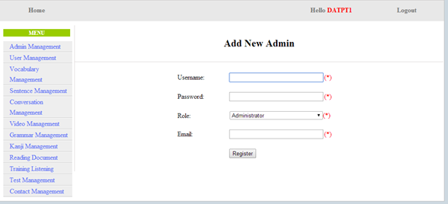

Step 4: Click “Register”

* Success: A new admin was created and system display admin list

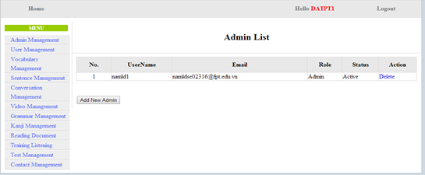

* Fails: Error message will notify. You must try again.

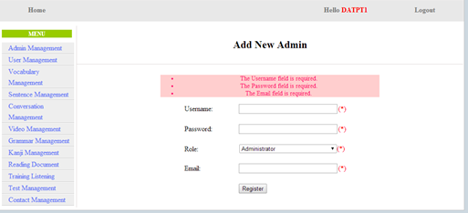

#### Edit profile

To use edit profile function on website, the users do the steps below:

Step 1: Login with admin account as 4.2.19.

Step 2: Click “username” link.

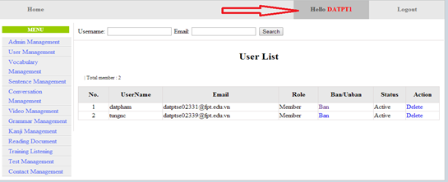

Step 3: Input correct information that you want change and click “Update” button.

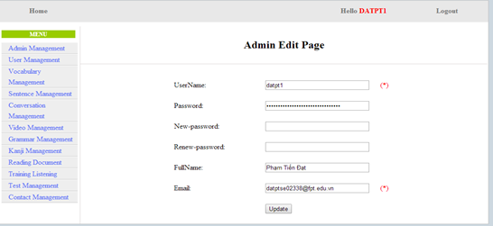

* Success: Redirect to homepage admin

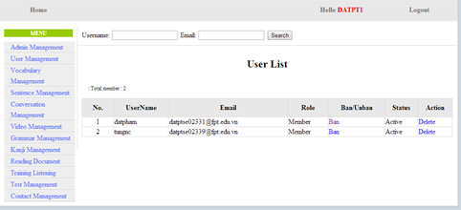

* Fails: Error message will notify. You must try again.

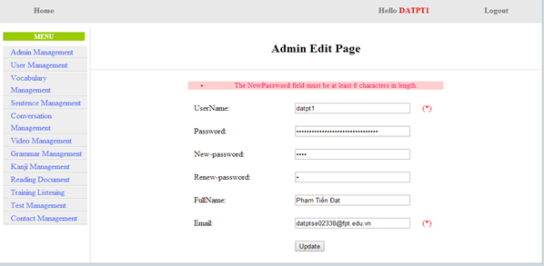

#### Delete Admin

To use delete admin function on website, the users do the steps below:

Step 1: Login with supper admin account as 4.2.19.

Step 2: Click “Admin Management” link. System will display list admin.

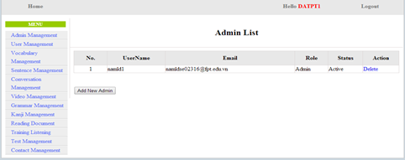

Step 3: Click “Delete” link. System will display list admin after delete a admin account.

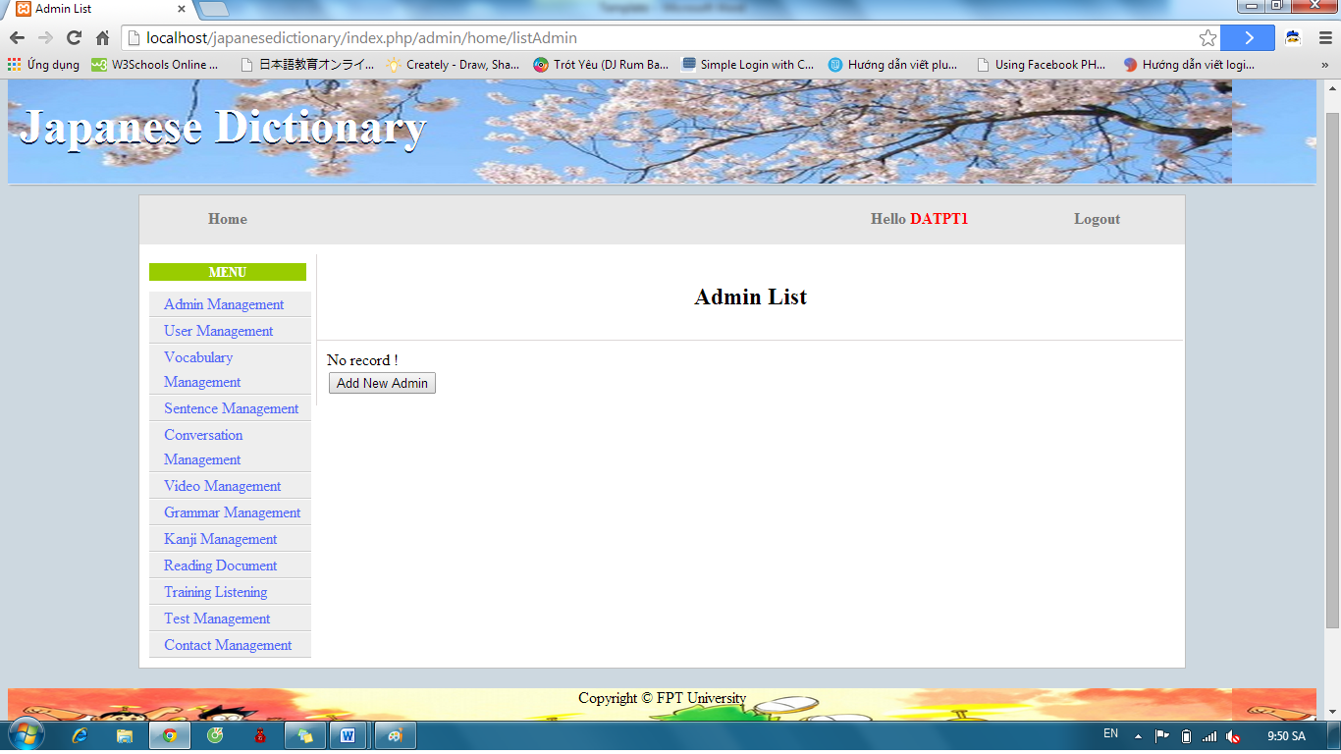

### Management Member’s account

#### Search member

To use search member function on website, the users do the steps below:

Step 1: Login with admin account as 4.2.19. System will display list User.

Step 2: Input username or email that you want find. Click “Search” button.

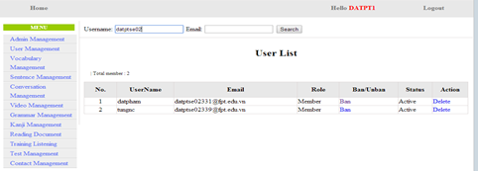

Step 3: View results found.

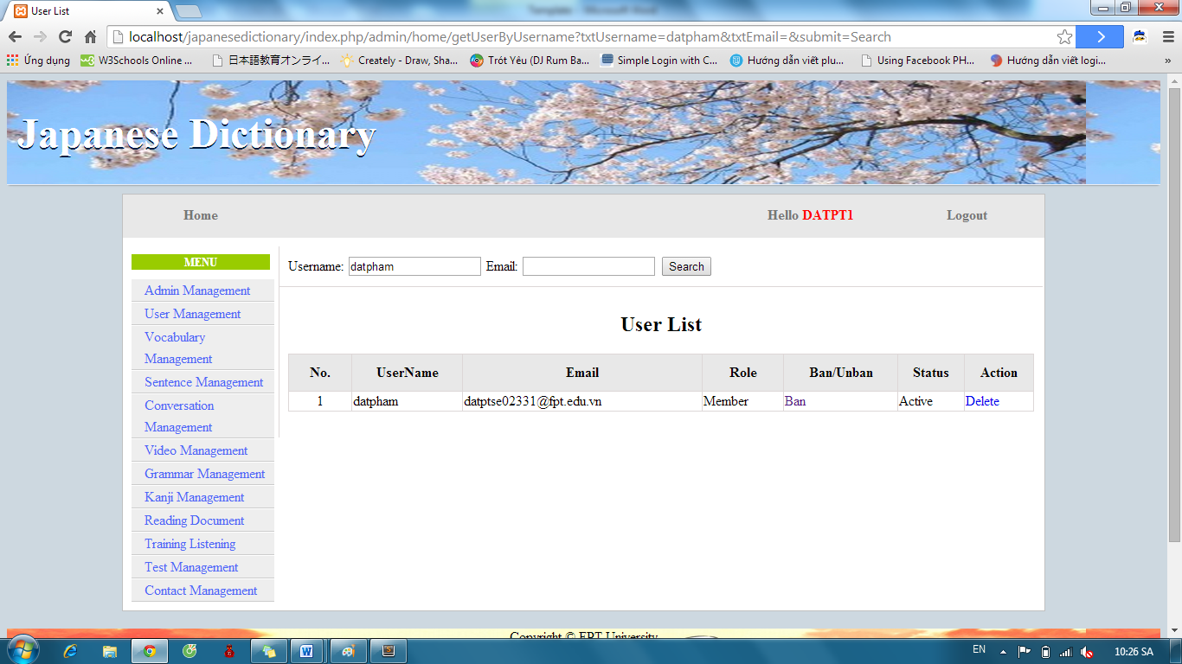

#### Ban/Unban member’s account.

To use ban/unban member’s account function on website, the users do the steps below:

Step 1: Login with admin account as 4.2.19. System will display list User.

Step 2: Click “Ban” or “Unban” link.

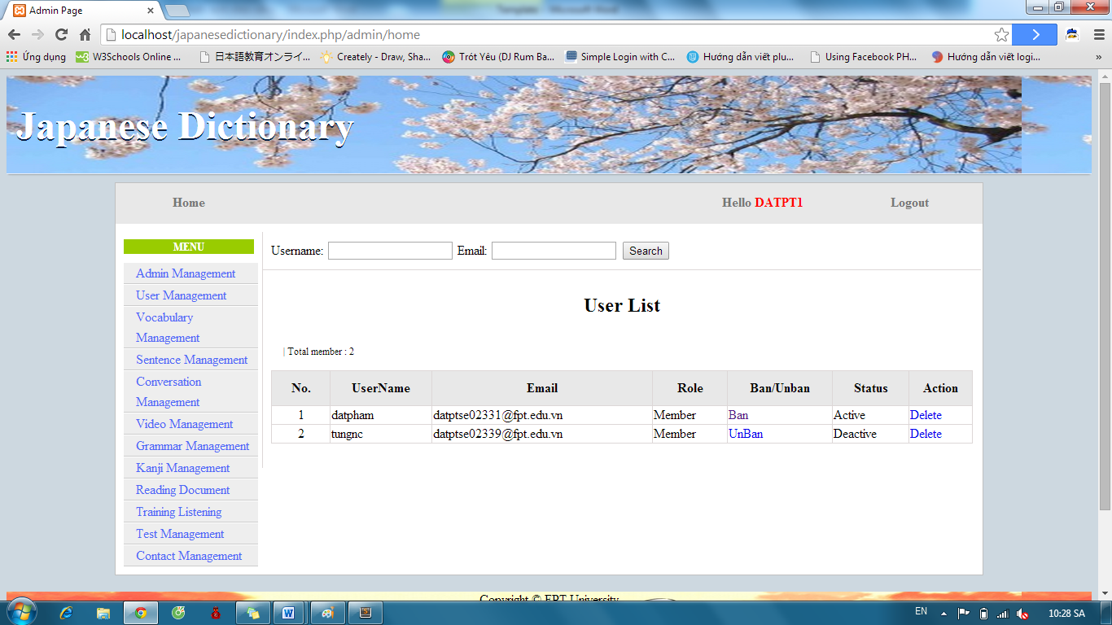

#### Delete member

To use delete member function on website, the users do the steps below:

Step 1: Login with admin account as 4.2.19. System will display list User.

Step 2: Click “Delete” link.



### Vocabulary Management

#### Search Vocabulary

To use search vocabulary function on website, the users do the steps below:

Step 1: Login with admin account as 4.2.19. System will display list User.

Step 2: Click “Vocabulary management” link. System will display list Vocabulary.

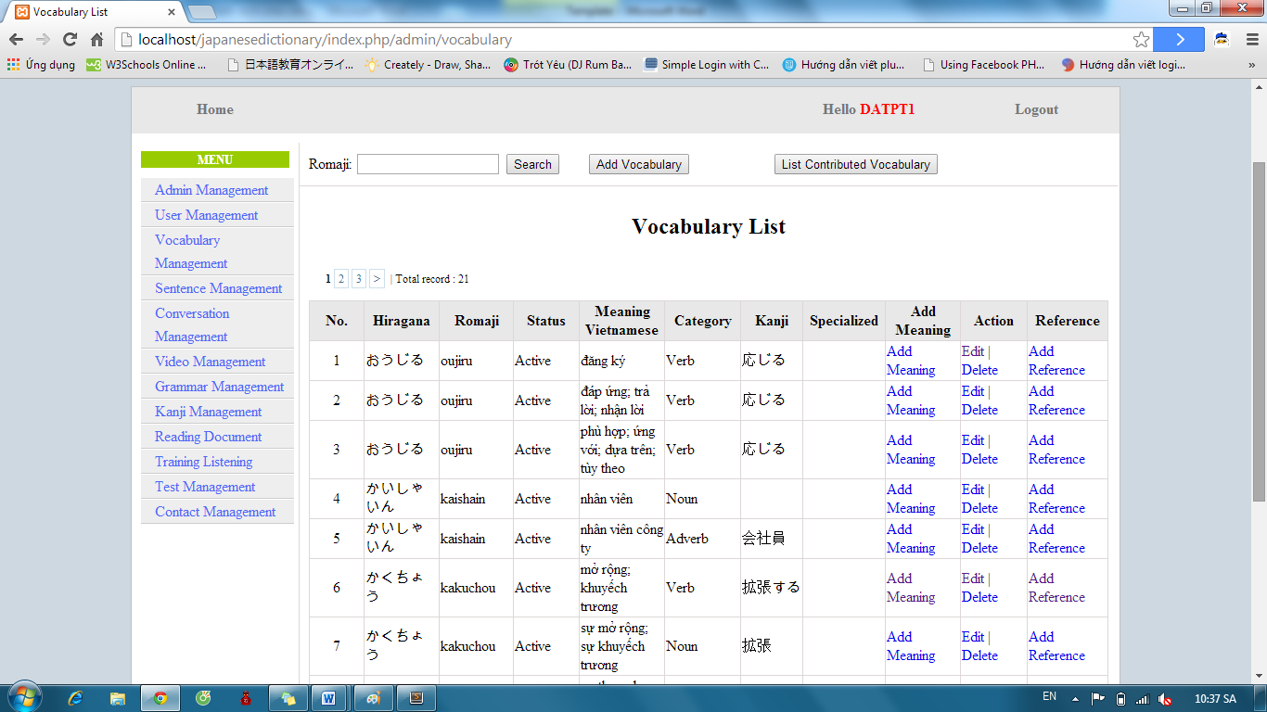

Step 3: Input vocabulary’s romaji and click “Search” button. Display results found.

* If exist : Display result

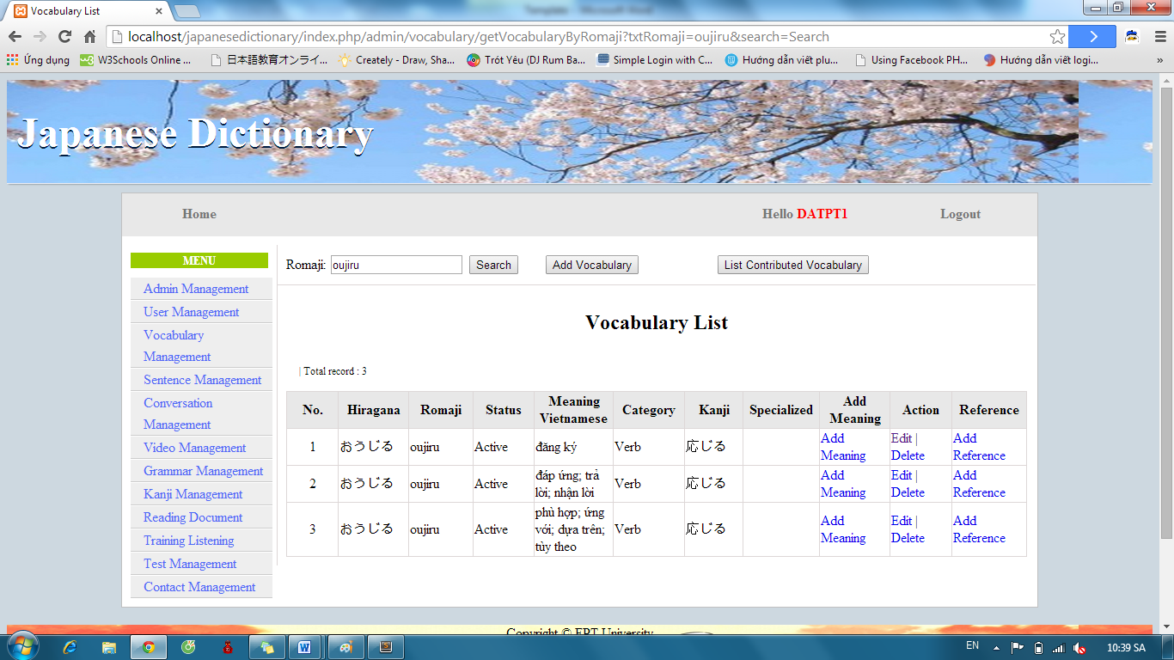

* If don’t exist : Display no record

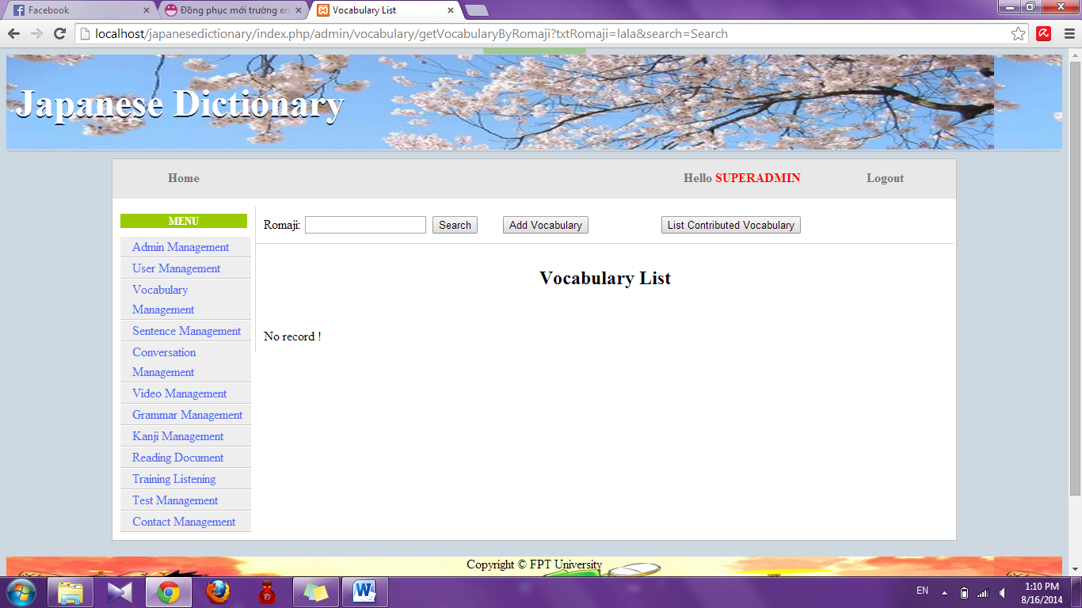

#### Add Vocabulary

To use add vocabulary function on website, the users do the steps below:

Step 1: Login with admin account as 4.2.19. System will display list User.

Step 2: Click “Vocabulary management” link. System will display list Vocabulary.



Step 3: Click “Add Vocabulary” button and input correct information of vocabulary that you want add.

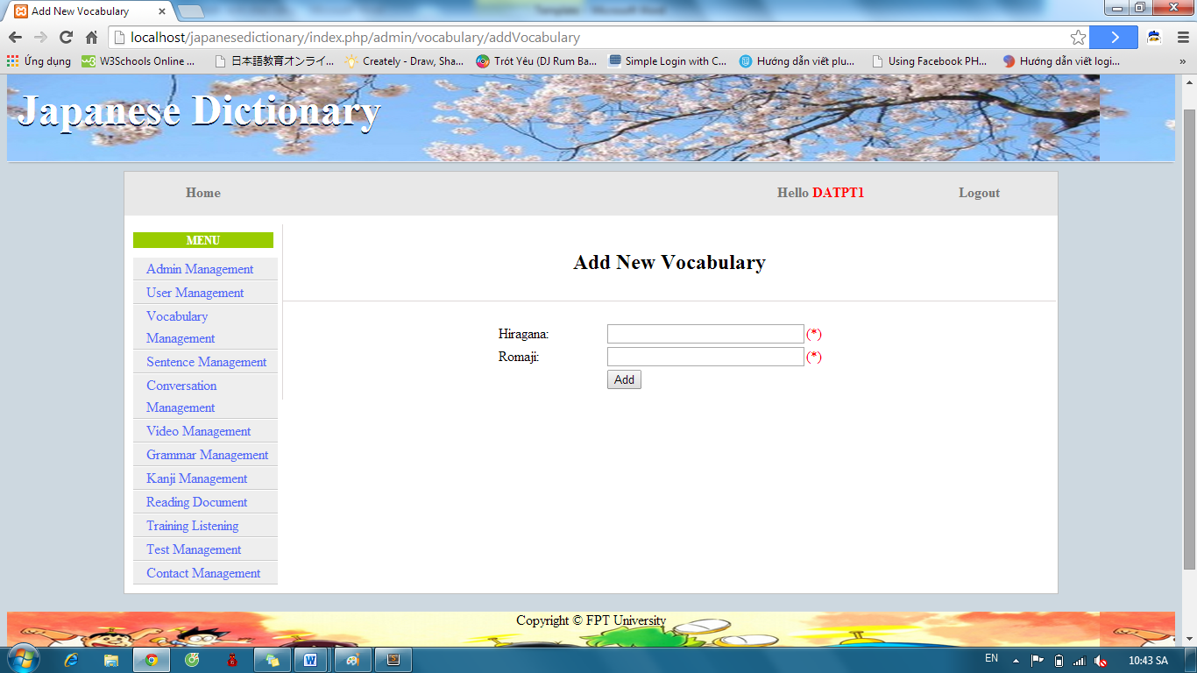

Step 4: After input, click “Add” button.

* Success: System display list Vocabulary with new vocabulary



* Fails: Error message will notify. You must try again.

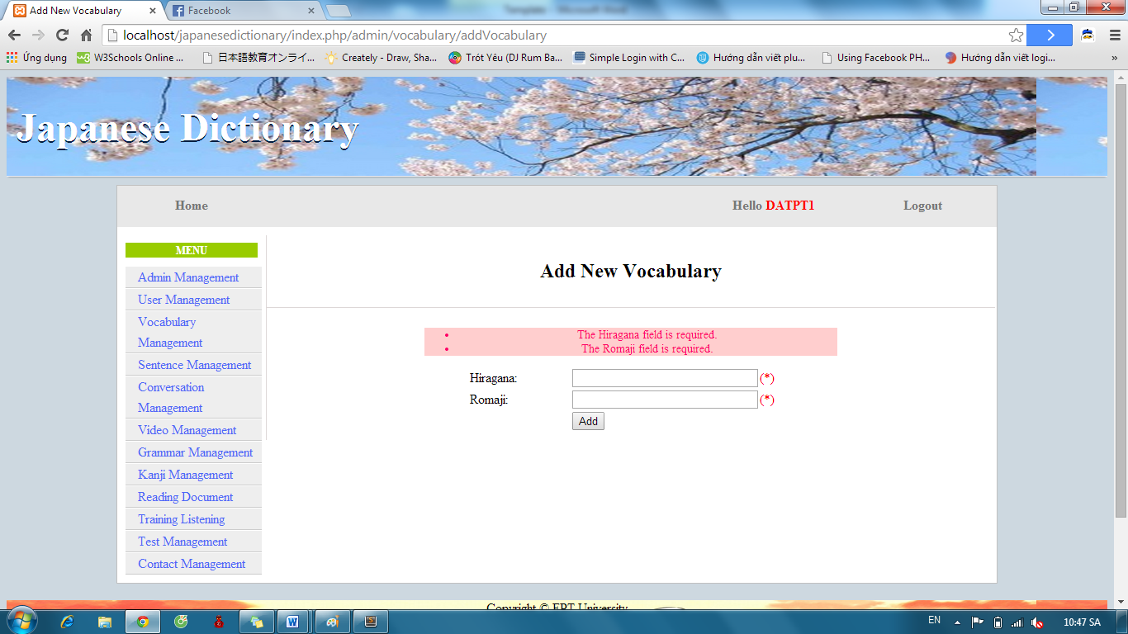

Step 5: After add vocabulary successful, click “Add Meaning” of corresponding Vocabulary.

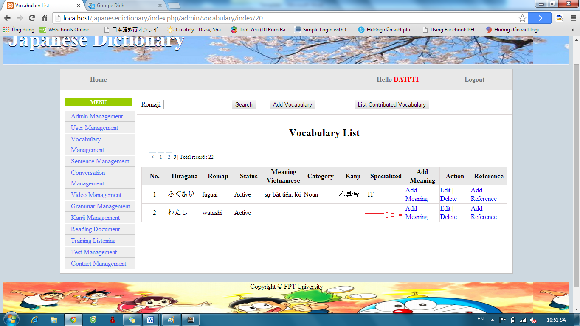

Step 6: Input correct information of vocabulary and click “Add” button

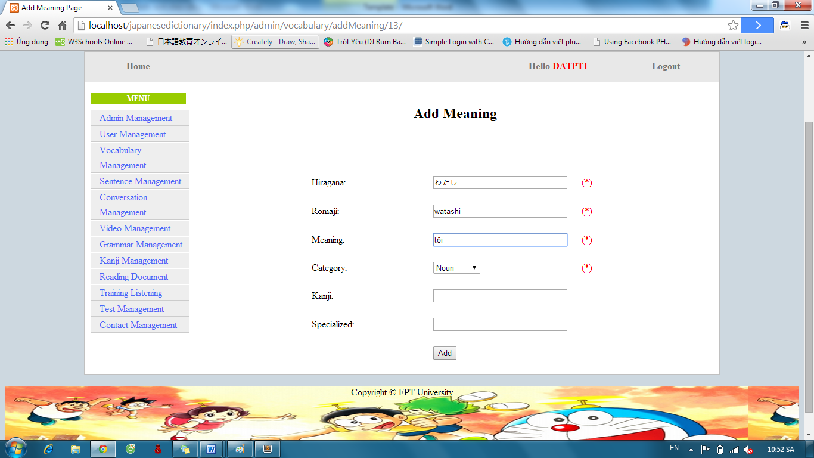

* Success : Display list Vocabulary



* Fails: Error message will notify. You must try again.

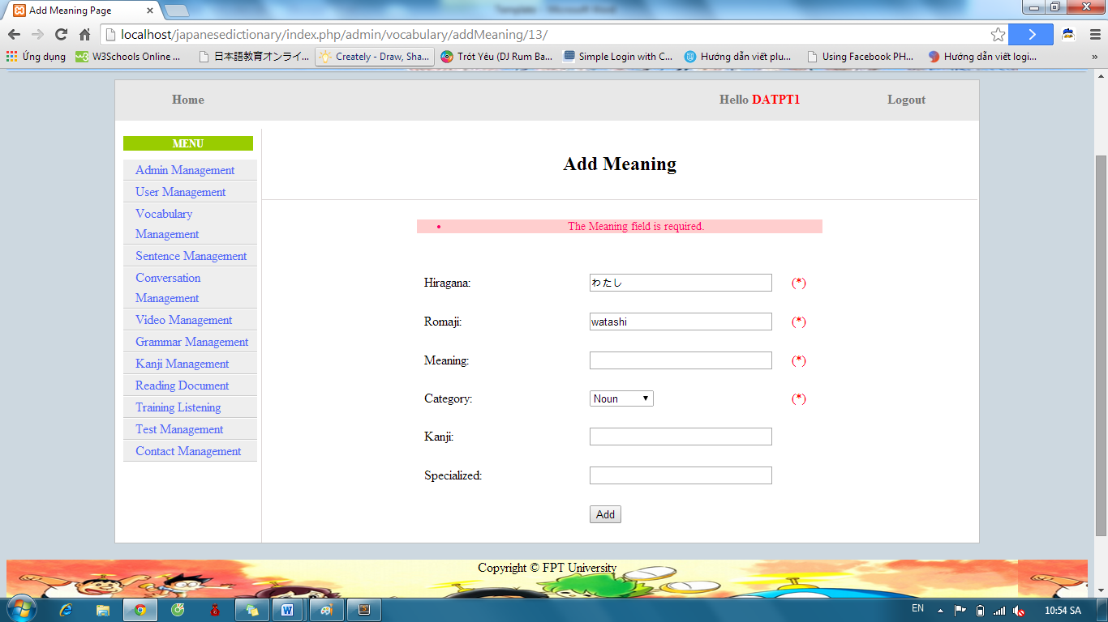

#### Edit Vocabulary

To use edit vocabulary function on website, the users do the steps below:

Step 1: Login with admin account as 4.2.19. System will display list User.

Step 2: Click “Vocabulary management” link. System will display list Vocabulary. After that, click “Edit” link.



Step 3: Input correct information of vocabulary that you want change and click “Edit” button.

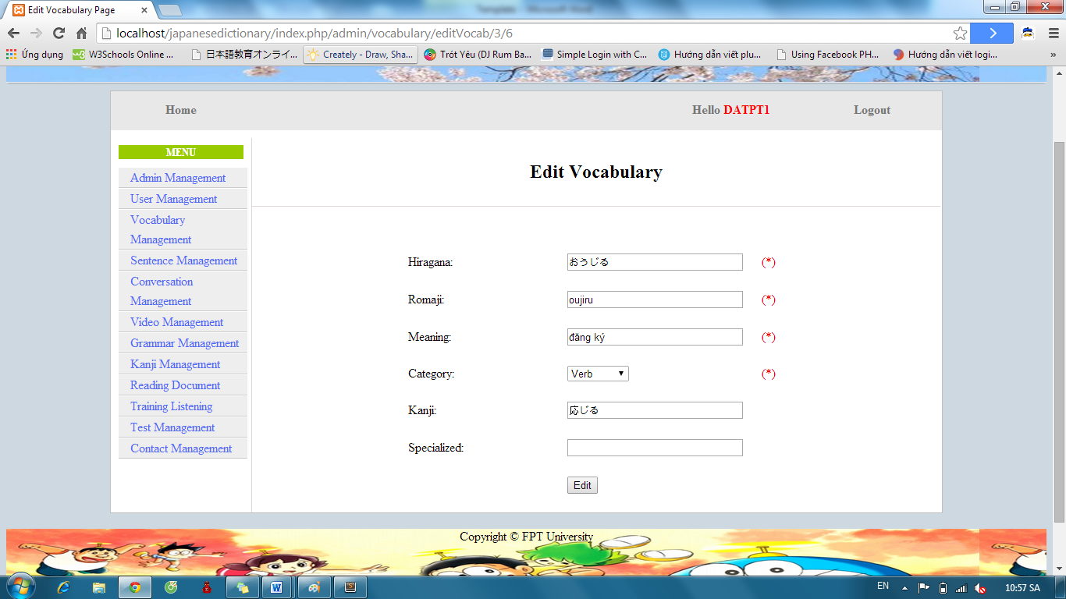

* Success : Display list vocabulary



* Fails: Error message will notify. You must try again.

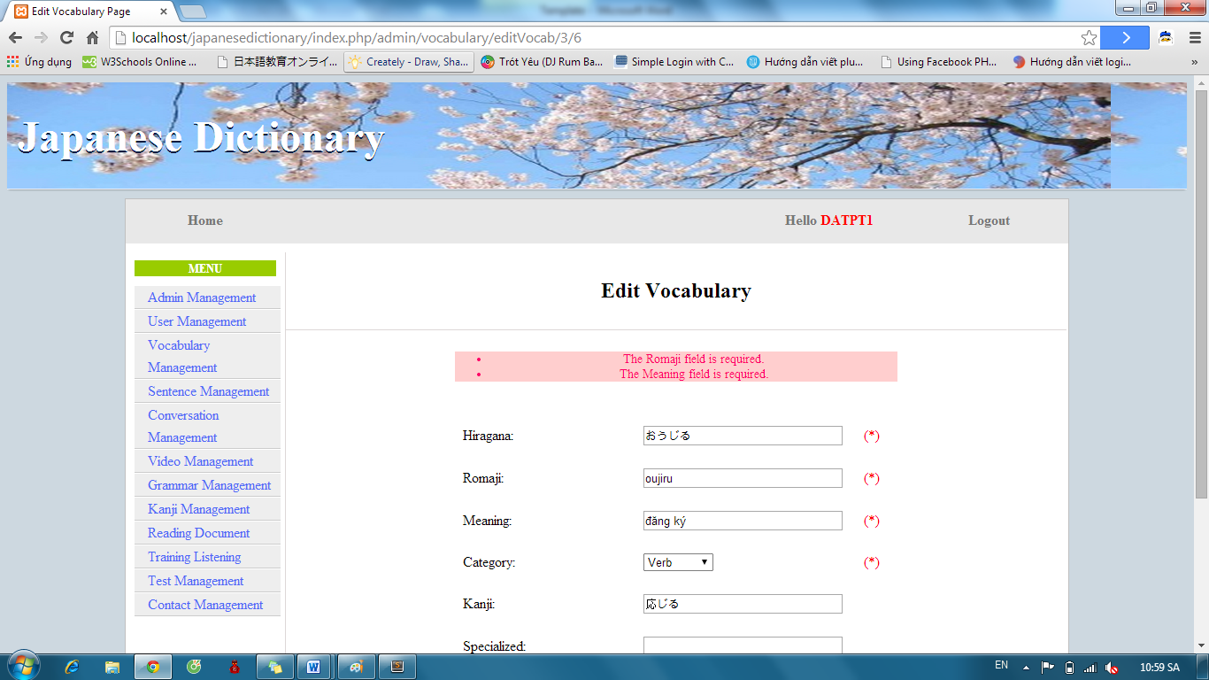

#### Delete Vocabulary

To use delete vocabulary function on website, the users do the steps below:

Step 1: Login with admin account as 4.2.19. System will display list User.

Step 2: Click “Vocabulary management” link. System will display list Vocabulary. After that, click “Delete” link.



If vocabulary has one meaning, it deleted. If vocabulary has many meaning, corresponding meaning with “Delete” link deleted.

#### Approve Vocabulary

To use approve vocabulary function on website, the user do the steps below:

Step 1: Login with admin account as 4.2.19. System will display list User

Step 2: Click “Vocabulary management” link. System will display list Vocabulary.



Step 3: Click “List contribute vocabulary” button. List vocabulary contribute will display

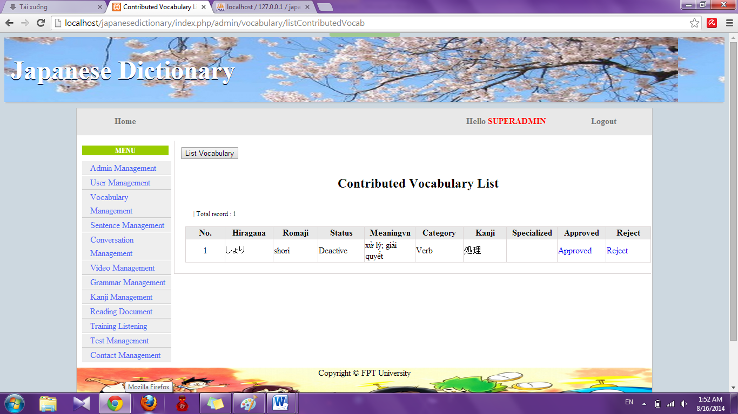

Step 4: Click “Approve” link. System will display approve page

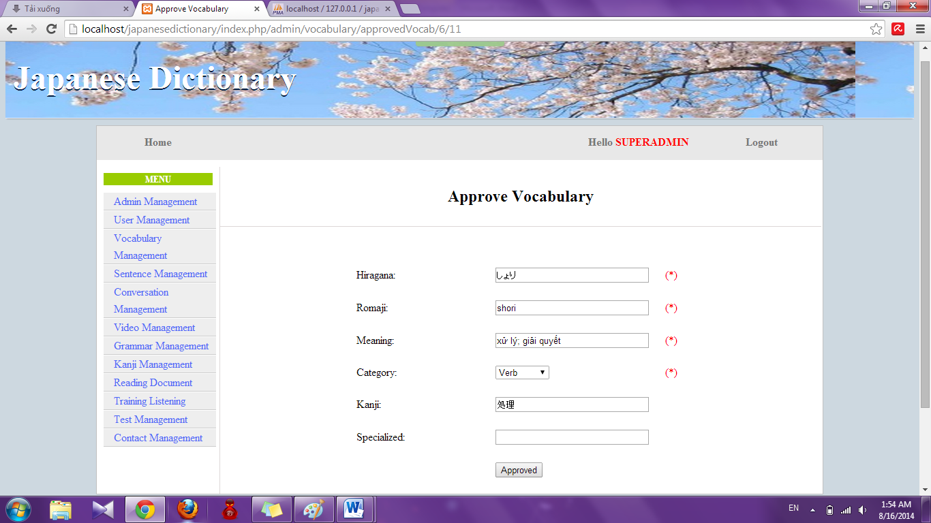

Step 5: Edit information (if need) and click “Approved” button

* Success : Redirect to Contribute Vocabulary list
* Fail : Error message will notify. You must try again.

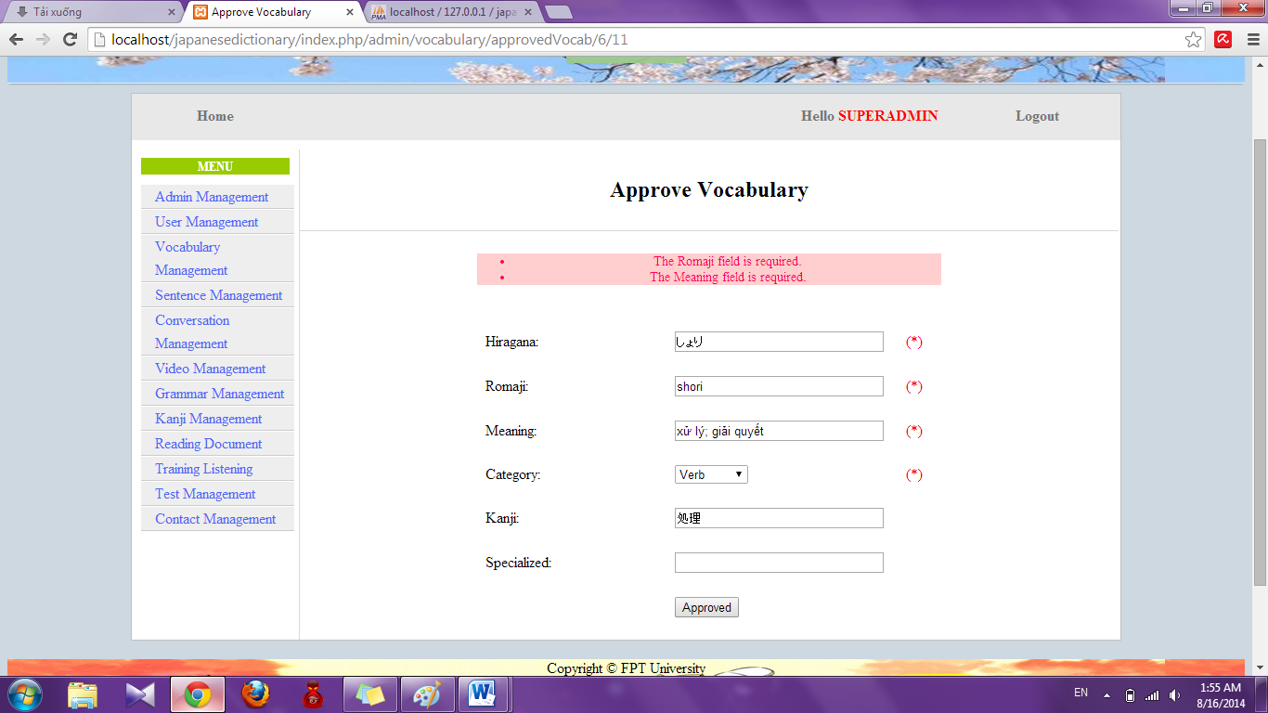

#### Reject Vocabulary

To use reject vocabulary function on website, the user do the steps below:

Step 1: Login with admin account as 4.2.19. System will display list User

Step 2: Click “Vocabulary management” link. System will display list Vocabulary.



Step 3: Click “List contribute vocabulary” button. List vocabulary contribute will display.

 Step 4: Click “Reject” link. System will reject that contribute

### Grammar Management

#### Search grammar

To use search grammar function on website, the users do the steps below:

Step 1: Login with admin account as 4.2.19. System will display list User.

Step 2: Click “Grammar management” link. System will display list Grammar.

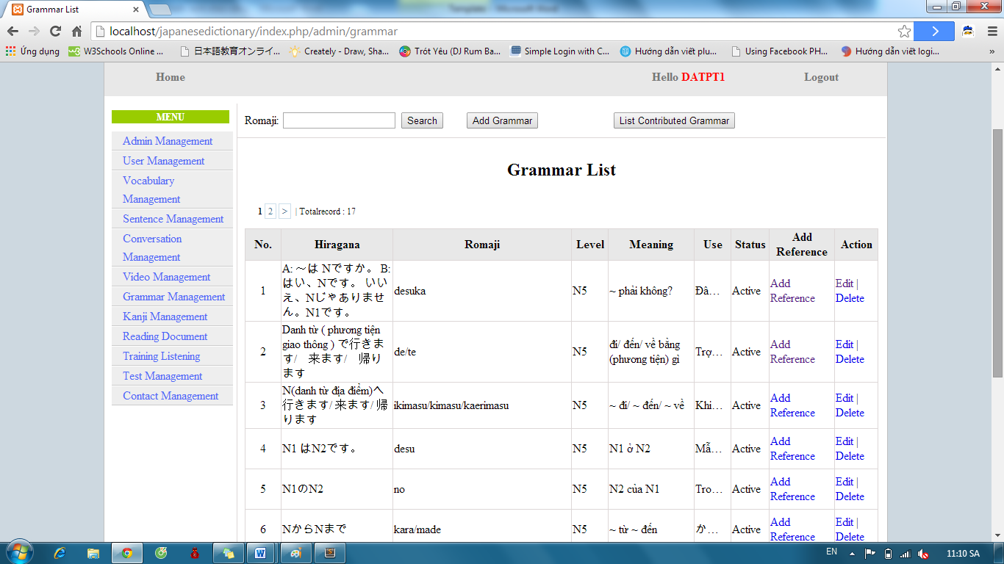

Step 3: Input grammar’s romaji and click “Search” button. Display results found.

* If exist : display result

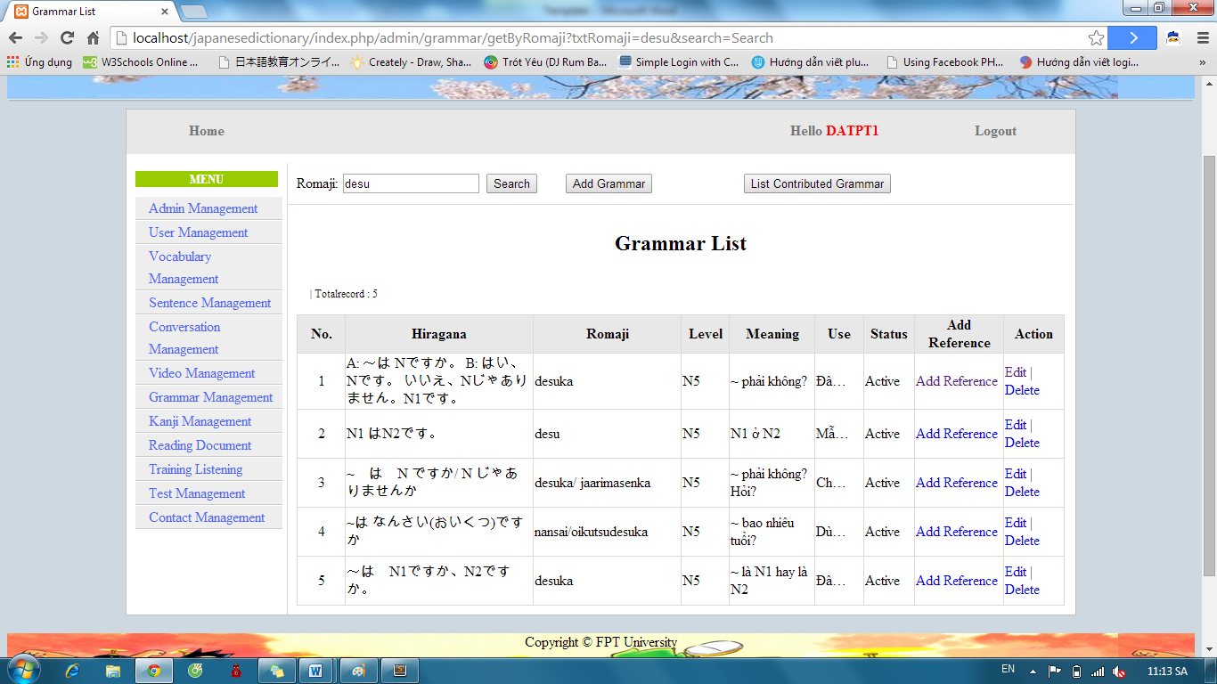

* If don’t exist : Display no record

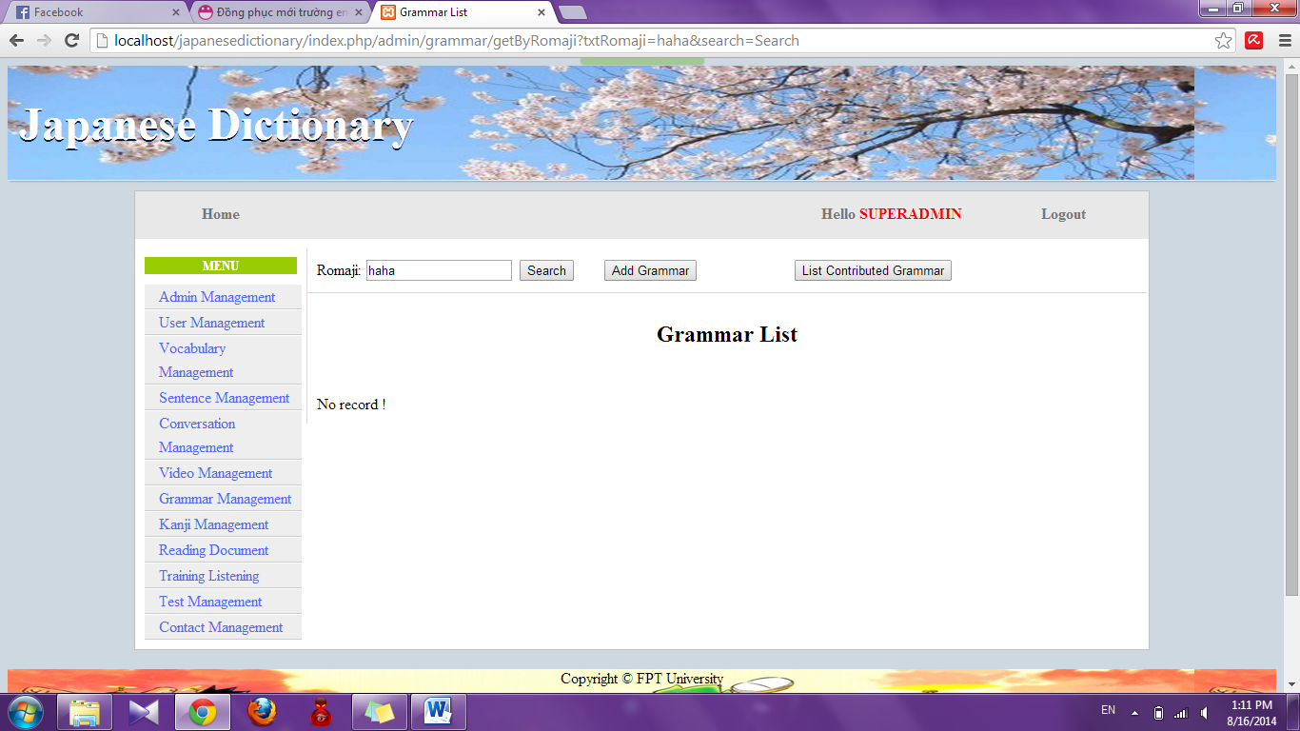

#### Add Grammar

To use add grammar function on website, the users do the steps below:

Step 1: Login with admin account as 4.2.19. System will display list User.

Step 2: Click “Grammar management” link. System will display list Grammar.



Step 3: Click “Add Grammar” button and input correct information of grammar that you want add.

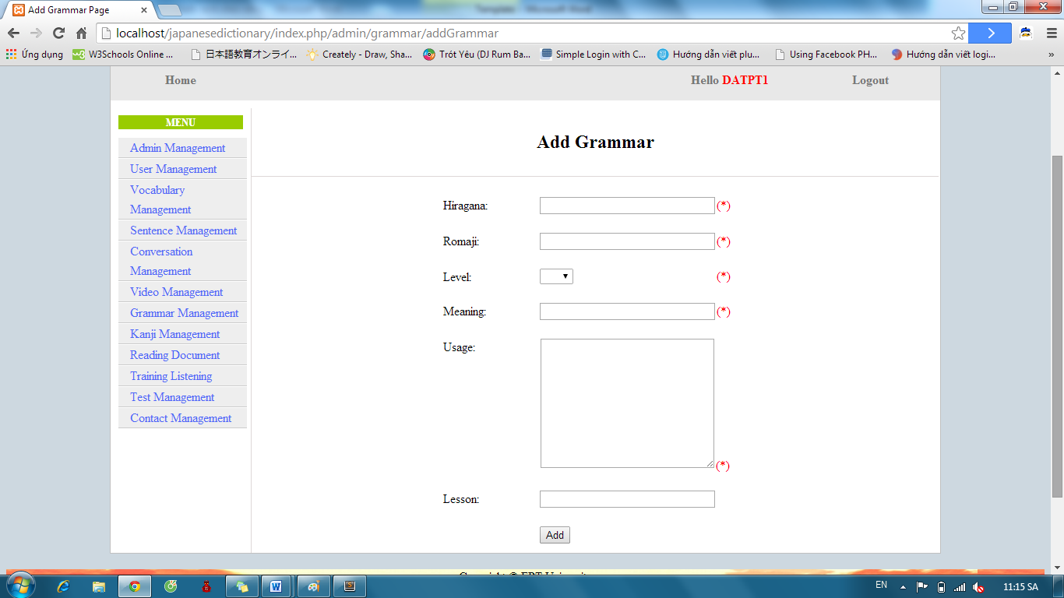 Step 4: After input, click “Add” button.

* Success: System display list Grammar with new grammar



* Fails: Error message will notify. You must try again.

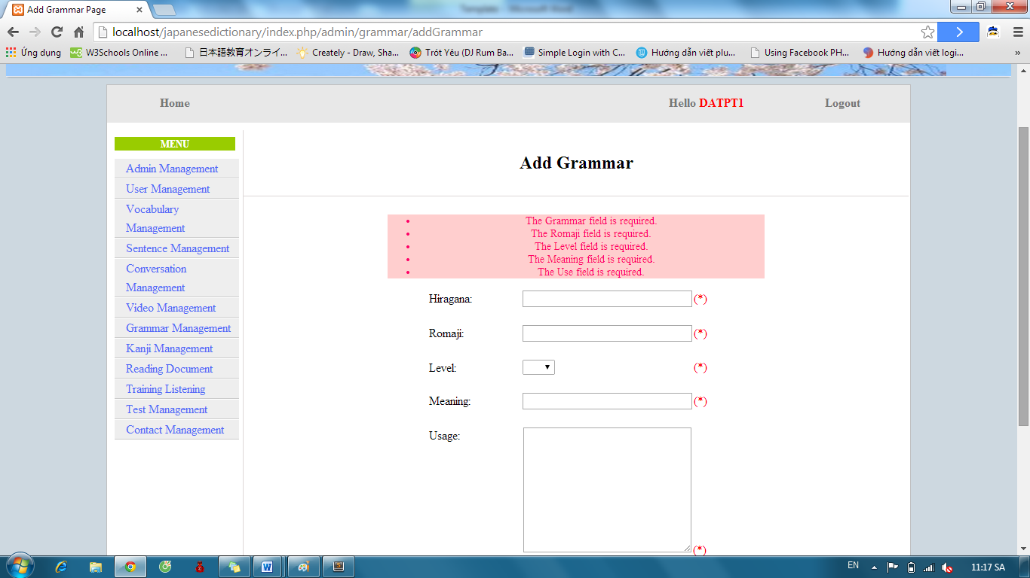

#### Edit Grammar

To use edit grammar function on website, the users do the steps below:

Step 1: Login with admin account as 4.2.19. System will display list User.

Step 2: Click “Grammar management” link. System will display list Grammar. After that, click “Edit” link.



Step 3: Input correct information of grammar that you want change and click “Edit” button.

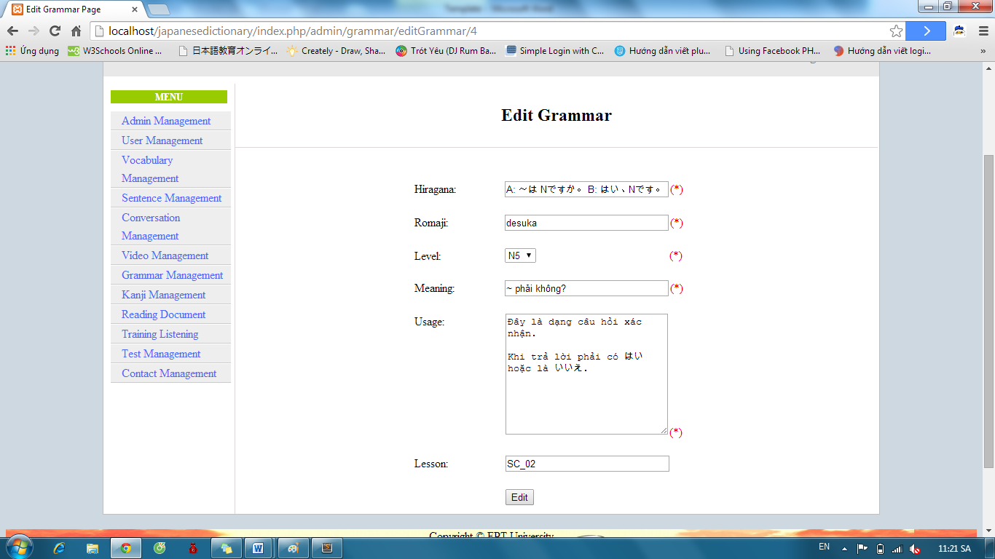

* Success: Display list Grammar.



* Fails: Error message will notify. You must try again.

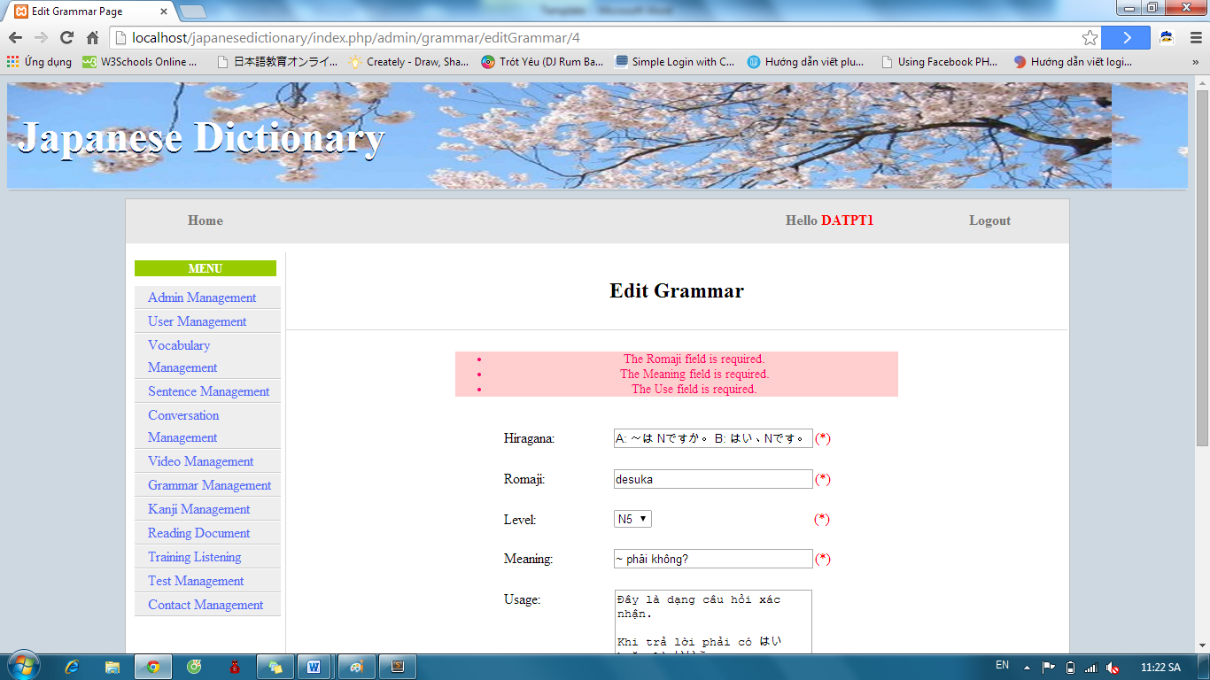

#### Delete Grammar

To use delete grammar function on website, the users do the steps below:

Step 1: Login with admin account as 4.2.19. System will display list User.

Step 2: Click “Grammar management” link. System will display list Vocabulary.



Step 3: Click “Delete” link with corresponding grammar.

#### Approve grammar contribute

To use approve grammar function on website, the users do the steps below:

Step 1: Login with admin account as 4.2.19. System will display list User.

Step 2: Click “Grammar management” link. System will display list Vocabulary.



Step 3: Click “List contributed grammar” button. System will display list contribute grammar

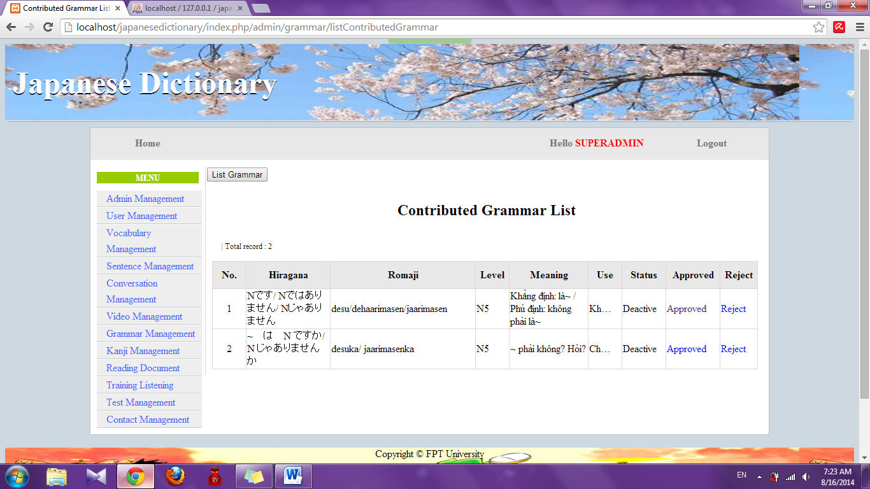

Step 4: Click “Approved” link. System will display approve page

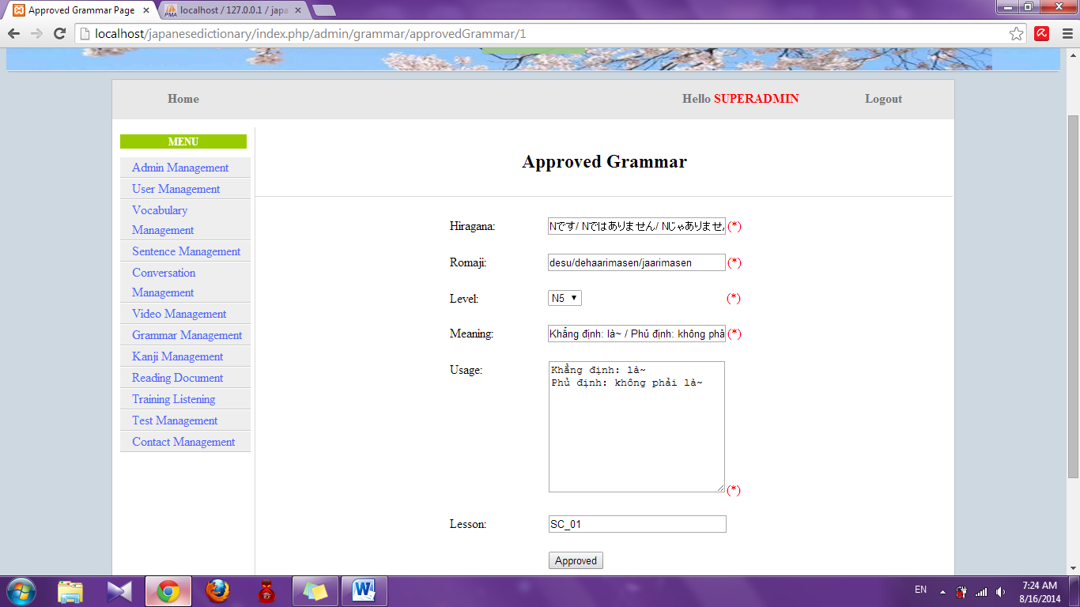

Step 5: Edit information (if need) and click “Approved” button

* Success : Redirect to list grammar contribute and display with new grammar
* Fail : Error message will notify. You must try again.

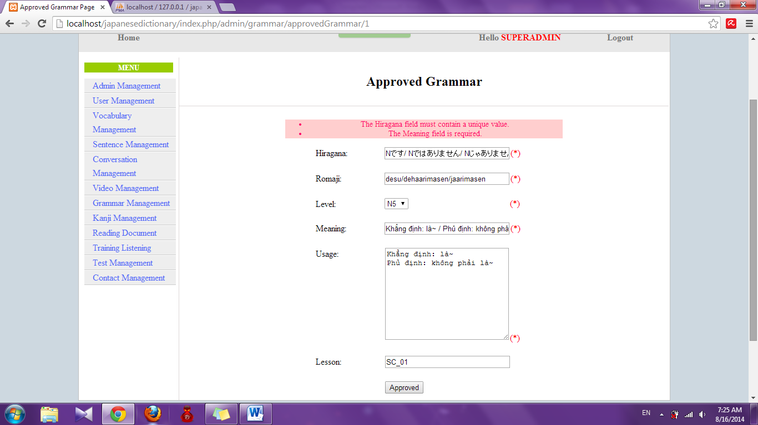

#### Reject grammar contribute

To use reject grammar function on website, the users do the steps below:

Step 1: Login with admin account as 4.2.19. System will display list User.

Step 2: Click “Grammar management” link. System will display list Vocabulary.



Step 3: Click “List contribute grammar” button. List grammar contribute will display.

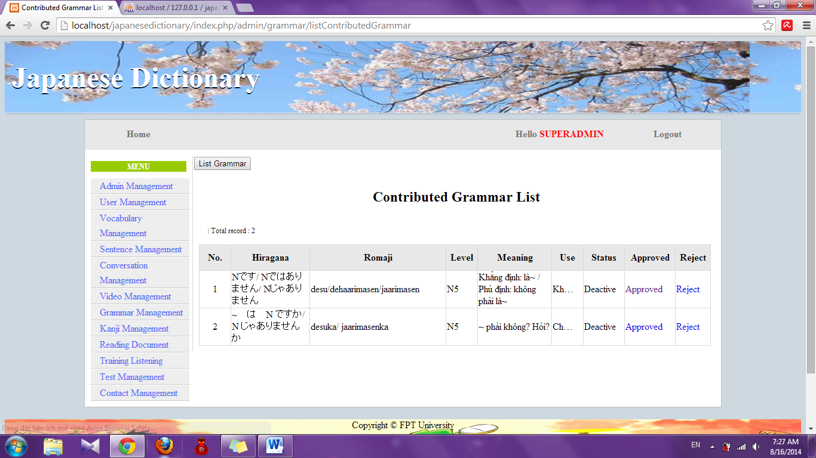

Step 4: Click “Reject” link. System will reject that contribute

### Conversation management

#### Search Conversation

To use search conversation function on website, the users do the steps below:

Step 1: Login with admin account as 4.2.19. System will display list User.

Step 2: Click “Conversation management” link. System will display list Conversation.

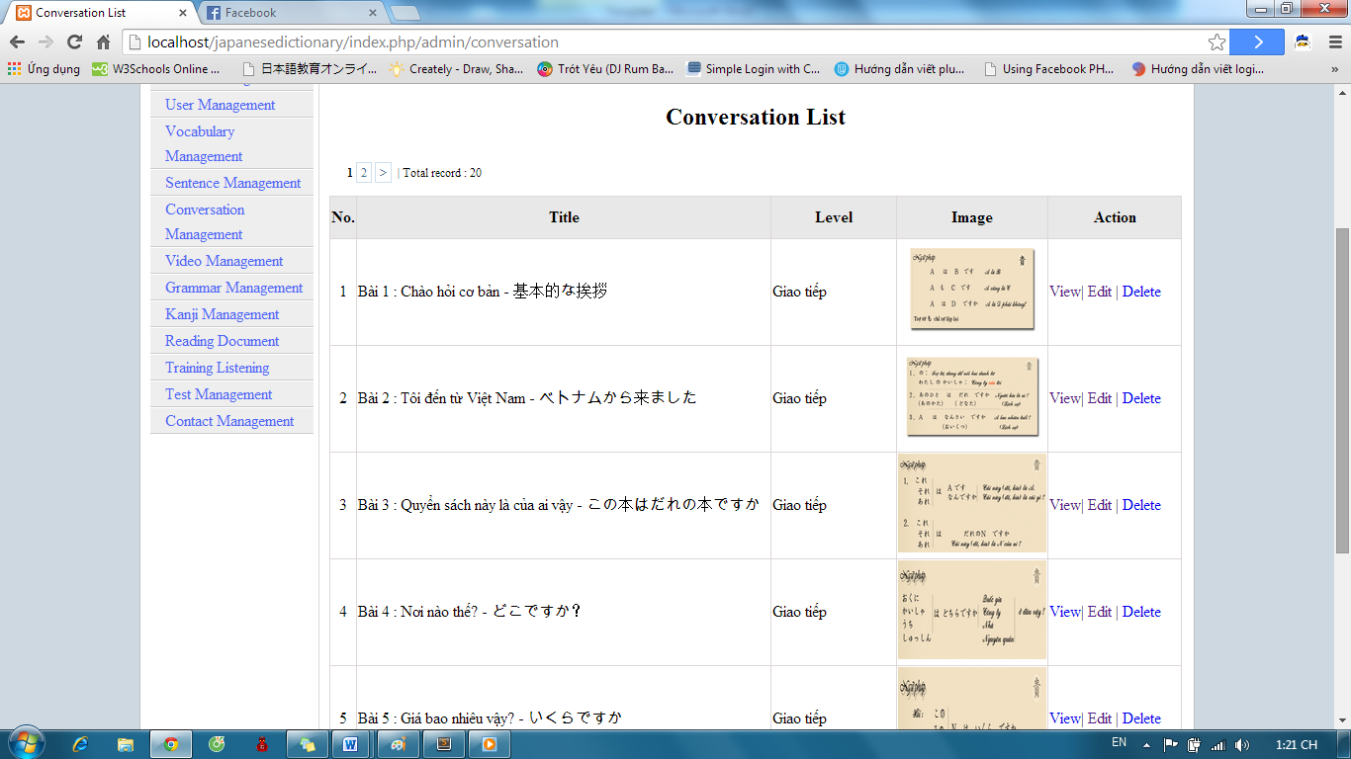

Step 3: Select option search and click “Search” button. Results search will be displayed.

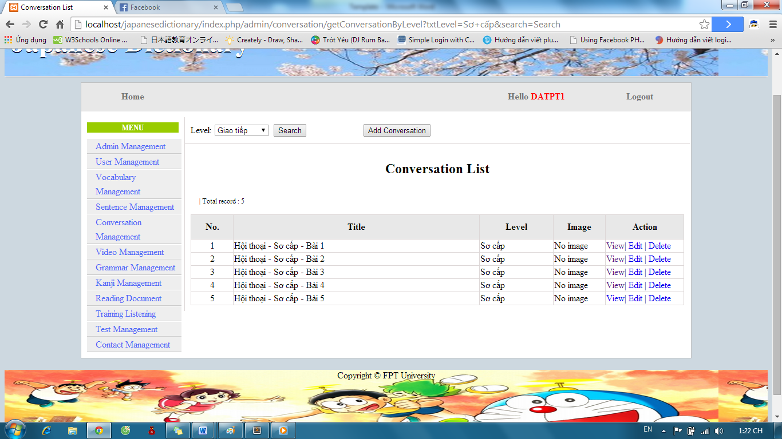

#### Add Conversation

To use add conversation function on website, the users do the steps below:

Step 1: Login with admin account as 4.2.19. System will display list User.

Step 2: Click “Conversation management” link. System will display list Conversation.

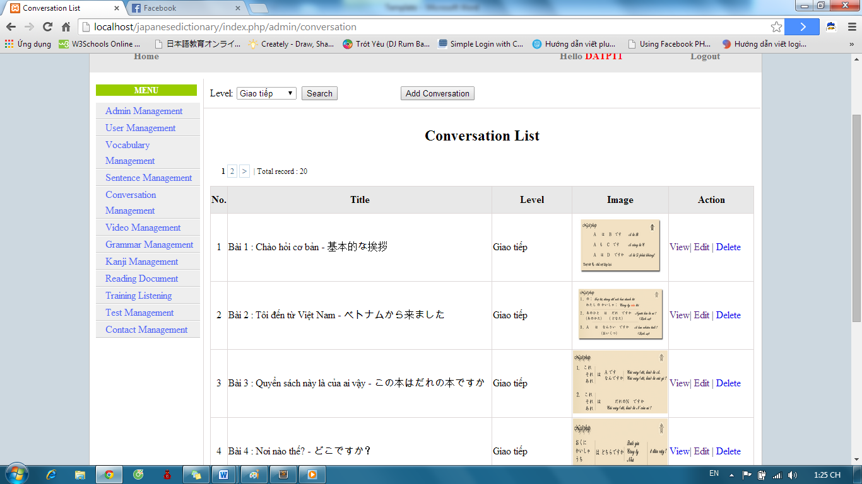

Step 3: Click “Add Conversation” button and input correct information of conversation that you want add.

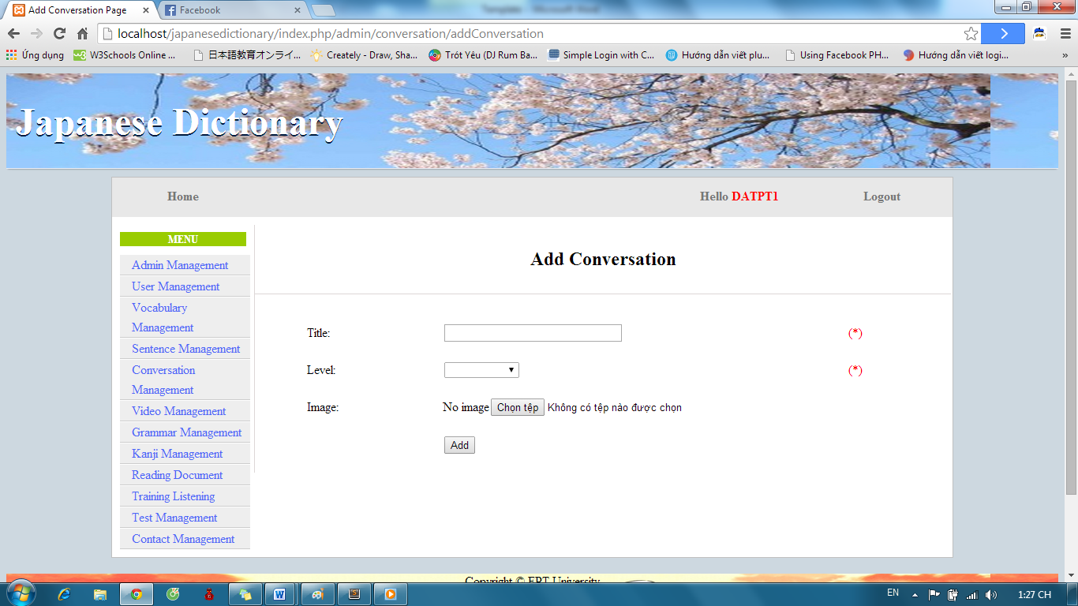

Step 4: After input, click “Add” button.

* Success: Display list conversation with new conversation



* Fails: Error message will notify. You must try again.

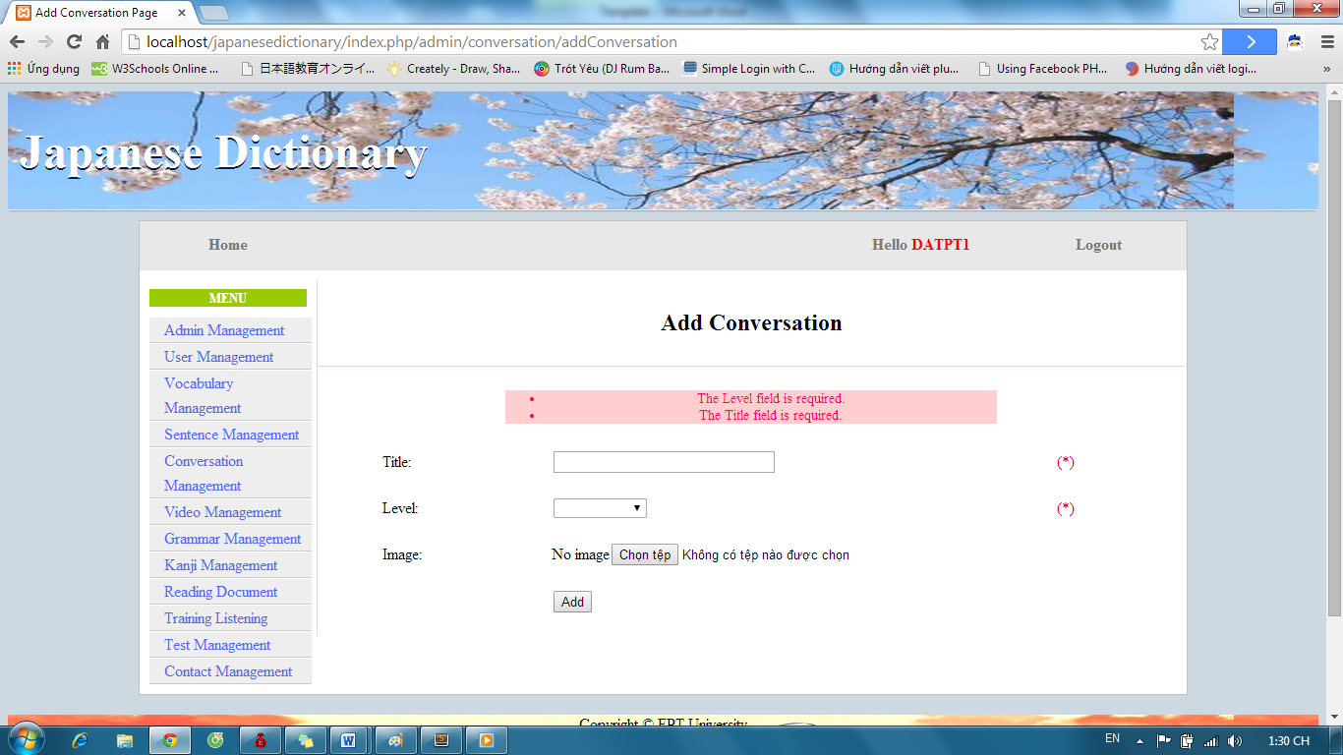

#### Add Content Conversation

To use add content conversation function on website, the users do the steps below:

Step 1: Login with admin account as 4.2.19. System will display list User.

Step 2: Click “Conversation management” link. System will display list Conversation.



Step 3: If you want add content for a conversation, click “View” link with corresponding conversation.

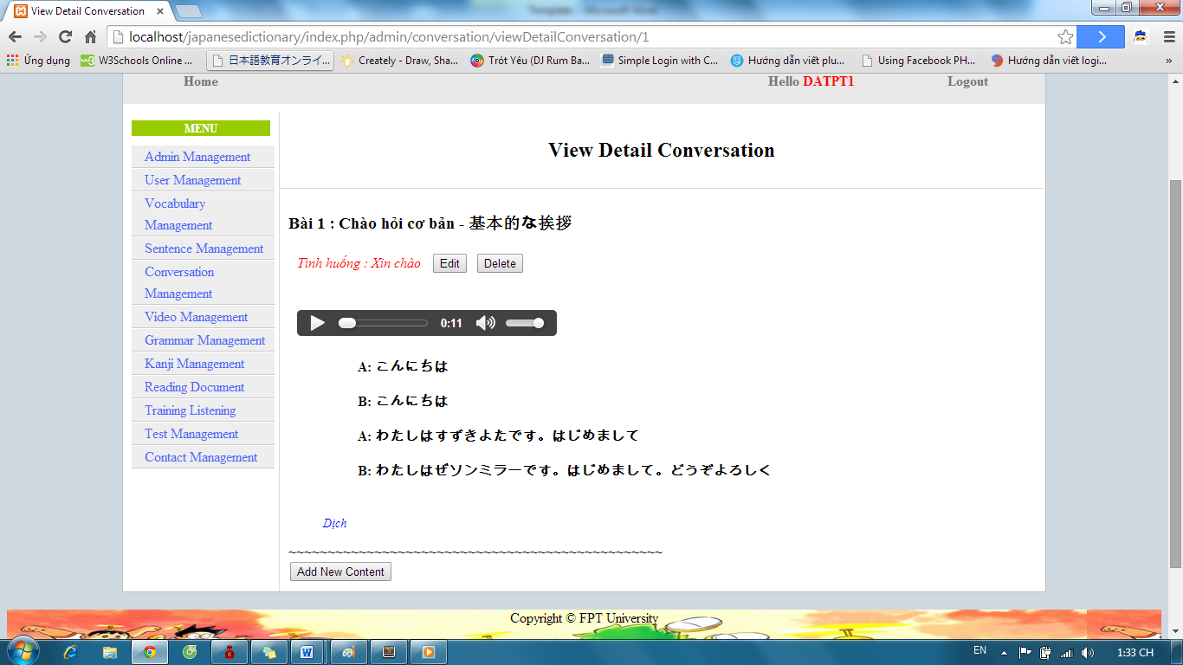

Step 4: Click “Add New Content” button and input correct information of conversation’s content.

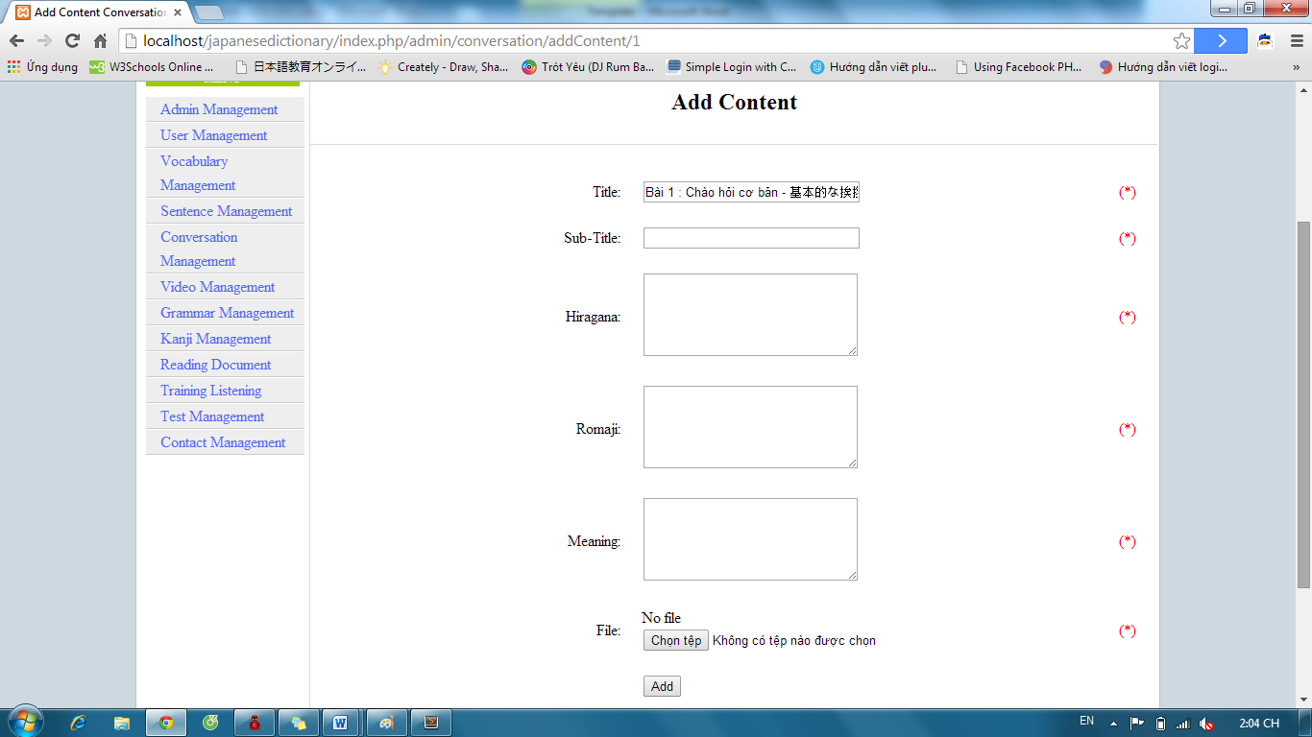

Step 5: Click “Add” button.

* Success : Display details conversation
* Fail : Display error message

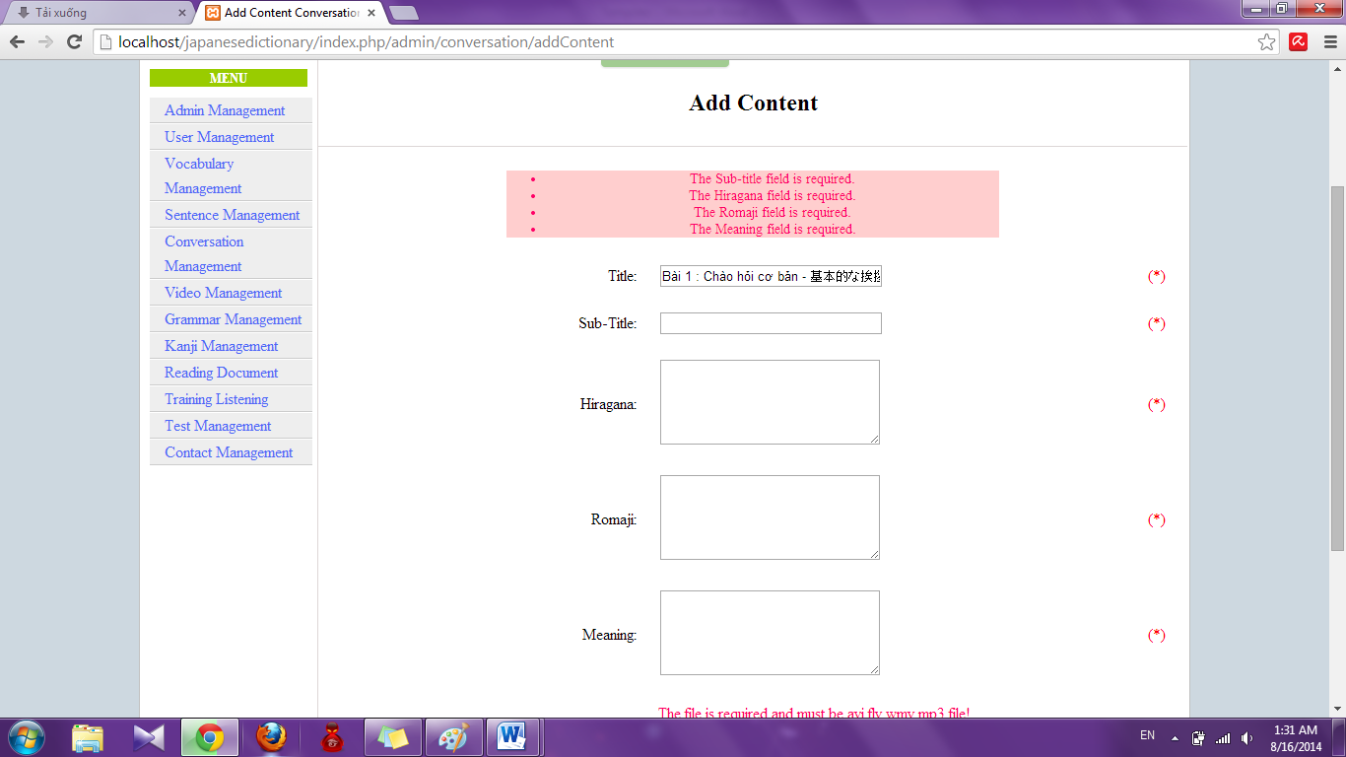

#### Edit Conversation

To use edit conversation function on website, the users do the steps below:

Step 1: Login with admin account as 4.2.19. System will display list User.

Step 2: Click “Conversation management” link. System will display list Conversation.



Step 3: Click to “Edit” link with corresponding conversation.

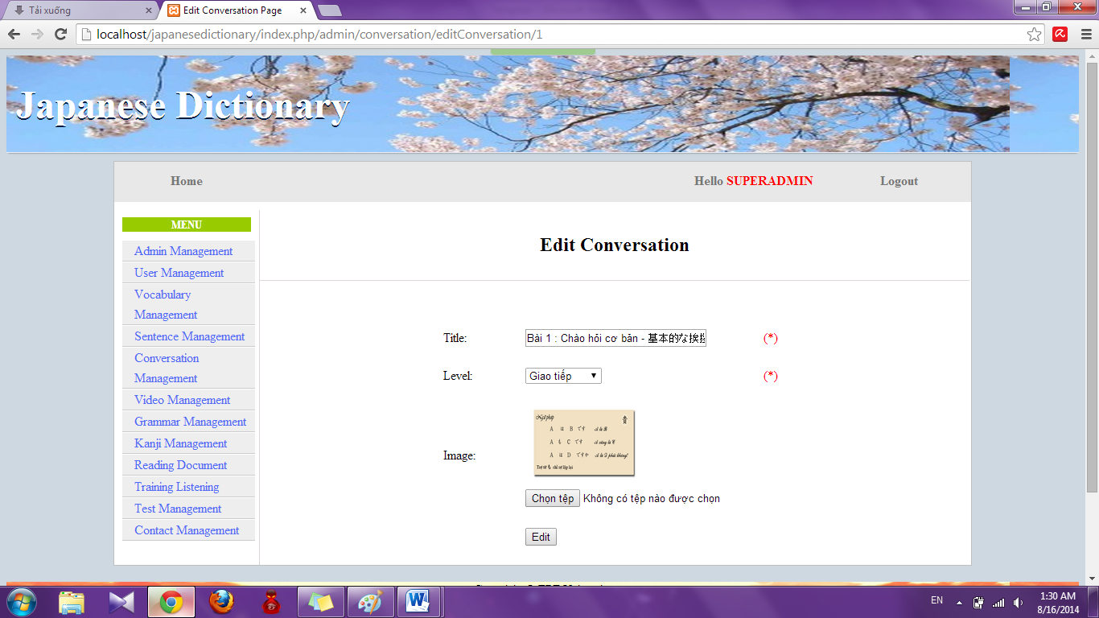

Step 4: Input information that you want to edit and click “Edit”

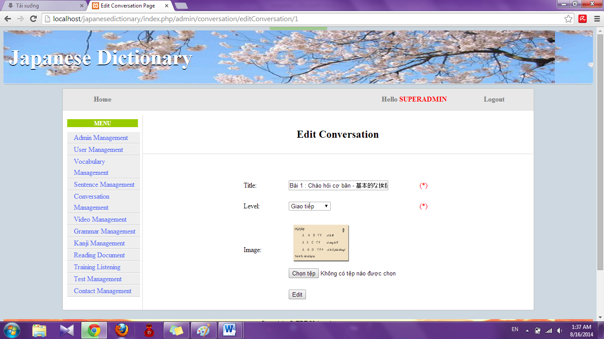

* Success : Redirect to conversation list

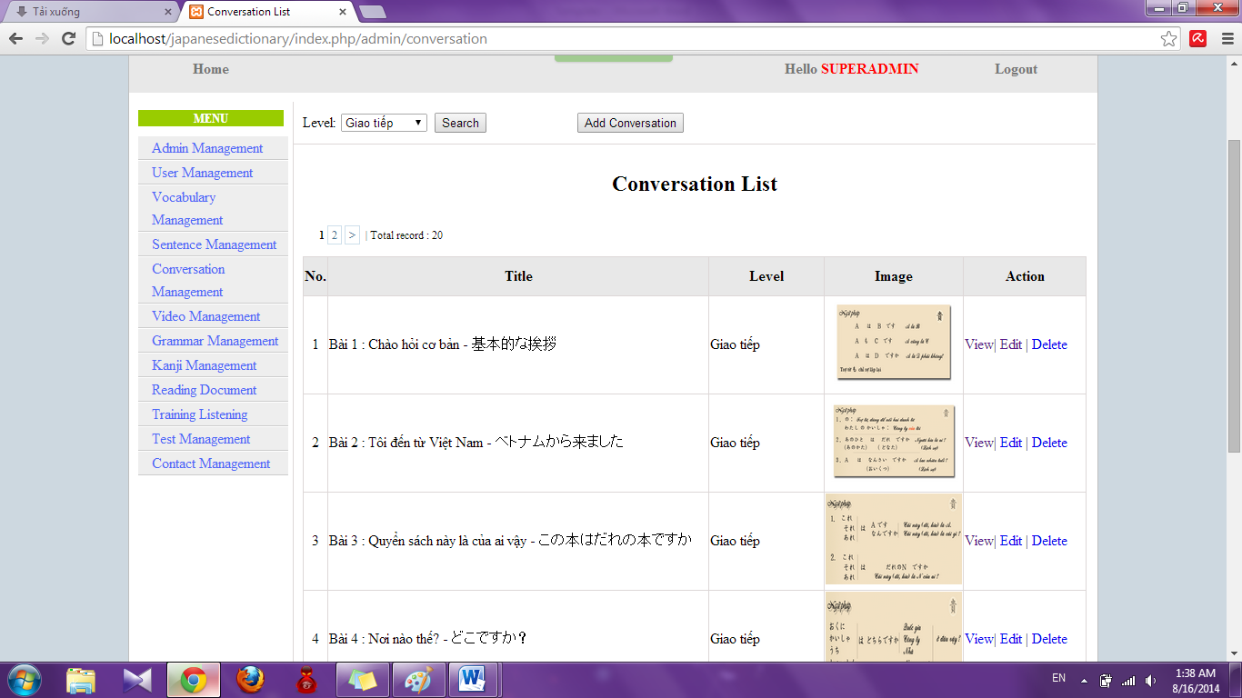

* Faill : Error message will notify. You must try again.

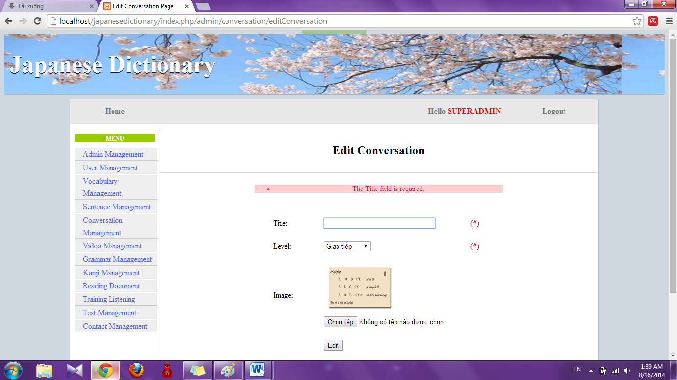

#### Edit Content

To use edit content conversation function on website, the users do the steps below:

Step 1: Login with admin account as 4.2.19. System will display list User.

Step 2: Click “Conversation management” link. System will display list Conversation.



Step 3: Click “View” link. System will display view of conversation

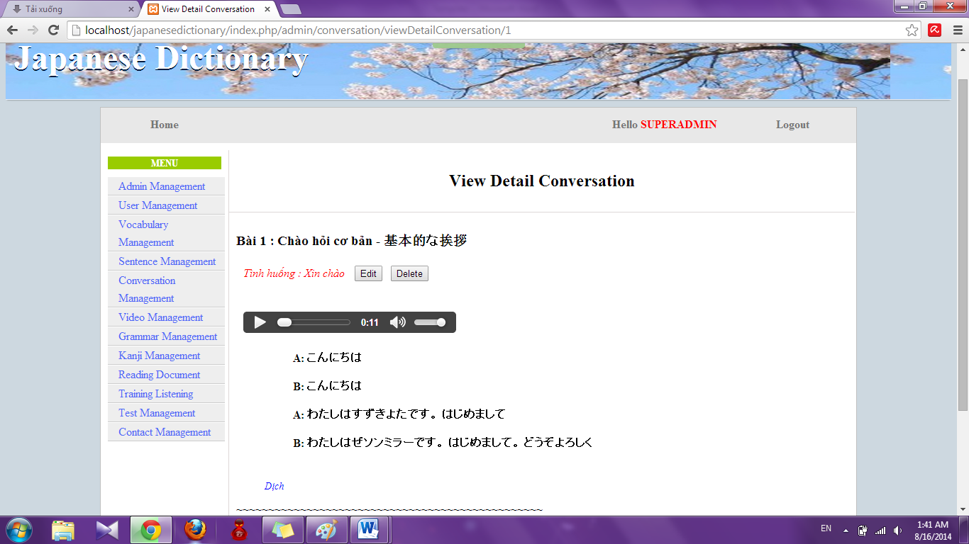

Step 4: Click “Edit” button. System will display Edit page

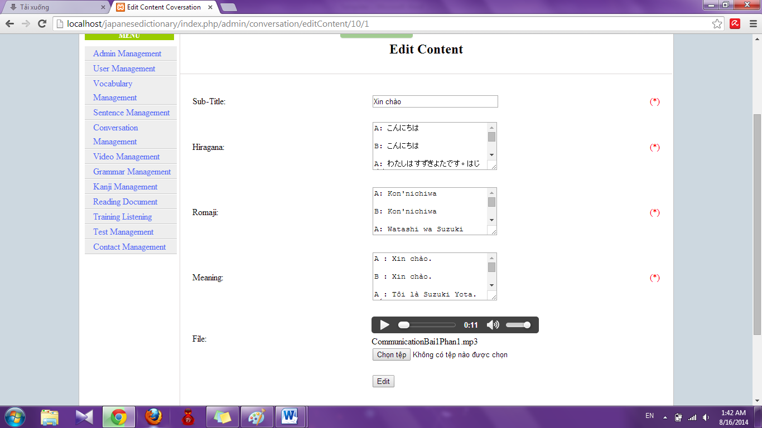

Step 5: Input information that you want to edit and click “Edit”

* Success : Display View details of conversation like Step 3
* Fail : Error message will notify. You must try again.

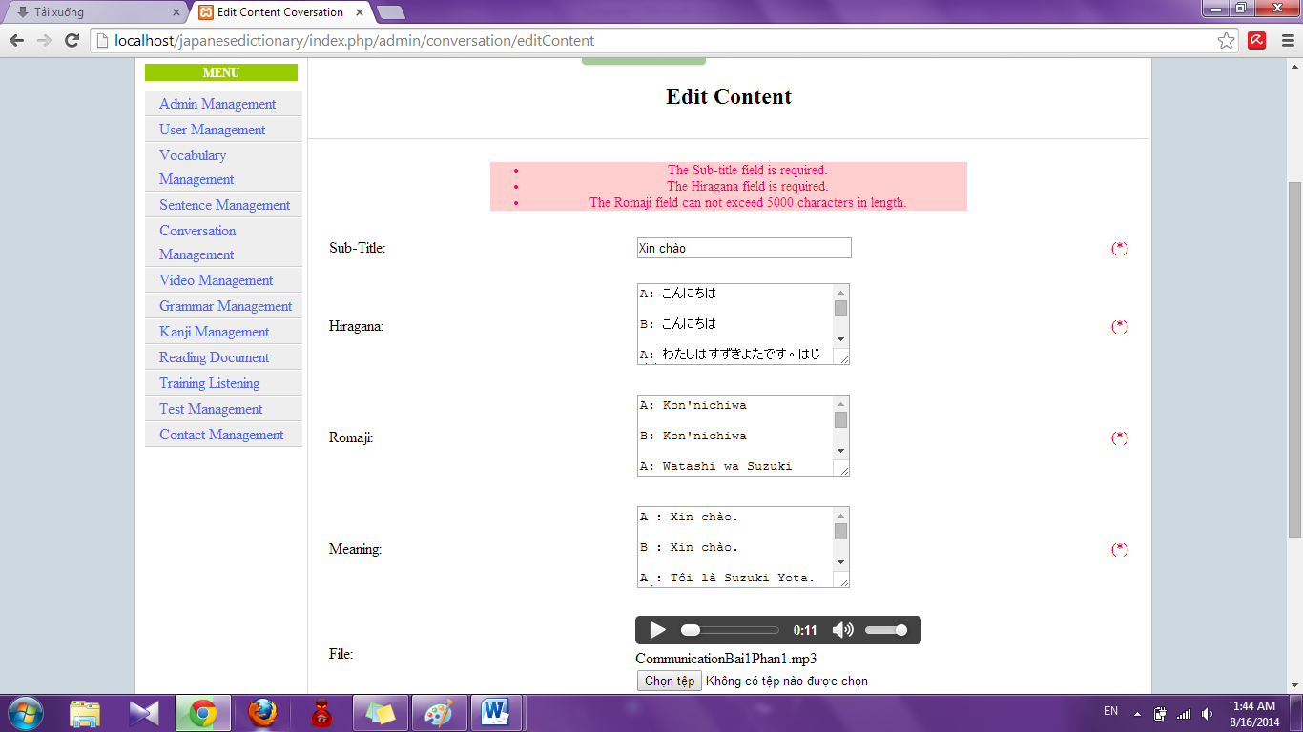

#### Delete Conversation

To use delete conversation function on website, the users do the steps below:

Step 1: Login with admin account as 4.2.19. System will display list User.

Step 2: Click “Conversation management” link. System will display list Conversation. 

Step 3: Click “Delete” link with corresponding conversation

#### Delete content

To use edit content conversation function on website, the users do the steps below:

Step 1: Login with admin account as 4.2.19. System will display list User.

Step 2: Click “Conversation management” link. System will display list Conversation.



Step 3: Click “View” link. System will display view of conversation. 

Step 4: Click “Delete” button. System will delete that content

### Reading document management

#### Search reading document

To use search reading document function on the website, the users do the steps below:

Step 1: Login with admin account as 4.2.19. System will display list User.

Step 2: Click “Reading document management” link. System will display list Reading document.

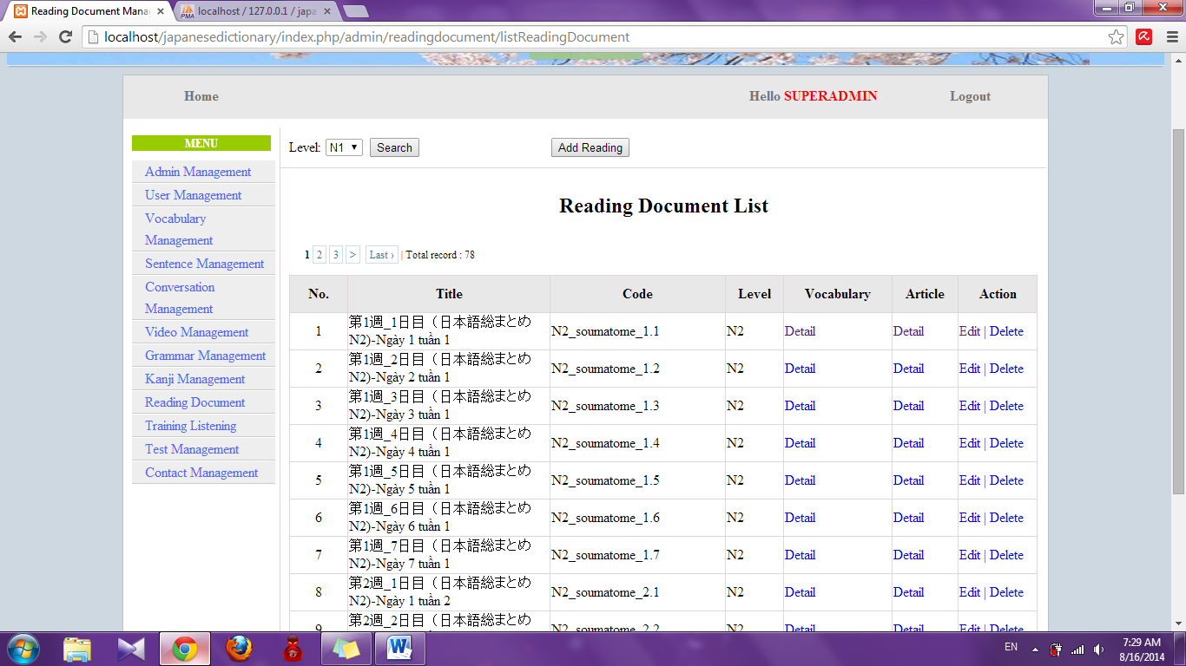

Step 3: Select option search and click “Search” button. Results search will be displayed

* If exist : display result of search

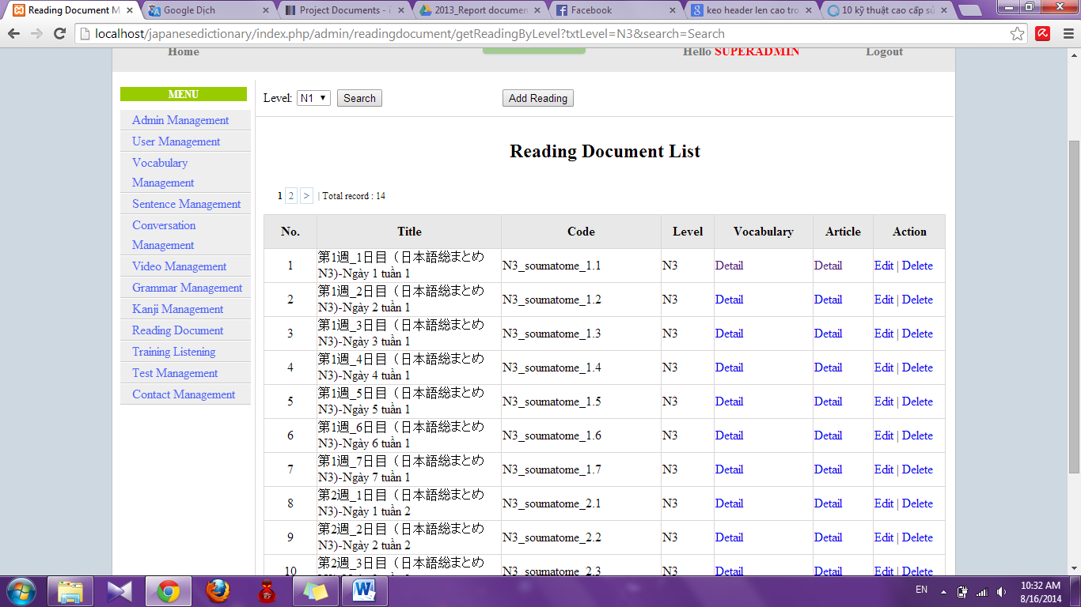

* If don’t exist : Display no record

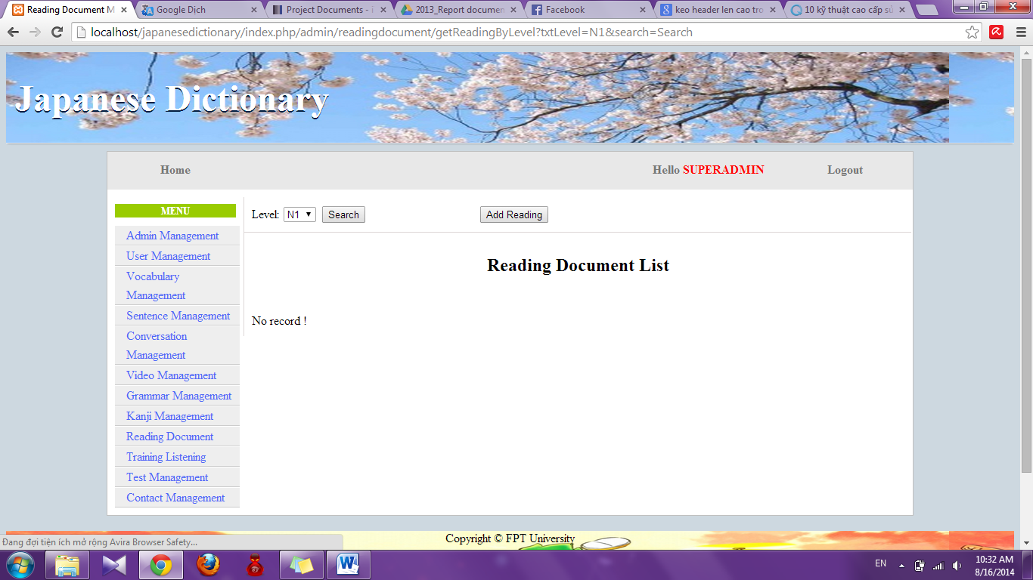

#### Add reading document

To use add reading document function on the website, the users do the steps below:

Step 1: Login with admin account as 4.2.19. System will display list User.

Step 2: Click “Reading document management” link. System will display list Reading document.



Step 3: Click “Add reading” button. System will display Add reading page

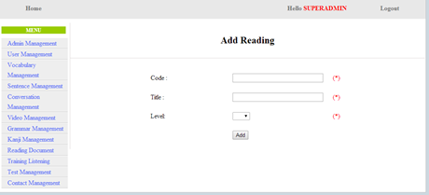

Step 4: Input correct information of conversation that you want add and click “Add” button

* Success : Display list reading document with new reading document
* Fail: Error message will notify. You must try again.

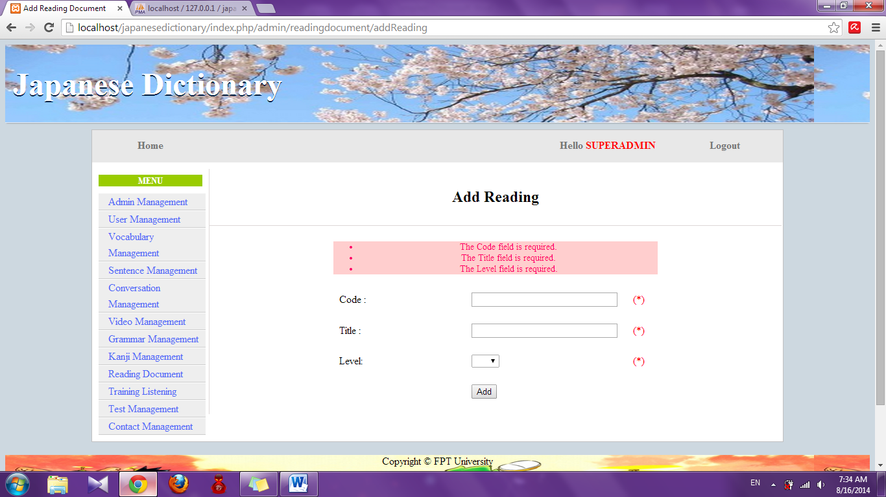

#### Add vocabulary of reading document

To use add vocabulary of reading document function on the website, the users do the steps below:

Step 1: Login with admin account as 4.2.19. System will display list User.

Step 2: Click “Reading document management” link. System will display list Reading document.



Step 3: Click “Detail” link of Vocabulary. System will display details of vocabulary

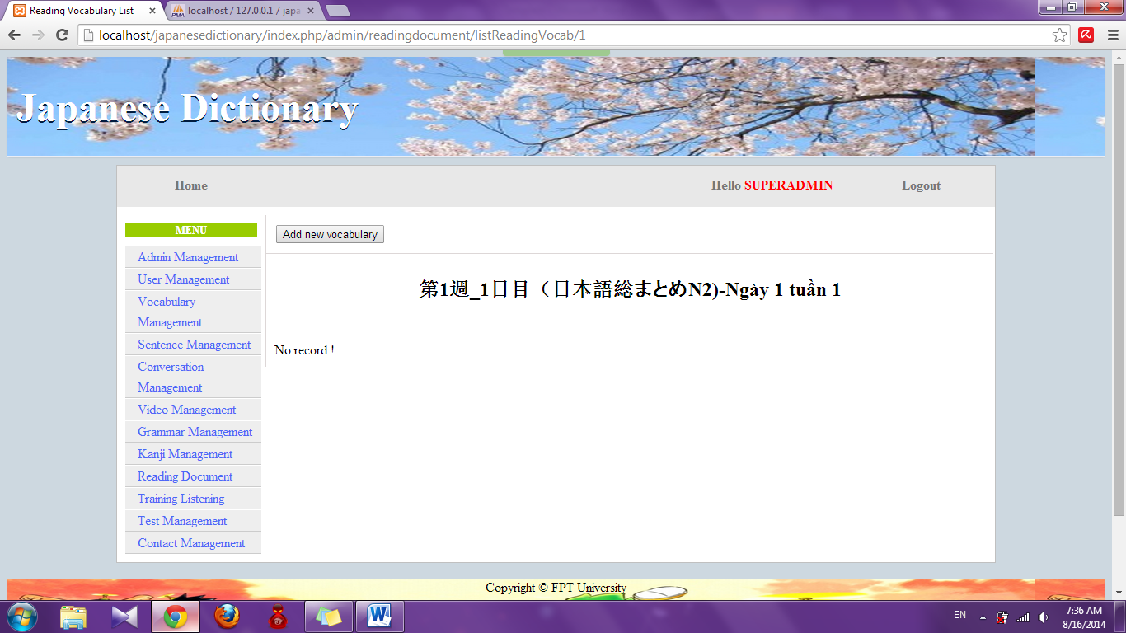

Step 4: Click “Add new vocabulary” button. System will display add vocabulary page

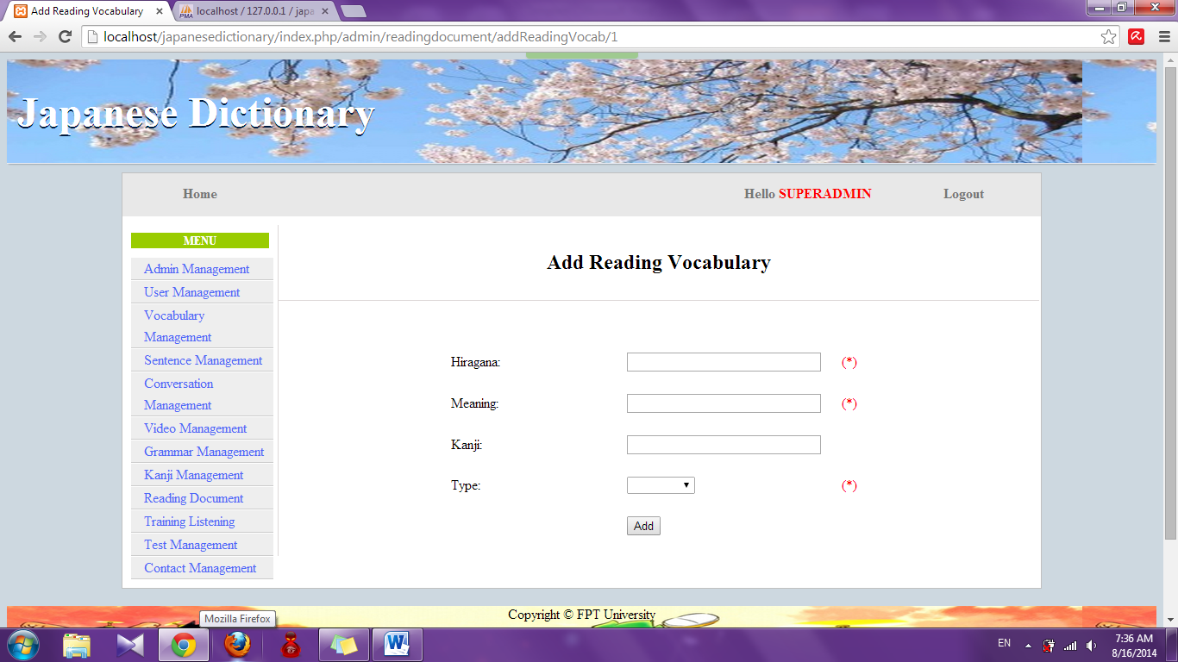

Step 5: Input information that you want to add and click “Add” button

* Success : Display list vocabulary of reading document
* Fail: Error message will notify. You must try again.

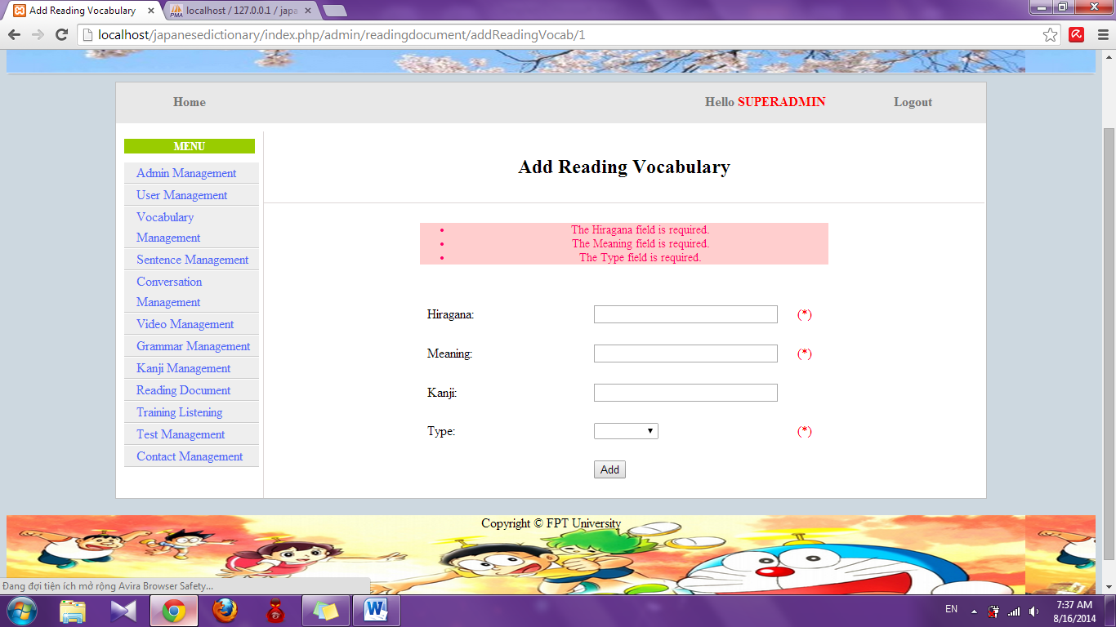

#### Add article of reading document

To use add article of reading document function on the website, the users do the steps below:

Step 1: Login with admin account as 4.2.19. System will display list User.

Step 2: Click “Reading document management” link. System will display list Reading document.



Step 3: Click “Detail” link of Article. System will display details of article

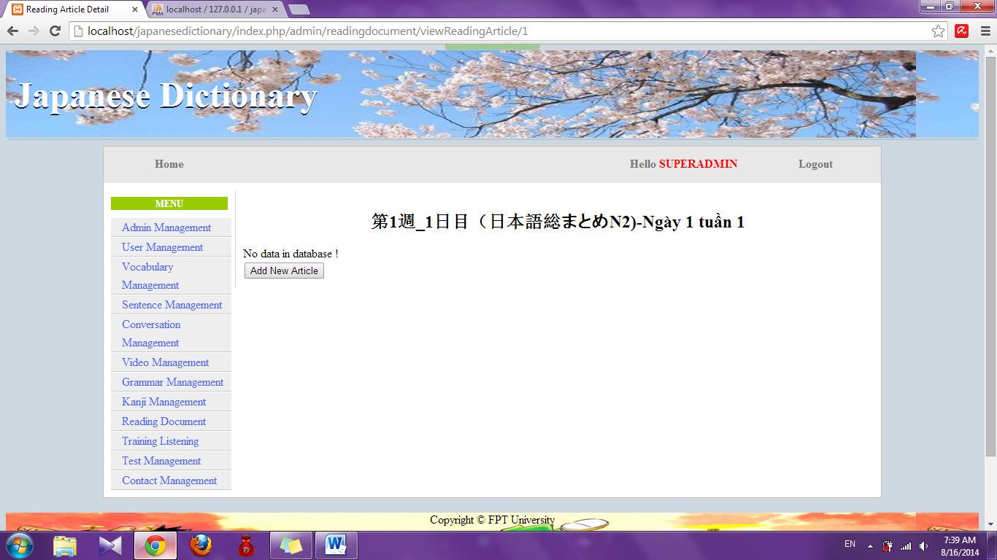

Step 4: Click “Add new article” button. System will display add new article page

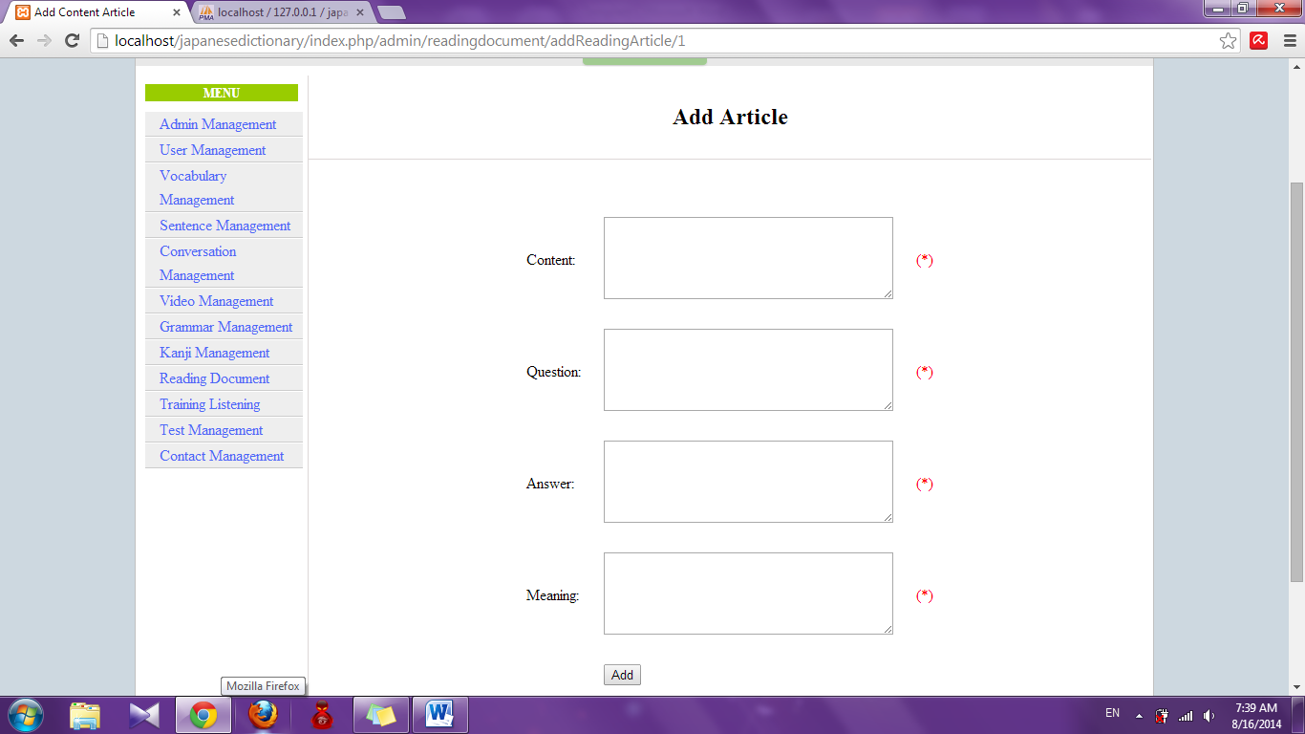

Step 5: Input information that you want to add and click “Add” button

* Success : Display detail of article page with new article
* Fail: Error message will notify. You must try again.

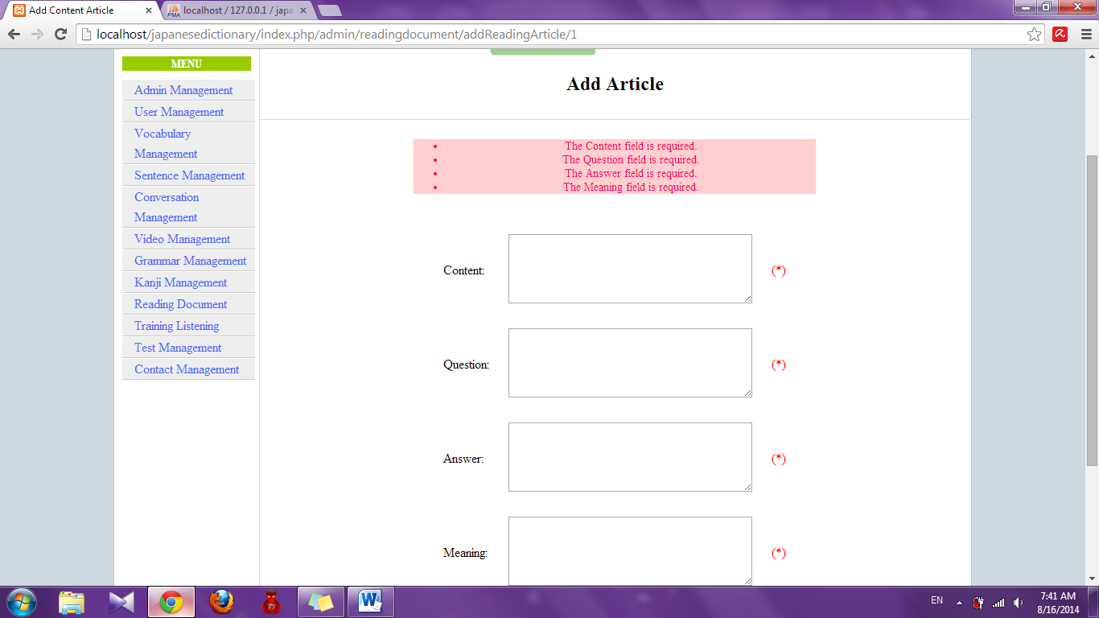

#### Edit reading document

To use edit reading document function on the website, the users do the steps below:

Step 1: Login with admin account as 4.2.19. System will display list User.

Step 2: Click “Reading document management” link. System will display list Reading document.



Step 3: Click “Edit” link. System will display edit reading document page

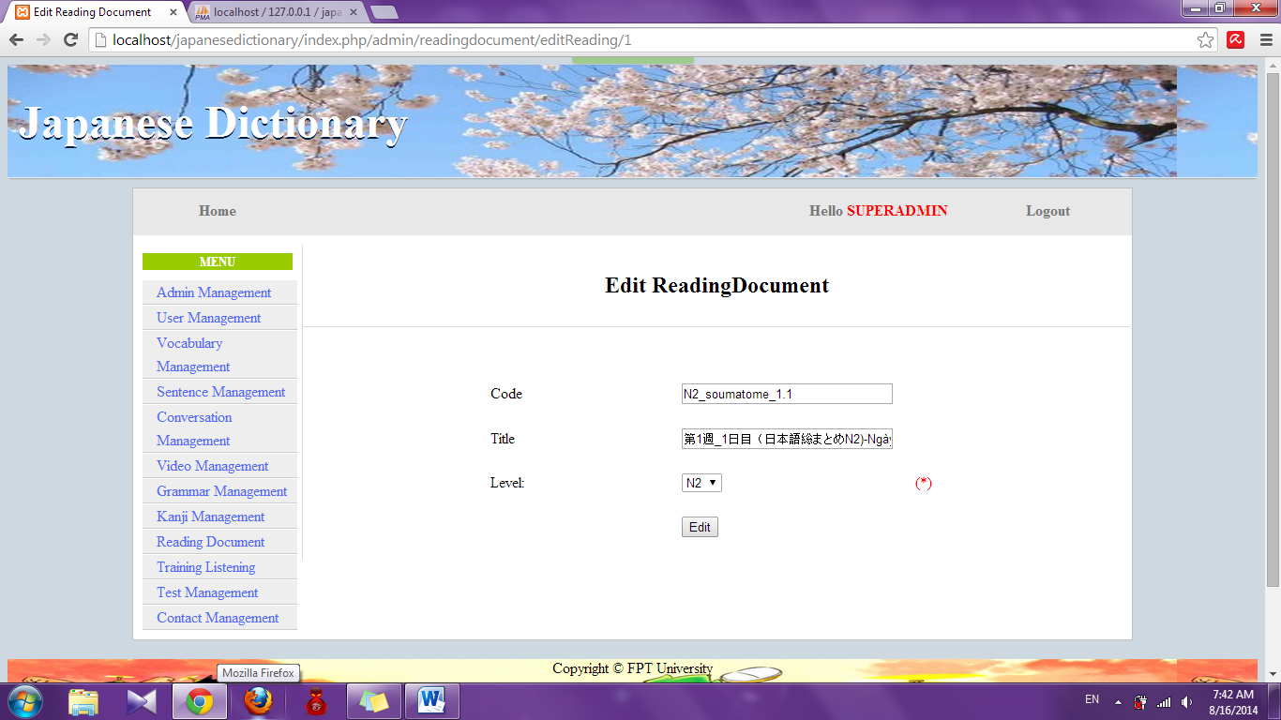

Step 4: Edit information and click “Edit” button

* Success: Display list reading document
* Fail : Error message will notify, you must try again

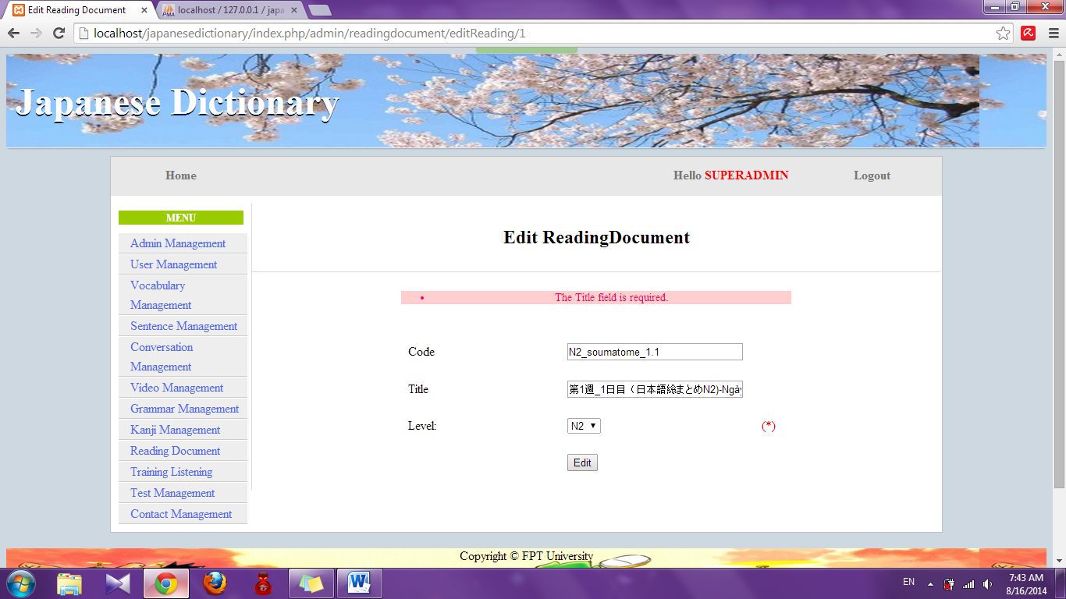

#### Edit vocabulary of reading document

To use edit vocabulary of reading document function on the website, the users do the steps below:

Step 1: Login with admin account as 4.2.19. System will display list User.

Step 2: Click “Reading document management” link. System will display list Reading document.



Step 3: Click “Detail” link of Vocabulary. System will display list vocabulary

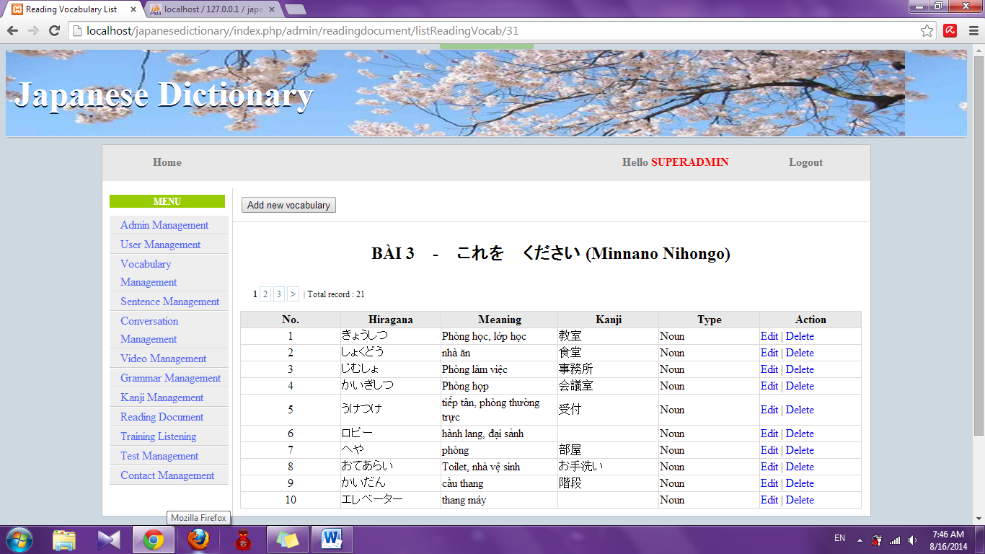

Step 4: Click “Edit” link. System will display edit vocabulary page

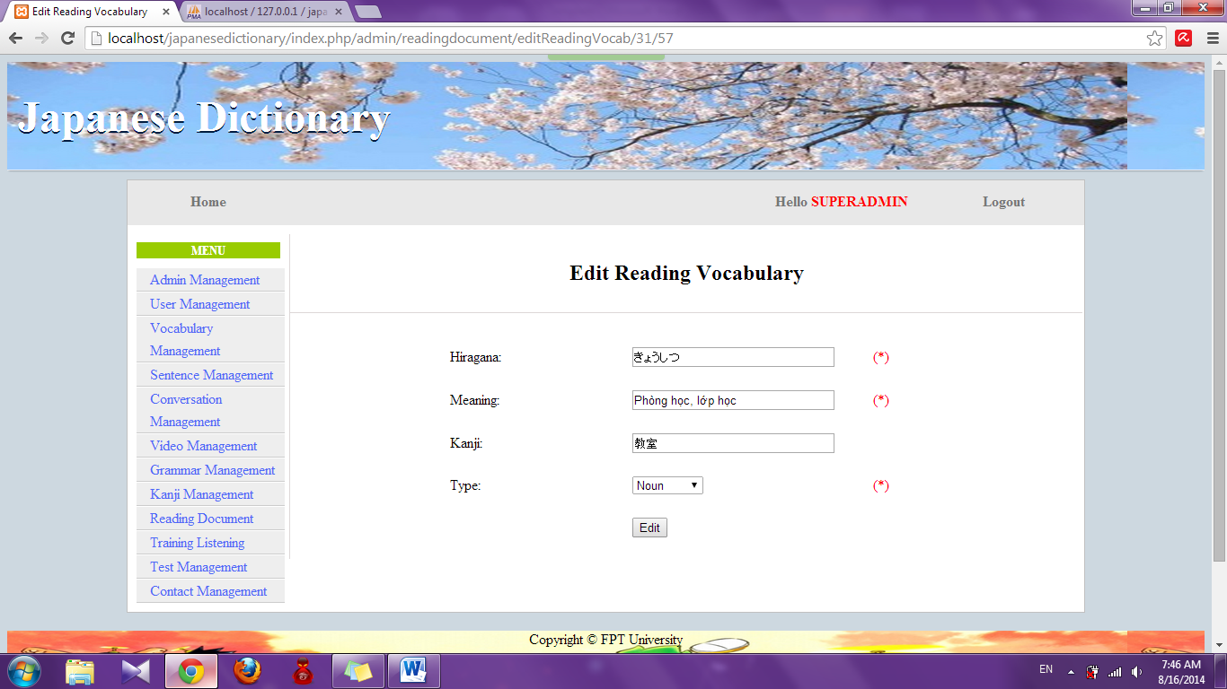

Step 5: Edit information and click “Edit” button

* Success : Display list vocabulary
* Fail : Error message will notify, you must try again

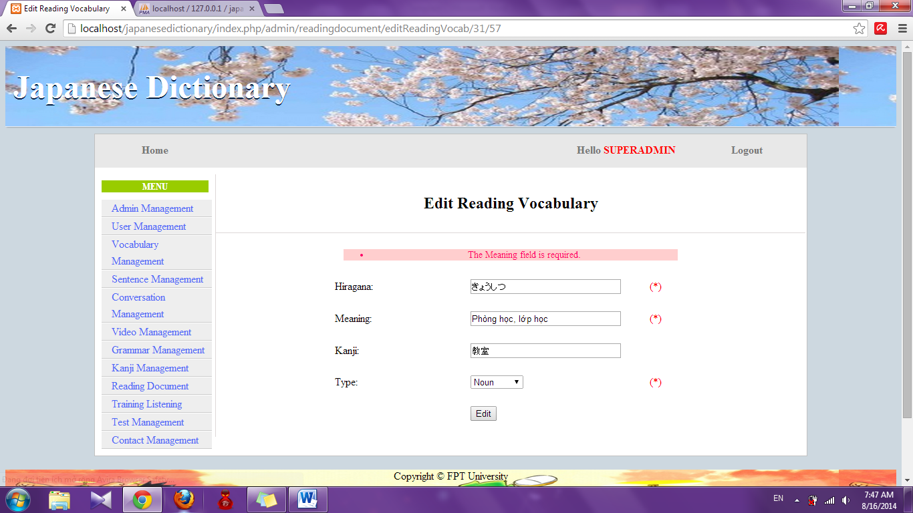

#### Edit article of reading document

To use edit article of reading document function on the website, the users do the steps below:

Step 1: Login with admin account as 4.2.19. System will display list User.

Step 2: Click “Reading document management” link. System will display list Reading document.



Step 3: Click “Detail” link of Article. System will display list article

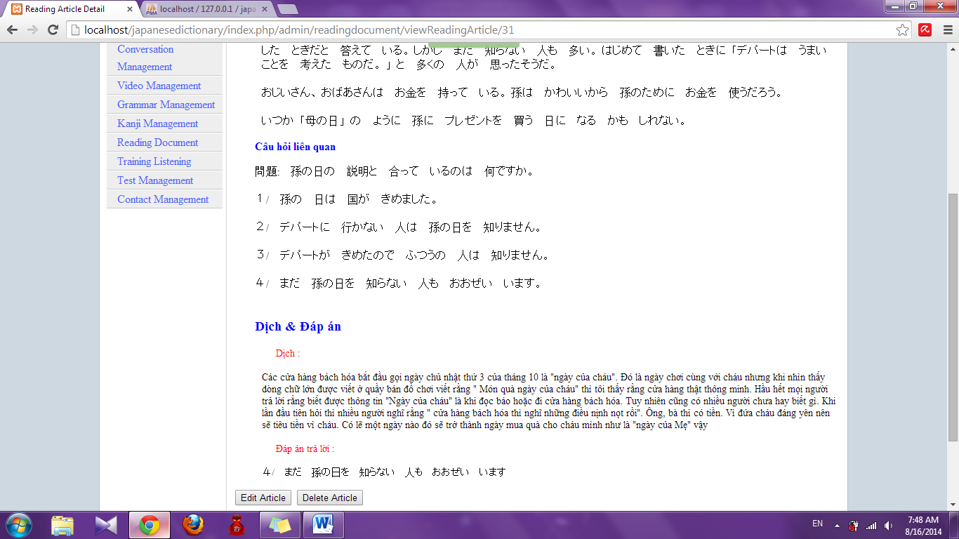

Step 4: Click “Edit article” button. System will display edit article page

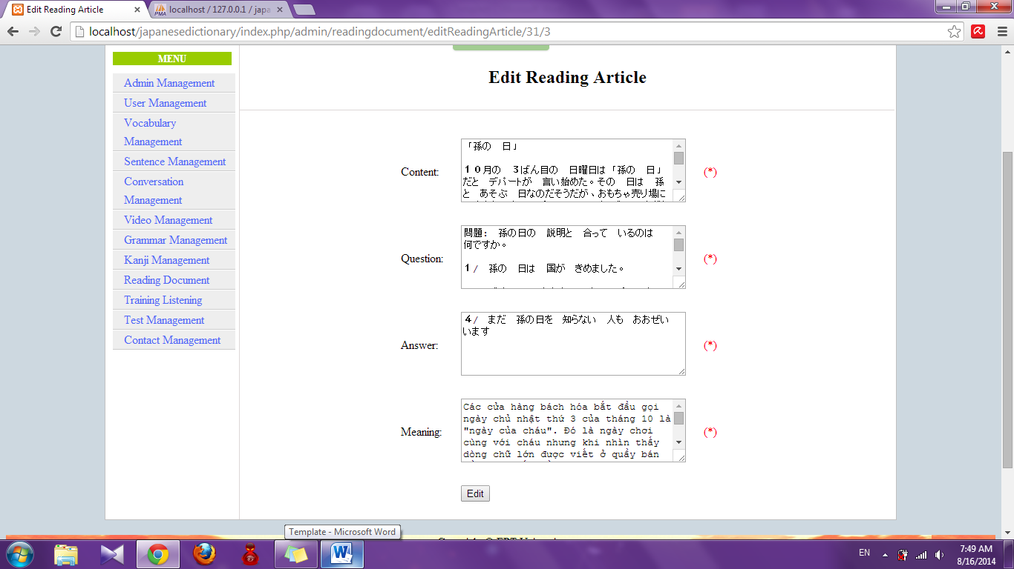

Step 5: Edit information and click “Edit” button

* Success : Display detail of reading article page
* Fail : Error message will notify, you must try again

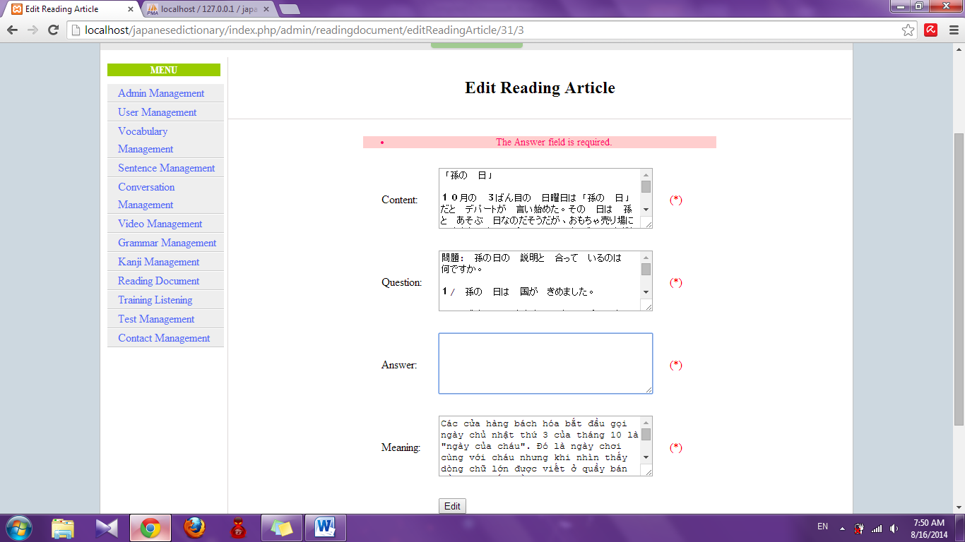

#### Delete reading document

To use detele reading document function on the website, the users do the steps below:

Step 1: Login with admin account as 4.2.19. System will display list User.

Step 2: Click “Reading document management” link. System will display list Reading document.

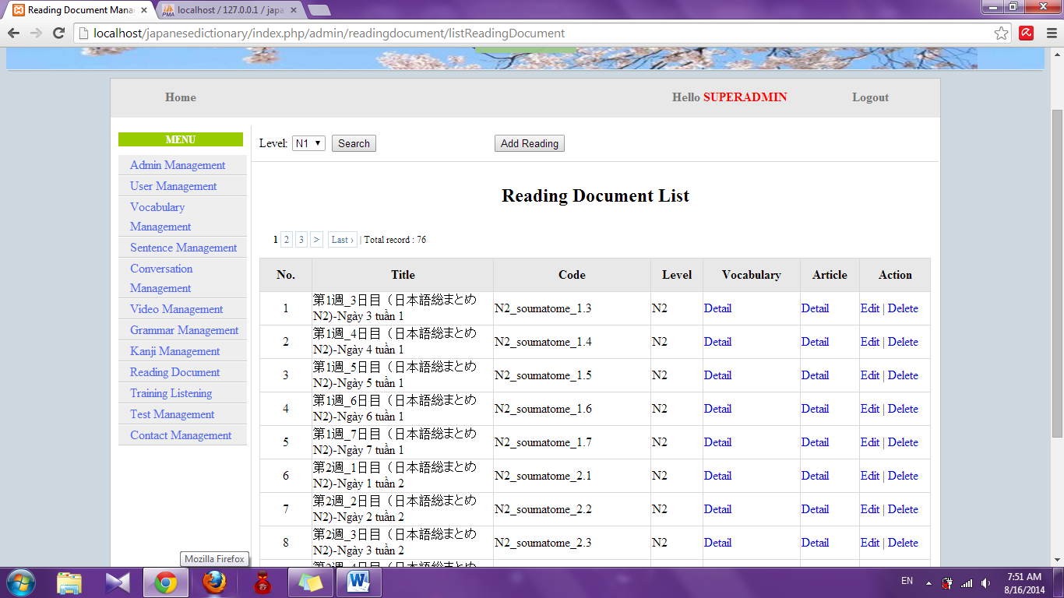

Step 3: Click “Delete” link. System will delete this document

#### Delete vocabulary of reading document

To use delete vocabulary of reading document function on the website, the users do the steps below:

Step 1: Login with admin account as 4.2.19. System will display list User.

Step 2: Click “Reading document management” link. System will display list Reading document. 

Step 3: Click “Detail” link of Vocabulary. System will display list vocabulary. 

Step 4: Click “Delete” link. System will delete this vocabulary

#### Delete article of reading document

To use edit article of reading document function on the website, the users do the steps below:

Step 1: Login with admin account as 4.2.19. System will display list User.

Step 2: Click “Reading document management” link. System will display list Reading document. 

Step 3: Click “Detail” link of Article. System will display list article. 

Step 4: Click “Delete article” button. System will delete that article

### Video management

#### Search video

To use search video function on the website, the users do the steps below:

Step 1: Login with admin account as 4.2.19. System will display list User.

Step 2: Click “Video management” link. System will display list Video

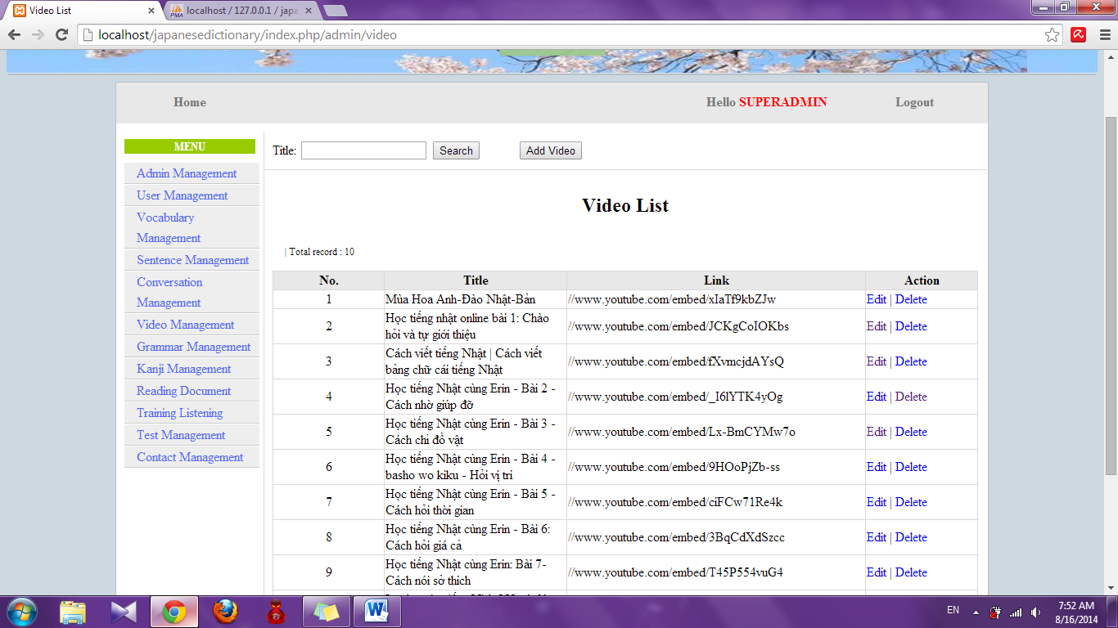

Step 3: Input title and click “Search”. System will display result

* If exist : display list video contain keyword you input

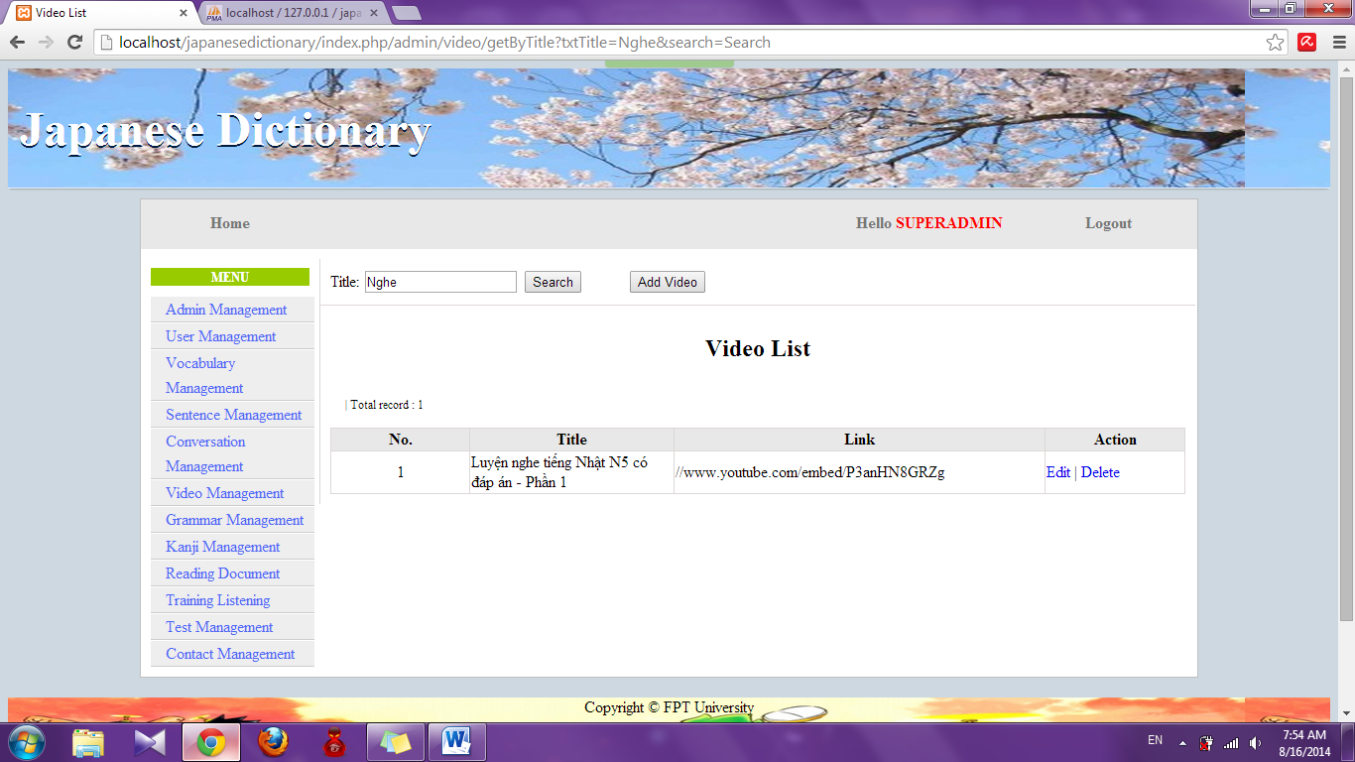

* If don’t exist : Display no record

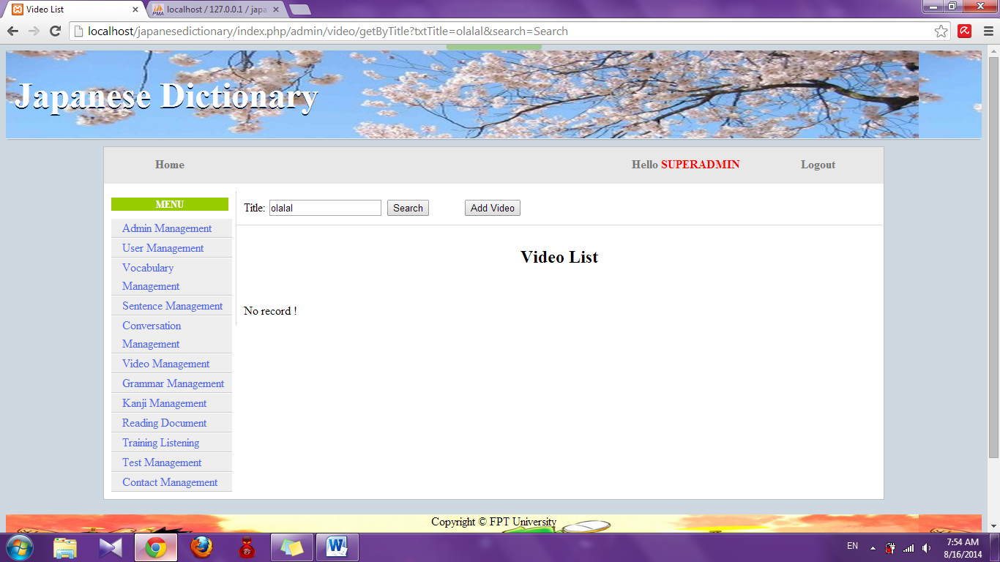

#### Add video

To use add video function on the website, the users do the steps below:

Step 1: Login with admin account as 4.2.19. System will display list User.

Step 2: Click “Video management” link. System will display list Video



Step 3: Click “Add video” button. System will display add video page

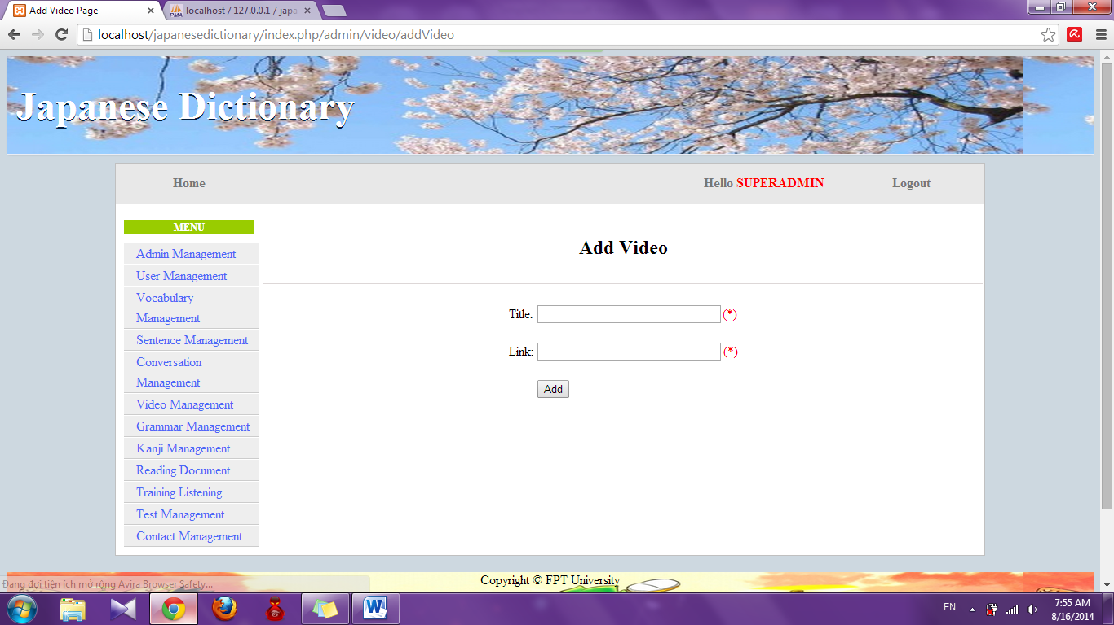

Step 4: Input information that you want to add and click “Add” button

* Success : Display list video with new video
* Fail : Error message will notify, you must try again

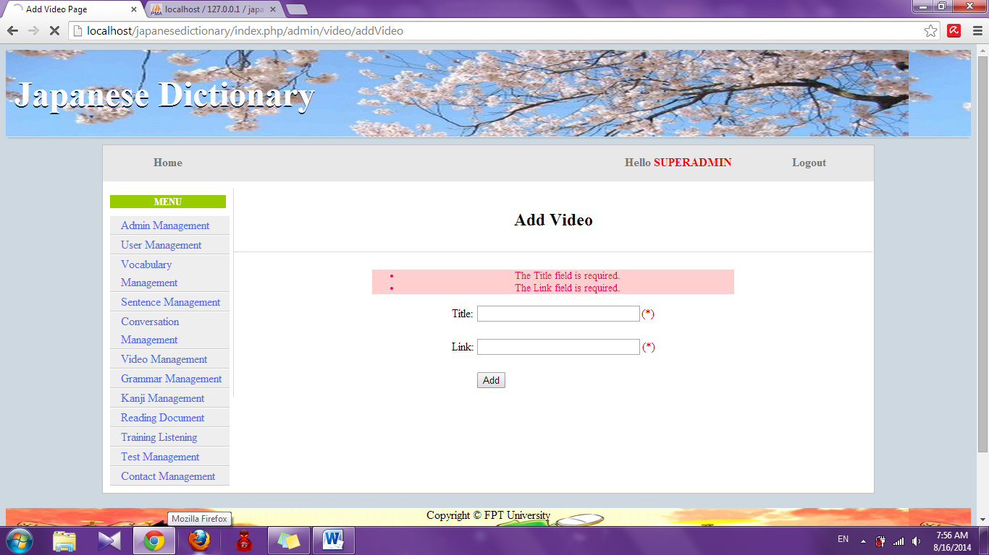

#### Edit video

To use edit video function on the website, the users do the steps below:

Step 1: Login with admin account as 4.2.19. System will display list User.

Step 2: Click “Video management” link. System will display list Video



Step 3: Click “Edit” link. System will display edit video page

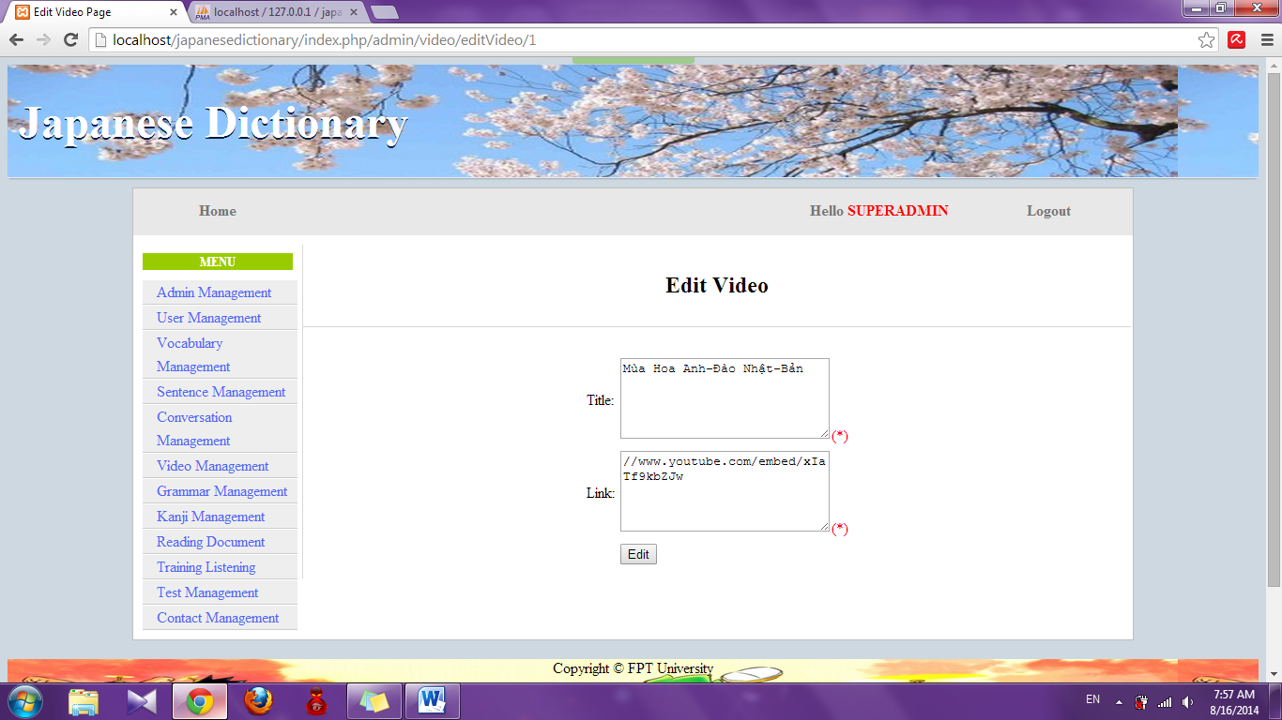

Step 4: Edit information and click “Edit” button

* Success : Display list video
* Fail : Error message will notify, you must try again

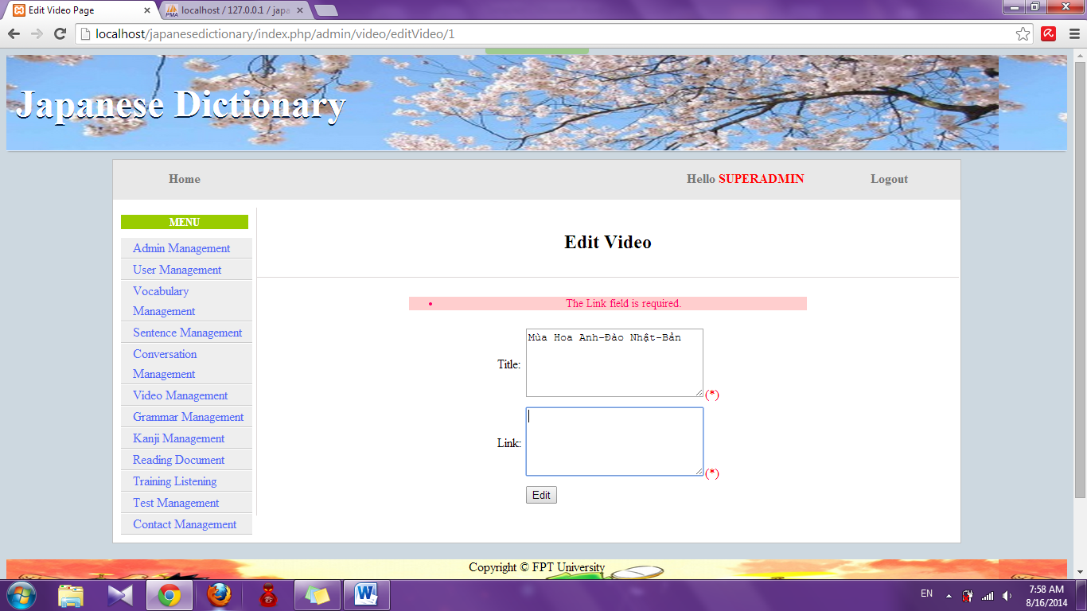

#### Delete video

To use edit video function on the website, the users do the steps below:

Step 1: Login with admin account as 4.2.19. System will display list User.

Step 2: Click “Video management” link. System will display list Video. 

Step 3: Click “Delete” link. System will delete that video

### Training listening management

#### Search listening

To use search training listening function on the website, the users do the steps below:

Step 1: Login with admin account as 4.2.19. System will display list User.

Step 2: Click “Training listening management” link. System will display list listening

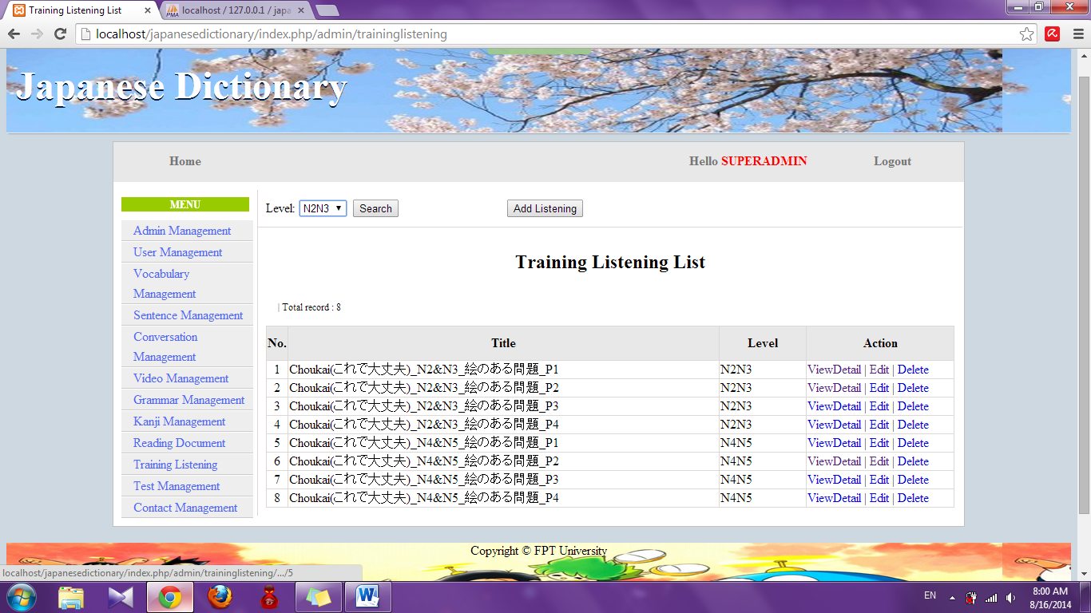

Step 3: Choose option search and click “Search” button. System will display result of search (If exist)

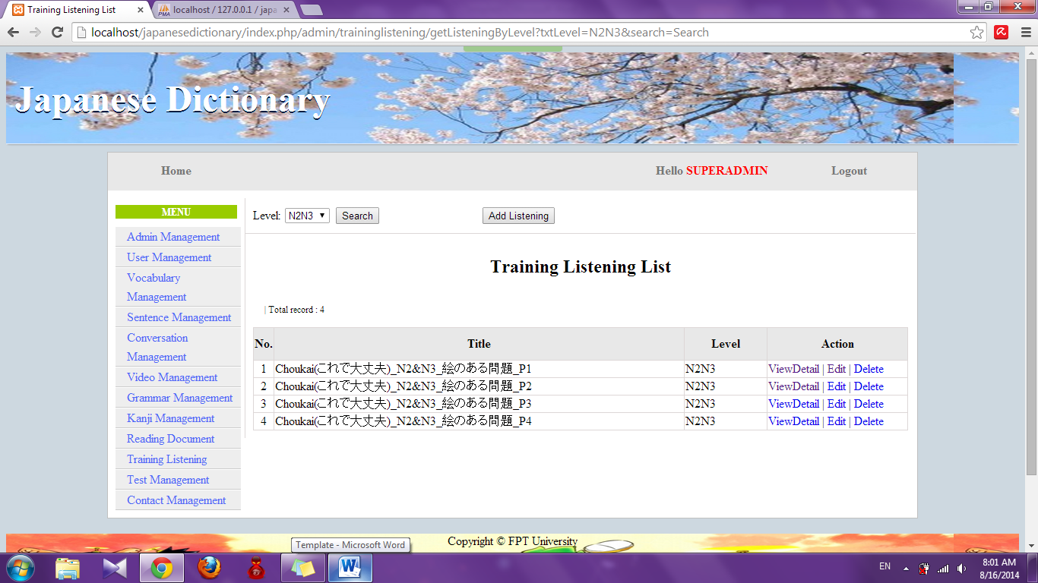

#### Add listening

To use add training listening function on the website, the users do the steps below:

Step 1: Login with admin account as 4.2.19. System will display list User.

Step 2: Click “Training listening management” link. System will display list listening



Step 3: Click “Add listening” button. System will display add listening page

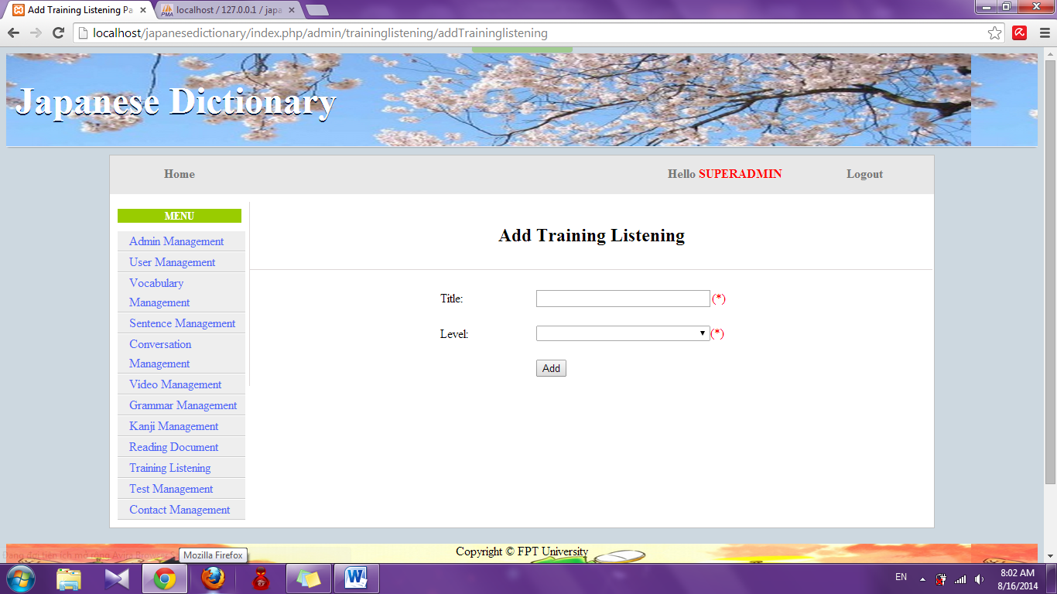

Step 4: Input information that you want to add and click “Add” button

* Success : Display list training listening with new listening
* Fail : Error message will notify, you must try again

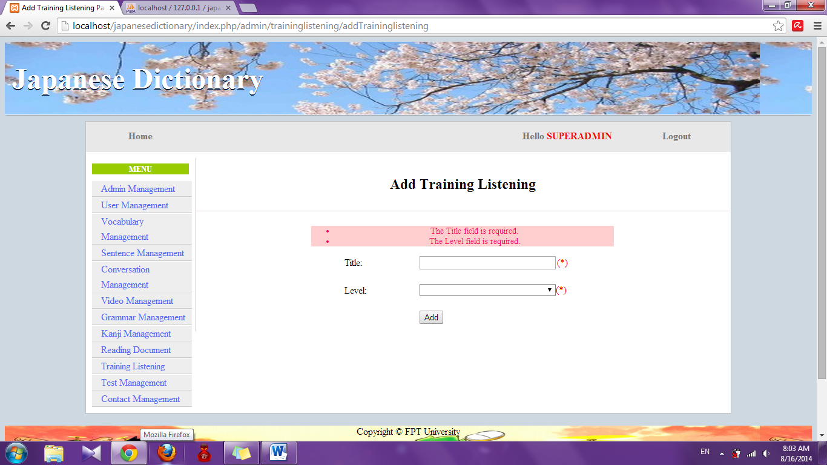

#### Add new source file

To use add new source file of training listening function on the website, the users do the steps below:

Step 1: Login with admin account as 4.2.19. System will display list User.

Step 2: Click “Training listening management” link. System will display list listening



Step 3: Click “View Detail” link. System will display detail of listening

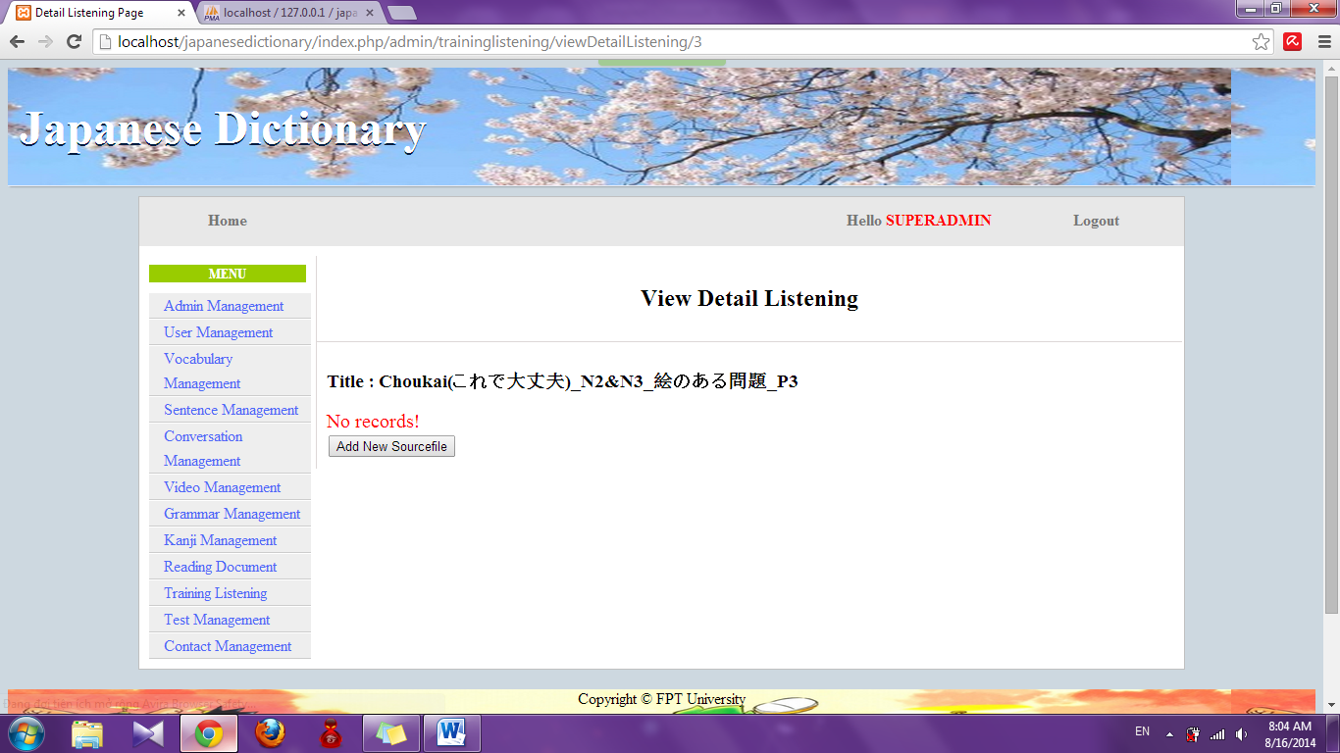

Step 4: Click “Add new sourcefile” button. System will display add new source file page

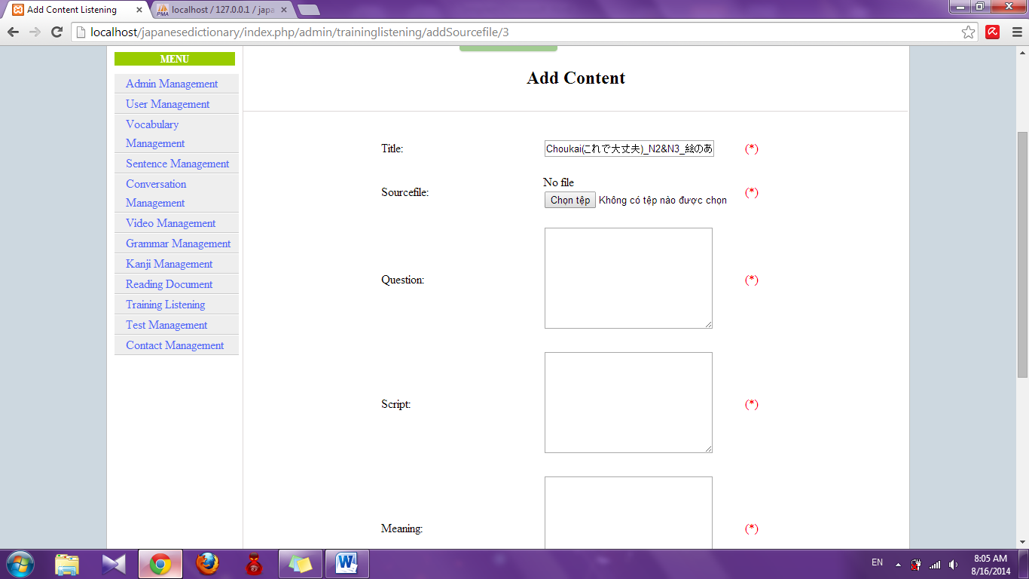

Step 5: Input information and click “Add” button

* Success : Display detail of listening

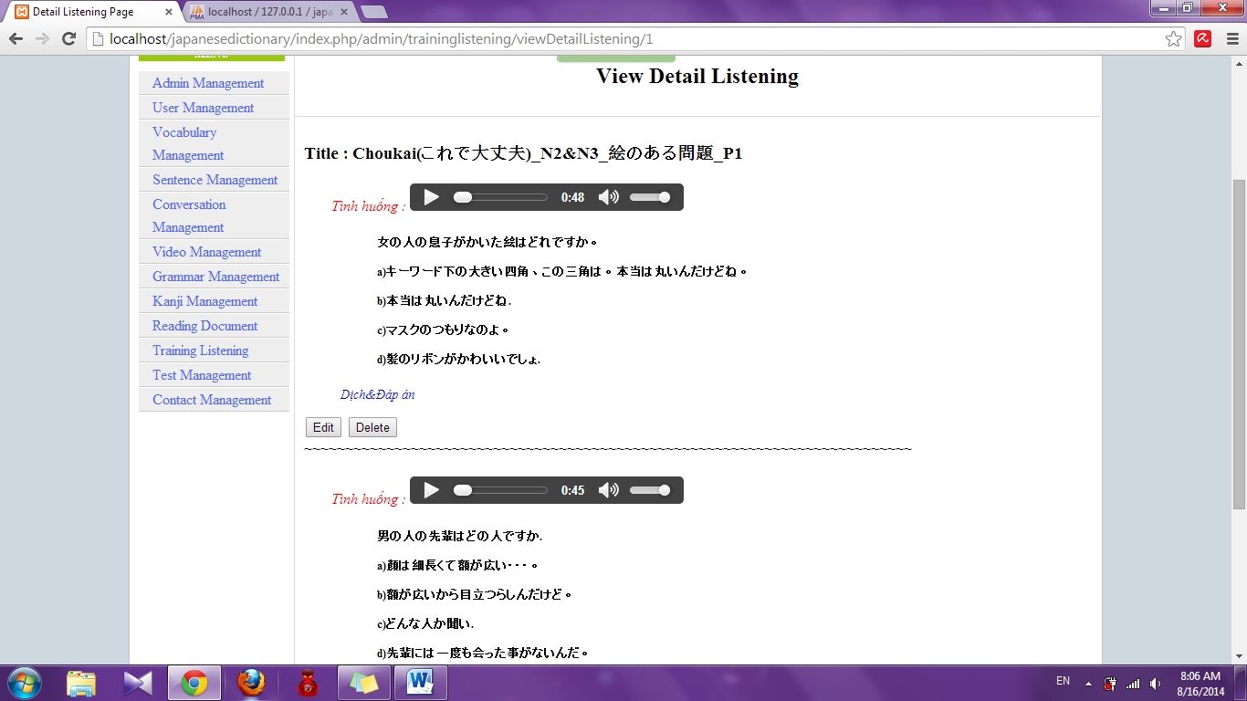

* Fail : Error message will notify, you must try again

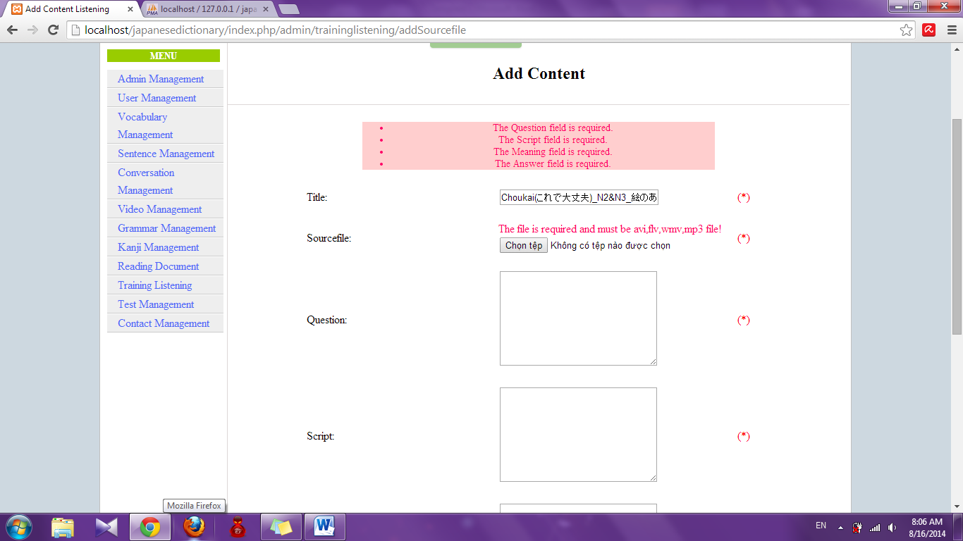

#### Edit listening

To use add edit training listening function on the website, the users do the steps below:

Step 1: Login with admin account as 4.2.19. System will display list User.

Step 2: Click “Training listening management” link. System will display list listening



Step 3: Click “Edit” link. System will display edit listening page

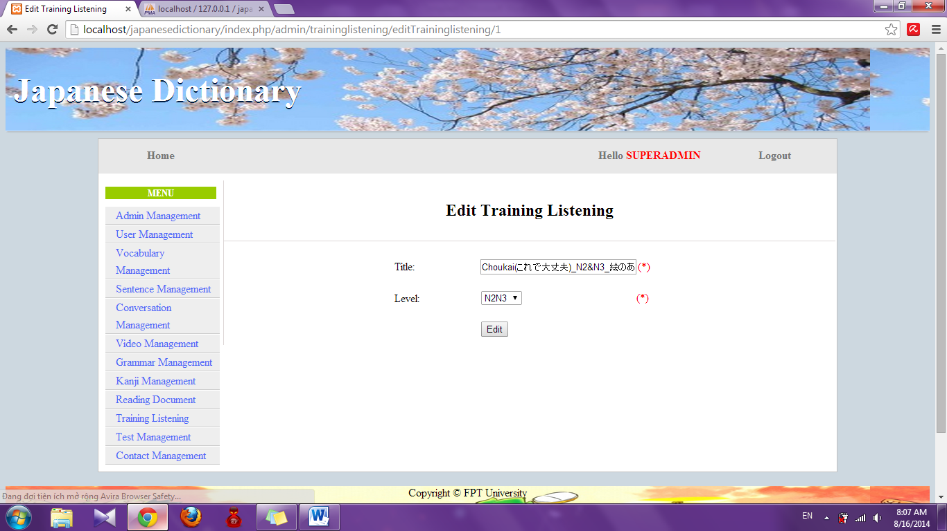

Step 4: Edit information and click “Edit” button

* Success : Display list listening
* Fail : Error message will notify, you must try again

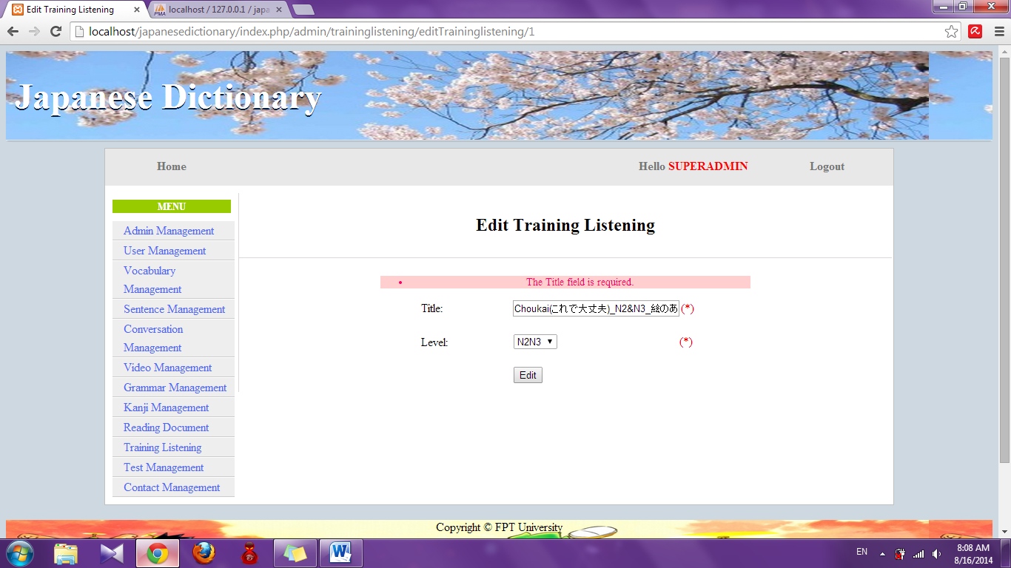

#### Edit source file

To use edit source file of training listening function on the website, the users do the steps below:

Step 1: Login with admin account as 4.2.19. System will display list User.

Step 2: Click “Training listening management” link. System will display list listening



Step 3: Click “View Detail” link. System will display detail of listening

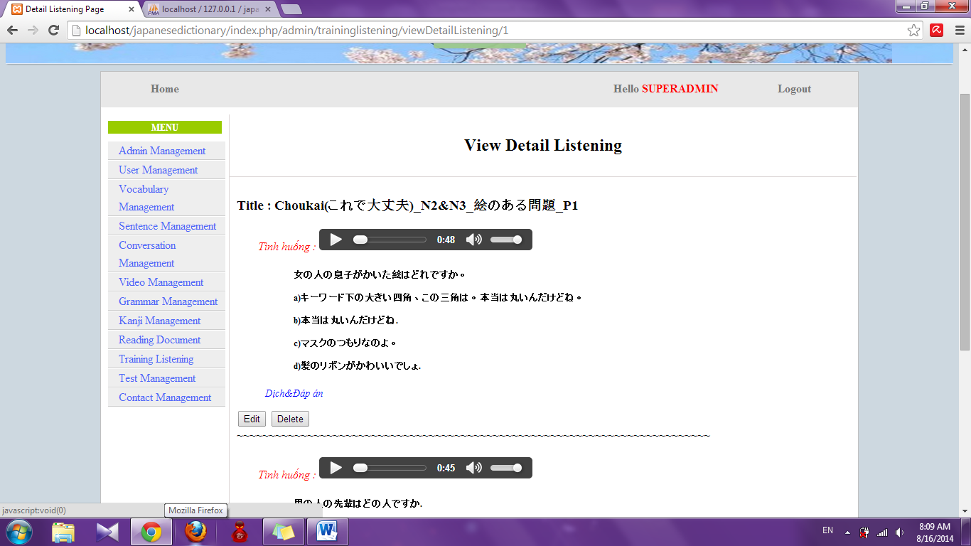

Step 4: Click “Edit” button. System will display edit source file page

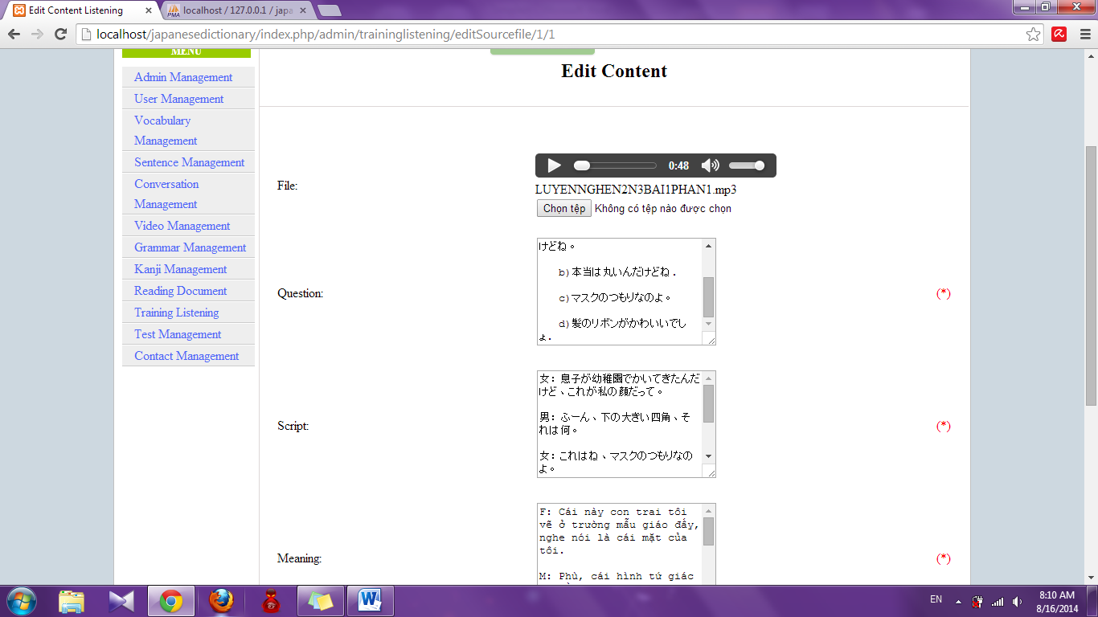

Step 5: Edit information and click “Edit” button

* Success : Display detail of listening
* Fail : Error message will notify, you must try again

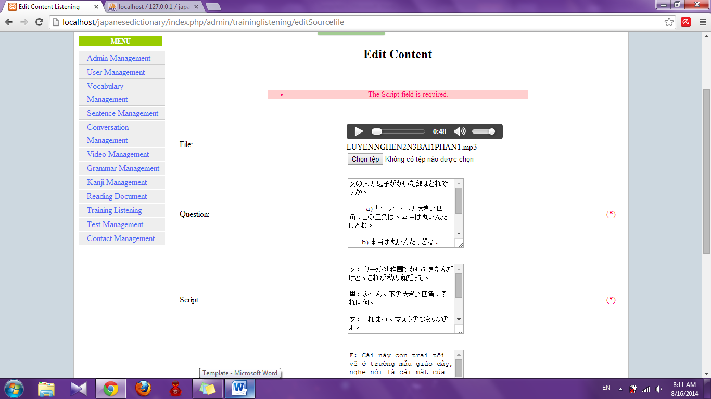

#### Delete source file

To use delete source file of training listening function on the website, the users do the steps below:

Step 1: Login with admin account as 4.2.19. System will display list User.

Step 2: Click “Training listening management” link. System will display list listening



Step 3: Click “View Detail” link. System will display detail of listening. 

Step 4: Click “Delete” button. System will delete that source file

#### Delete listening

To use delete training listening function on the website, the users do the steps below:

Step 1: Login with admin account as 4.2.19. System will display list User.

Step 2: Click “Training listening management” link. System will display list listening. 

Step 3: Click “Delete” link. System will delete that listening

### Test management

#### Search test

To use search test function on the website, the users do the steps below:

Step 1: Login with admin account as 4.2.19. System will display list User.

Step 2: Click “Test management” link. System will display list test

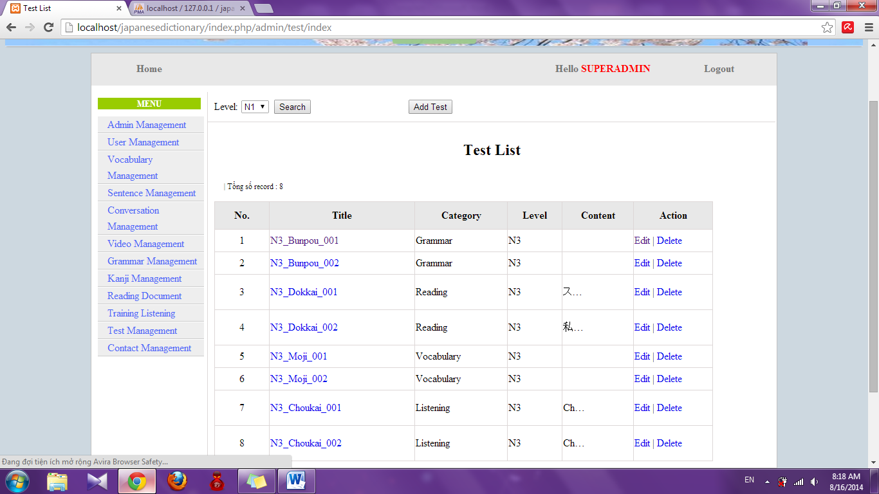

Step 3: Choose option search and click “Search” button. System will display result

* If exist : display result of search

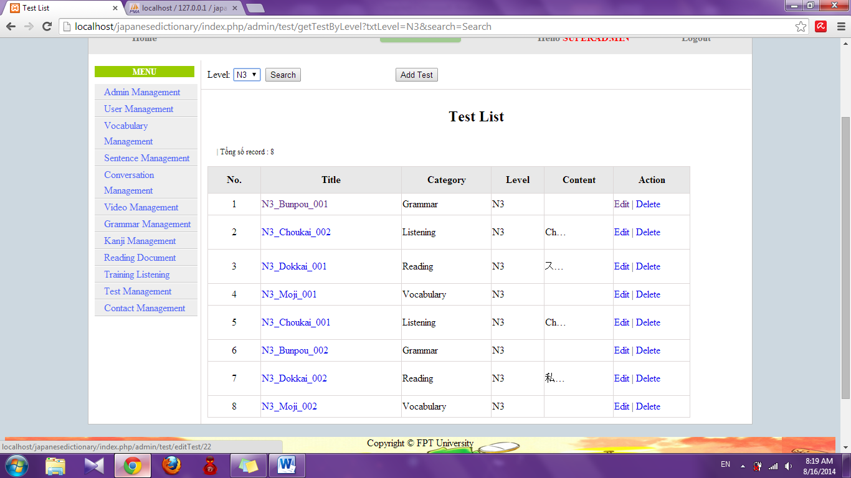

* If don’t exist : Display no record

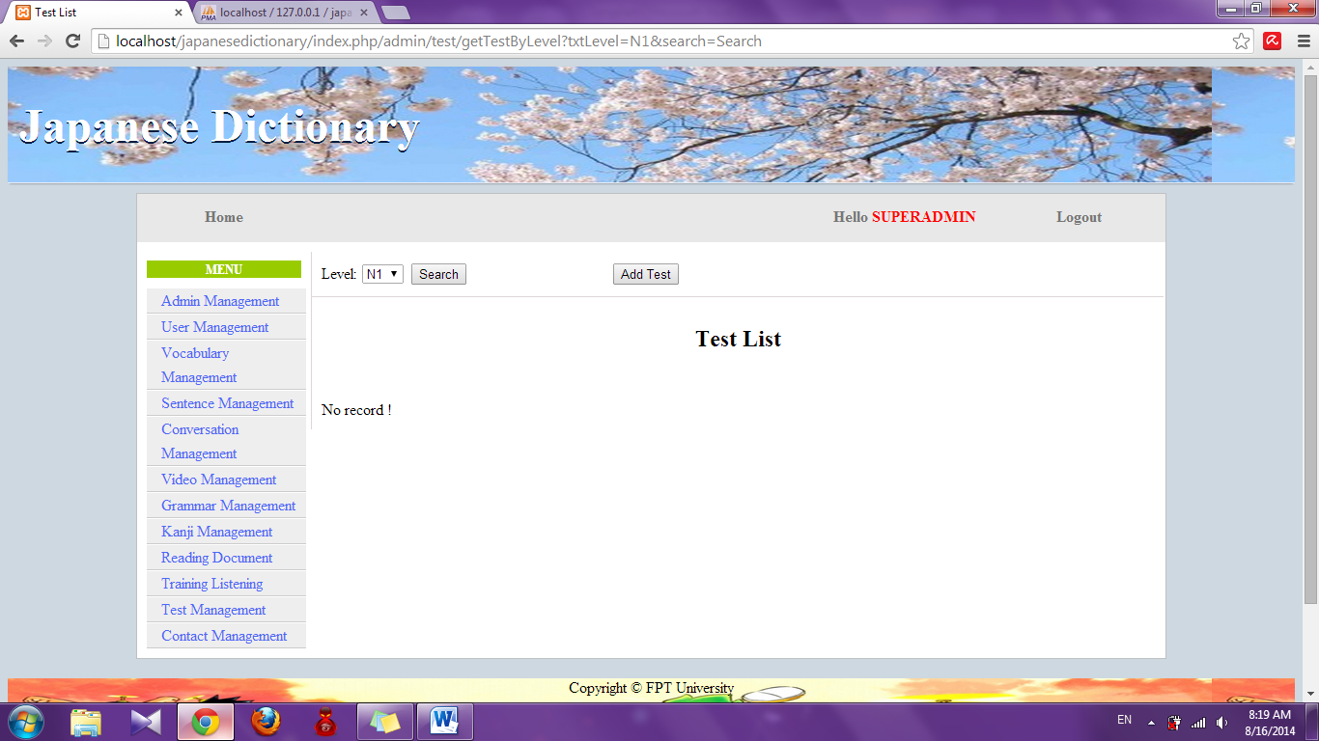

#### Add test

To use add test function on the website, the users do the steps below:

Step 1: Login with admin account as 4.2.19. System will display list User.

Step 2: Click “Test management” link. System will display list test



Step 3: Click “Add test” button. System will display add test page.

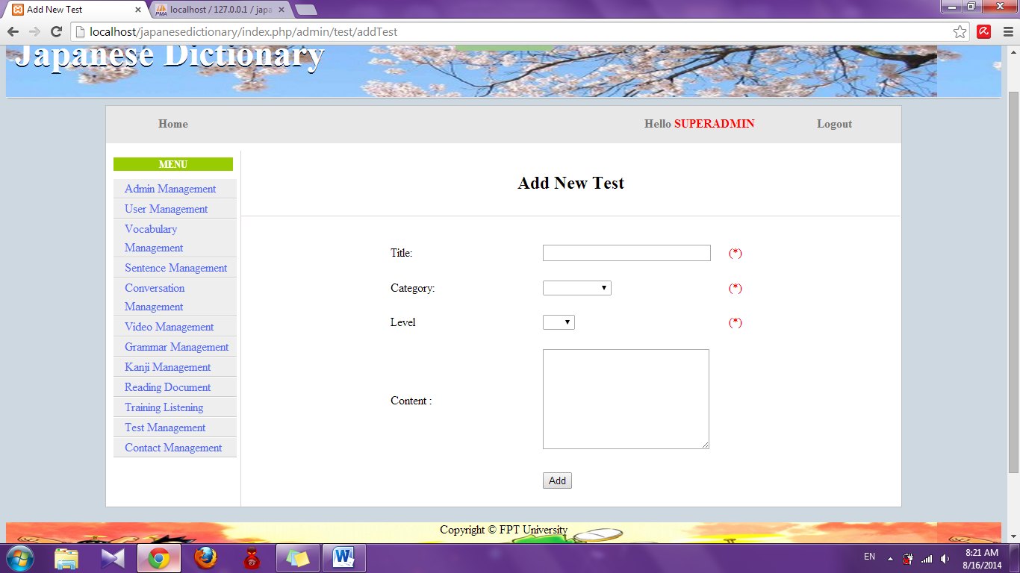

Step 4: Input information that you want to add and click “Add” button

* Success : Display list test with new test
* Fail : Error message will notify, you must try again

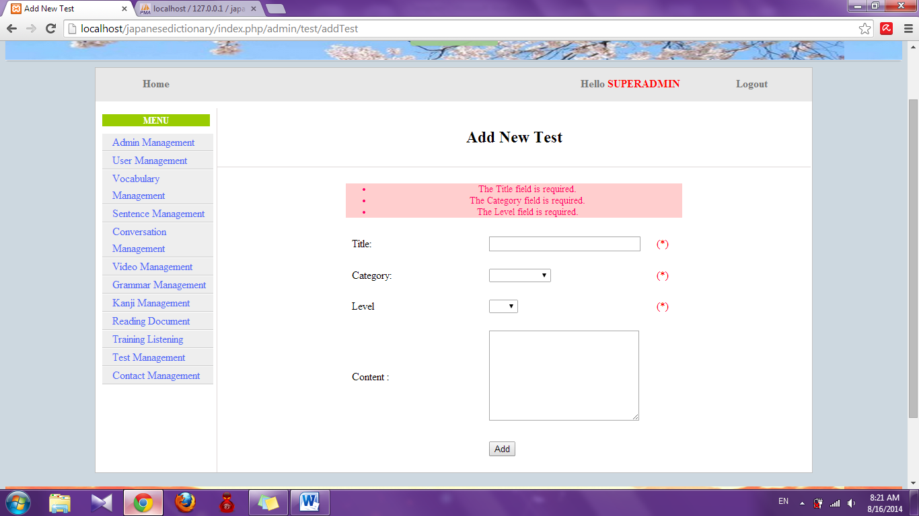

#### Add new question

To use add new question function on the website, the users do the steps below:

Step 1: Login with admin account as 4.2.19. System will display list User.

Step 2: Click “Test management” link. System will display list test



Step 3: Click title of test. System will display detail of test

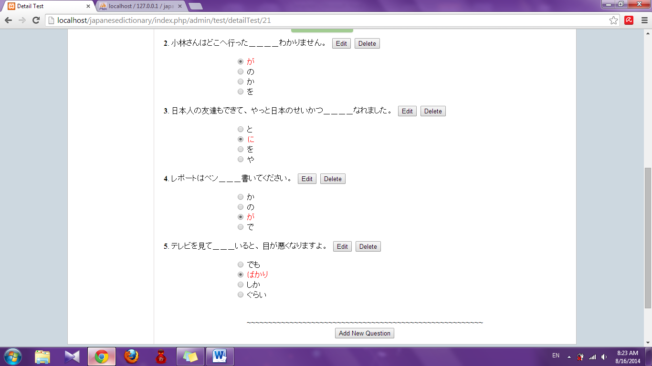

Step 4: Click “Add new question” button. System will display add new question page

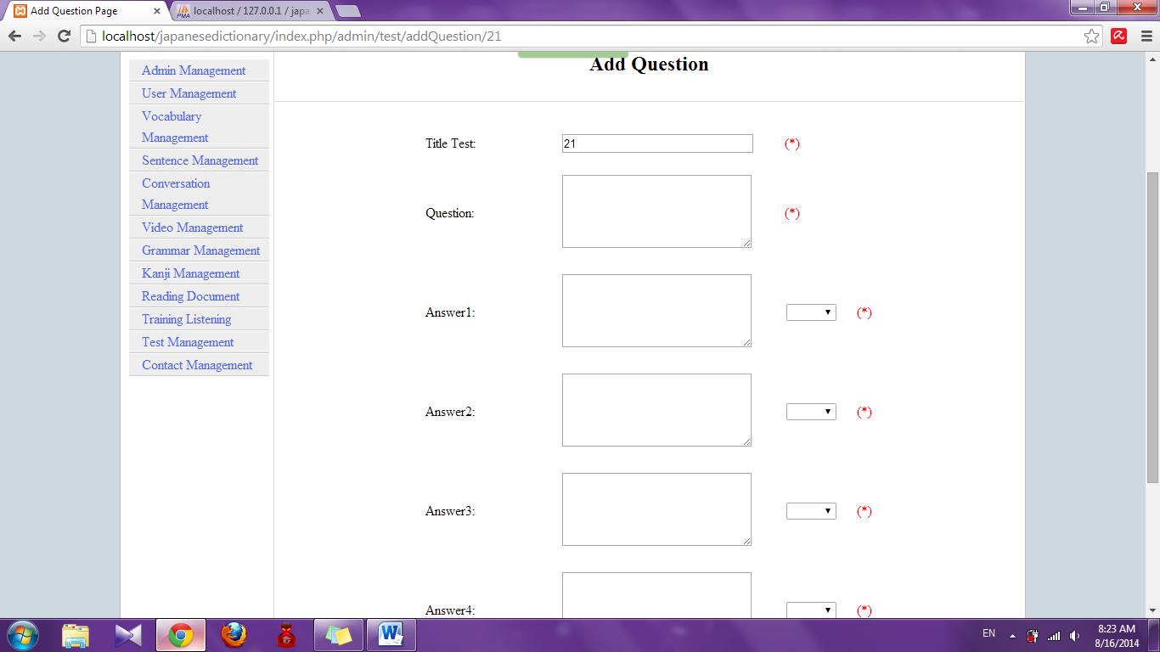

Step 5: Input information and click “Add” button

* Success : Display detail of test
* Fail : Error message will notify, you must try again

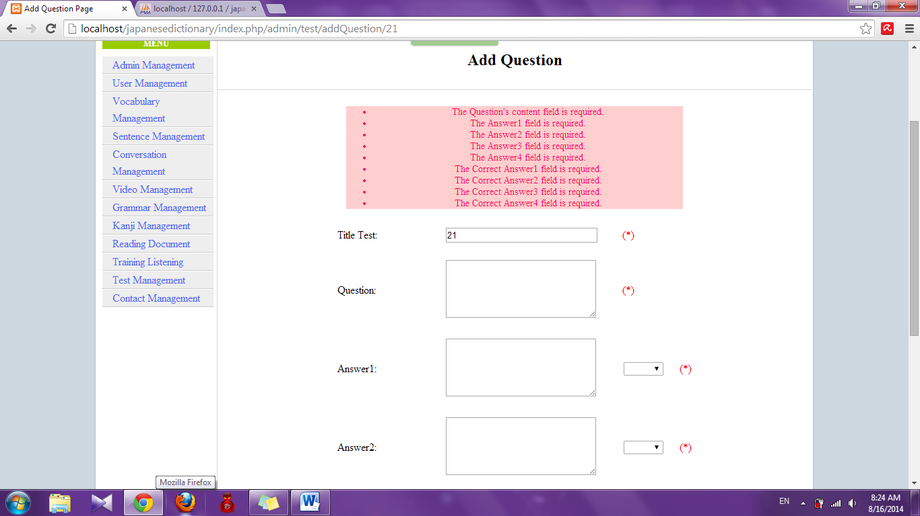

#### Edit test

To use edit test function on the website, the users do the steps below:

Step 1: Login with admin account as 4.2.19. System will display list User.

Step 2: Click “Test management” link. System will display list test



Step 3: Click “Edit” link. System will display edit test page

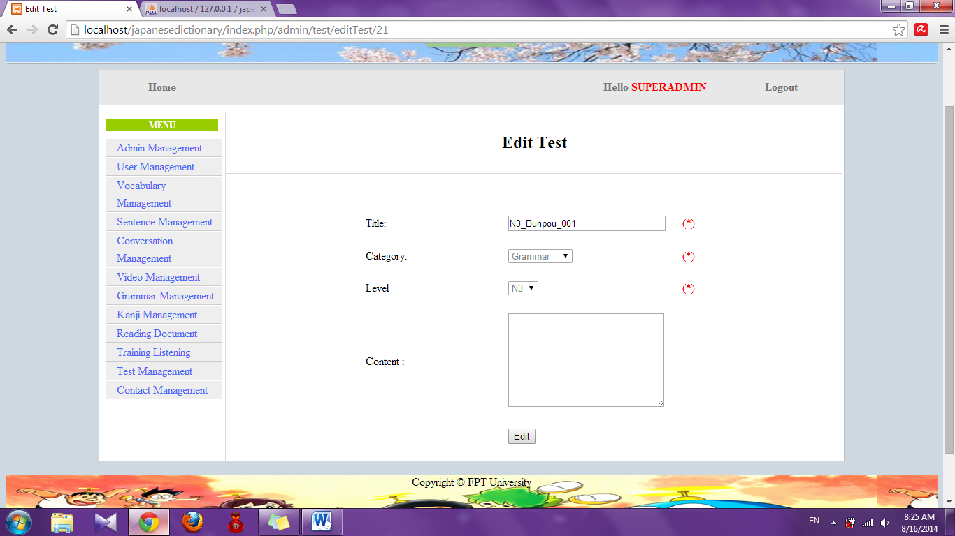

Step 4: Edit information and click “Edit”. System will display list test with edited test

#### Edit question

To use edit question function on the website, the users do the steps below:

Step 1: Login with admin account as 4.2.19. System will display list User.

Step 2: Click “Test management” link. System will display list test



Step 3: Click title of test. System will display detail of test



Step 4: Click “Edit” button. System will display edit question page

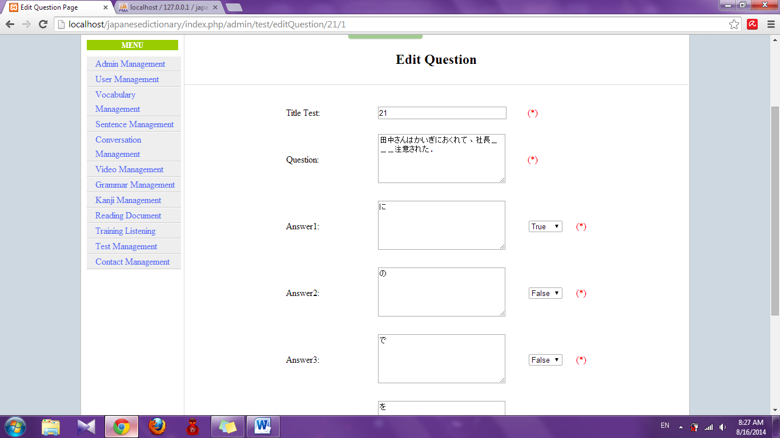

Step 5: Edit information and click “Edit” button

* Success: Display detail of test
* Fail : Error message will notify, you must try again

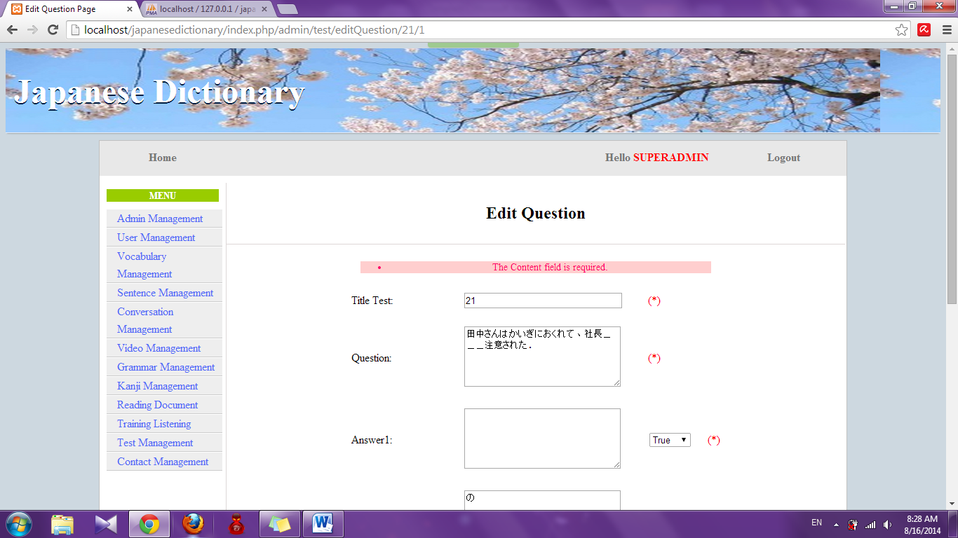

#### Delete question

To use delete question function on the website, the users do the steps below:

Step 1: Login with admin account as 4.2.19. System will display list User.

Step 2: Click “Test management” link. System will display list test



Step 3: Click title of test. System will display detail of test.



Step 4: Click “Delete” button. System will delete that question

#### Delete test

To use add test function on the website, the users do the steps below:

Step 1: Login with admin account as 4.2.19. System will display list User.

Step 2: Click “Test management” link. System will display list test.



Step 3: Click “Delete” link. System will delete that test

### Contact management

#### Search contact

To use search contact function on the website, the users do the steps below:

Step 1: Login with admin account as 4.2.19. System will display list User.

Step 2: Click “Contact management” link. System will display list contact

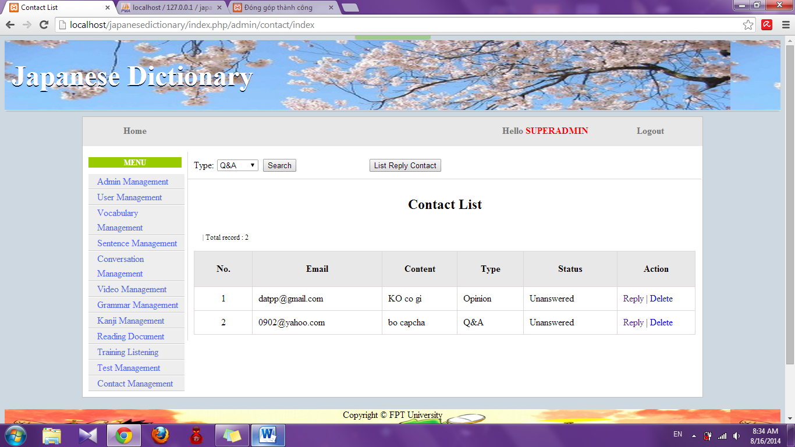

Step 3: Choose option search and click “Search” button. System will display result

* If exist : Display list results

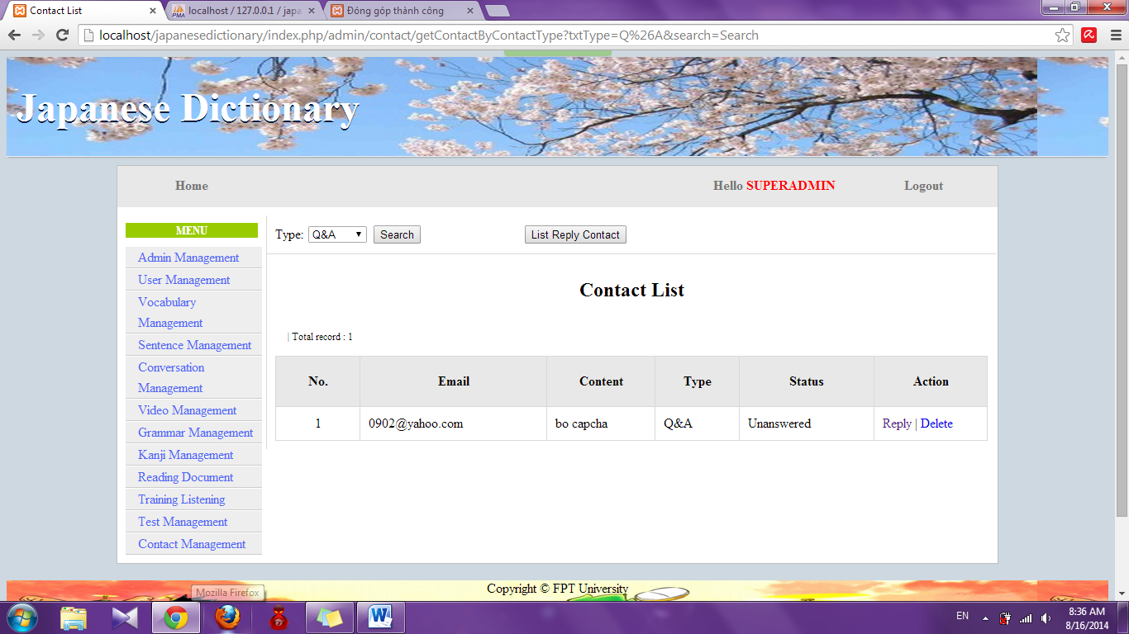

* If don’t exist : Display no record

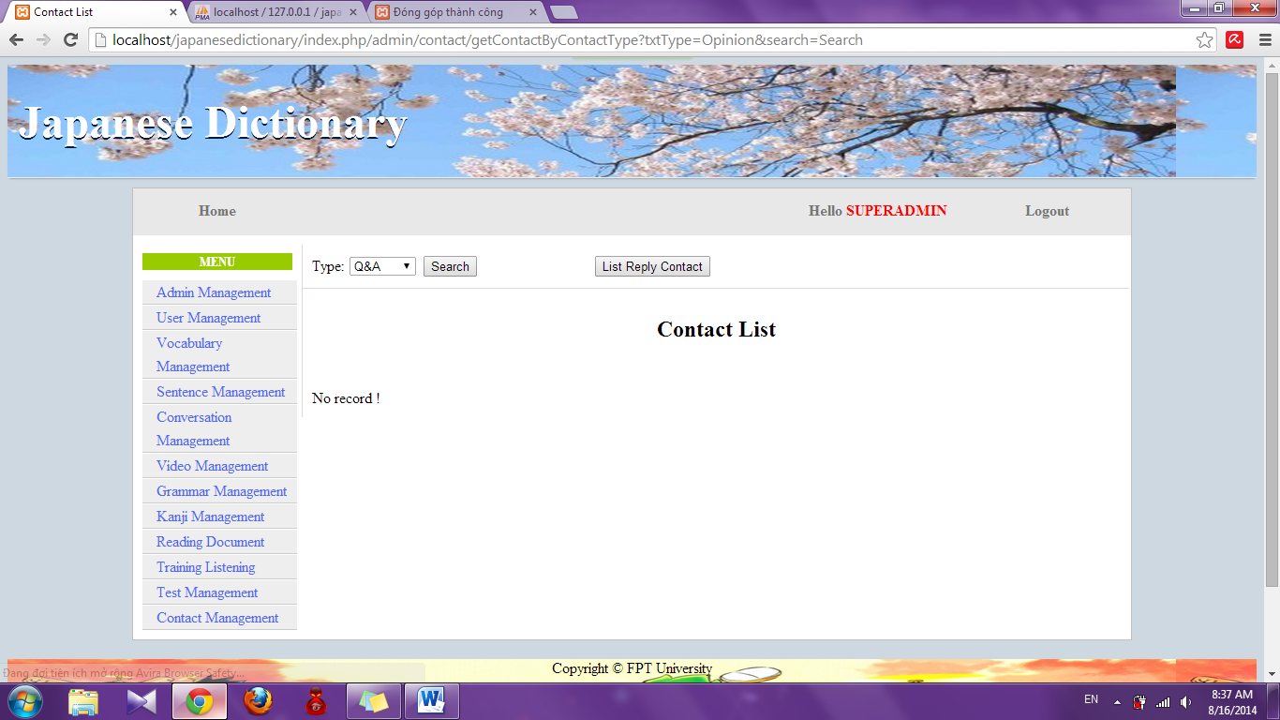

#### Reply contact

To use reply contact function on the website, the users do the steps below:

Step 1: Login with admin account as 4.2.19. System will display list User.

Step 2: Click “Contact management” link. System will display list contact



Step 3: Click “Reply” link. System will display reply page

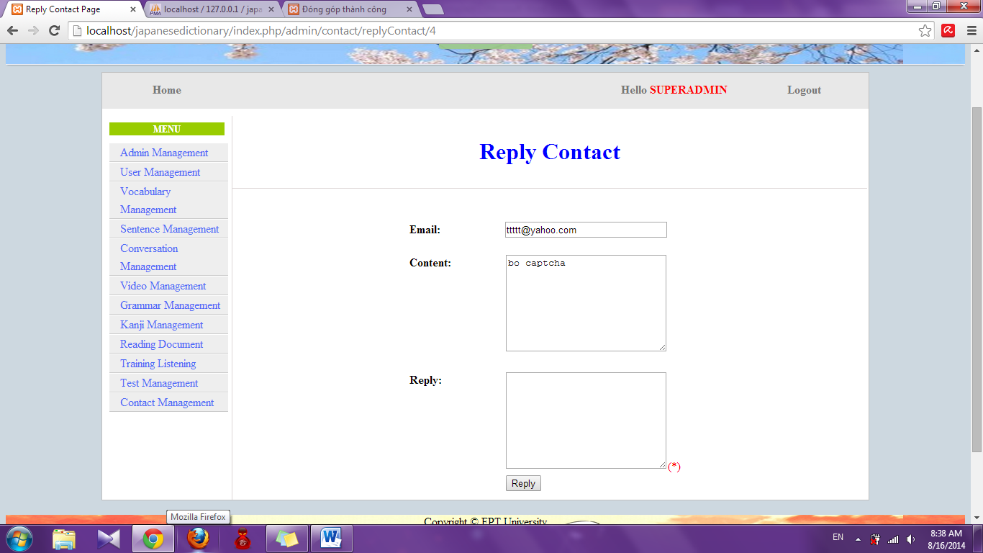

Step 4: Input reply and click “Reply” button. System will display list contact.

#### View list reply contact

To use view list reply contact function on the website, the users do the steps below:

Step 1: Login with admin account as 4.2.19. System will display list User.

Step 2: Click “Contact management” link. System will display list contact



Step 3: Click “List reply contact” button. System will display list replied contact

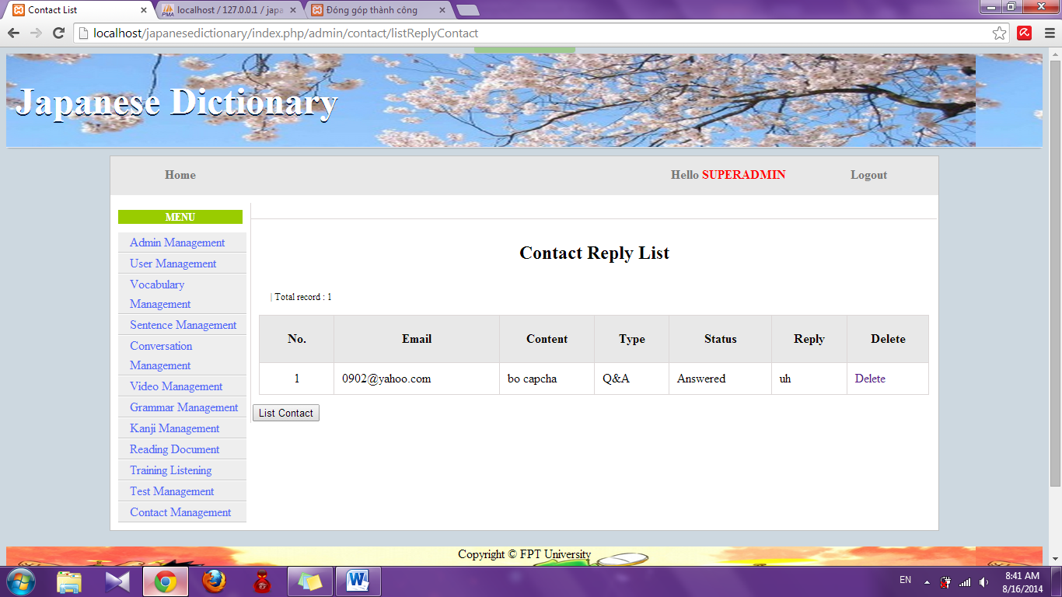

#### Delete contact

To use delete list reply contact function on the website, the users do the steps below:

Step 1: Login with admin account as 4.2.19. System will display list User.

Step 2: Click “Contact management” link. System will display list contact



Step 3: Click “Delete” link. System will delete that contact

# Appendix

* UJD_VN_Software requirement specification_v1.2_EN
* UJD_VN_Defects Log Management_v1.0_VN
* UJD_VN_Q&A Management Sheet_v1.0_JS

# PROJECT RESULT REPORT

## Product Judging

### Advantage of UJD_VN System

The idea of the Useful Japanese dictionary for Vietnamese project is to develop a new website that inherits the advantages and improve issues and learns from other website. And the new website would have the opportunity to add a lot of enhancements.

As the goals that we have set before started the project, the Useful Japanese dictionary for Vietnamese project has been developed in a right direction. And what it provides to users is in the list below:

The user using Useful Japanese dictionary for Vietnamese system will save time, save money but can learn Japanese most convenient.

• Guest:

+ Useful Japanese dictionary for Vietnamese system help guest can search and reading document in website fastest.

• Member:

+ Useful Japanese dictionary for Vietnamese system help can do test that check their knowledge and view learning process.

### Current Limitations

* GUI and function meet demand of almost of user about searching vocabulary, searching conversation and practicing listening Japanese. However, interface also has some limitations like not support on Mobile version, user interface is not support English.
* Not have money for upload website to host.

### Expectation in Future

* Upload to host that user easy to use.
* Product can get many attracking from user, who care Japanese.
* Providing more function to user and expect to commercialized product in the future.

## Product Summary

|  |  |  |  |  |
| --- | --- | --- | --- | --- |
| **Project Title** | | **Useful Japanese dictionary for Vietnamese** | | |
| **Project Supervisor** | | Nguyễn Văn Sang | | |
| **Committers (4)** | | | | |
| **1** | **Project Manager** | Lê Đình Nam | [NamLDSE02316@fpt.edu.vn](mailto:XuanLT01913@fpt.edu.vn) | |
| **2** | **Project Technical Leader** | Phạm Tiến Đạt | [DatPTSE02336@fpt.edu.vn](mailto:KhoiPH01888@fpt.edu.vn) | |
| **3** | **Tester** | Phạm Thị Minh | [MinhPTSE02300@fpt.edu.vn](mailto:TuPM01770@fpt.edu.vn) | |
| **4** | **Tester** | Nguyễn Ngọc Tuấn | [TuanNNSE02189@fpt.edu.vn](mailto:HaiPH01727@fpt.edu.vn) | |
| **Main objective** | | Develop a system which will provide to users functionality to search and reading document online and the other users log-in and do the test. | | |
| **Purpose** | | Provide a UJD_VN online on website. | | |
| **Source Repository** | | **https**://[japanesedictionary.googlecode.com/svn/trunk/](http://japanesedictionary.googlecode.com/svn/trunk/) | | |
|  | | **Plan** | | **Actual** |
| **Start Date** | | 12/05/2014 | | 12/05/2014 |
| **End Date** | | 22/08/2014 | | 30/08/2014 |
| **Releases version** | | 1.0 | | 1.0 |
| **Duration** | | 75 | | 81 |
| **Effort (person-day)** | | 2400 | | 2464 |
| **Test cases** | | 2600 | | 2528 |
| **Defects** | | 240-340 | | 56 |
| **Document pages** | | 1500 pages | | 2000 pages |
| **Lines of code** | | ~20000 | | ~ 24000 |

## Lesson Learn

* Understand ways of working with Japanese style.
* Putting knowledge into practice.
* Improve skill
* Technical: CSS, JavaScript, PHP Codeigniter, MySQL
* Soft skill: brainstorm, teamwork, research and self-study, plan management, time management.
* Risk and issues management
* Technical:

+ When thinking ideas for project, all member of team decided to develop project by PHP language (user Codeigniter framework) and MySQL. But member haven’t experience about PHP Codeigniter. So before start project about 1 month, two members were assigned training PHP language and MySQL.

+ In process coding, we had a function which not completed on time. And our solution is thanks to the help from people who have some experience about PHP language and researching internet.

+ In process of do document, we have difficulty in manage document. Some document was lost because of we don’t have many experience about SVN. So we were meeting and training about SVN in one day.

* Human resource:

+ Some members are lazy for their task. So at 6.00pm, everyday we have meeting to report about task of each member.

+ In process coding, one member was sick about one week and the remaining members can’t cover all function. So after that we have worked over time to ensured completion system.